Introduction to Pathophysiology

Dr. Mayada omar

Pathophysiology:
- May be defined as the physiology of altered health.
- The term combines the words pathology and physiology.
- Pathology (from the Greek pathos, meaning “disease”) deals with the study of the structural and functional changes in cells, tissues, and organs of the body that cause or are caused by disease.
- Physiology deals with the functions of the human body. Thus, pathophysiology deals not only with the cellular and organ changes that occur with disease, but also with the effects that these changes have on total body function.
- In addition, pathophysiology focuses on the mechanisms of the underlying disease process and provides the background for preventive as well as therapeutic health care measures and practices.

  - Disease : may be defined as an interruption, cessation, or disorder of a body system or organ structure that is characterized usually by a recognized etiologic agent or agents, an identifiable group of signs and symptoms, or consistent anatomic alterations.
  - The aspects of the disease process include:
  - Etiology
  - Pathogenesis
  - Morphologic changes
  - Clinical manifestations

- Etiology
- The causes of disease are known as etiologic factors.
- Among the recognized etiologic agents are biologic agents (e.g., bacteria, viruses), physical forces (e.g., trauma, burns, radiation), chemical agents (e.g., poisons, alcohol), and nutritional excesses or deficits.

  - Pathogenesis
  - Pathogenesis is the sequence of cellular and tissue events that take place from the time of initial contact with an etiologic agent until the ultimate expression of a disease. In other word the pathogenesis describes how the disease process evolves.

- Morphology:
- Morphology refers to the fundamental structure or form of cells or tissues.
- Morphologic changes are concerned with both the gross anatomic and microscopic changes that are characteristic of a disease.

- A lesion represents a pathologic or traumatic discontinuity of a body organ or tissue. Descriptions of lesion size and characteristics often can be obtained through the use of radiographs, ultrasonography, and other imaging methods. Lesions also may be sampled by biopsy and the tissue samples subjected to histologic study.

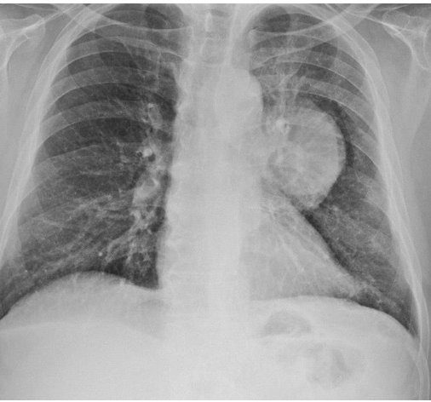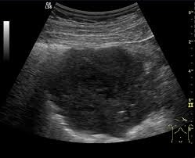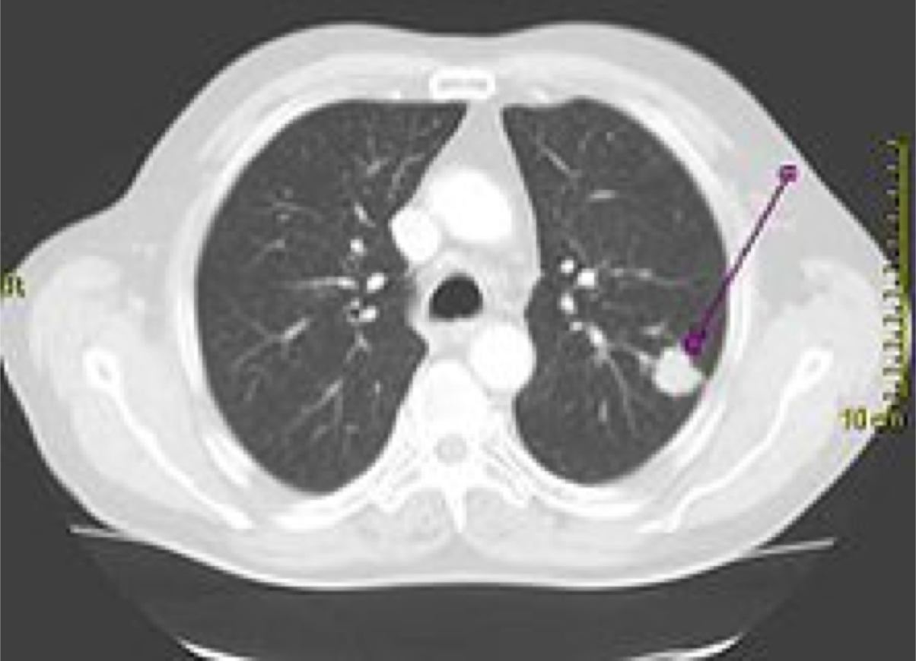

Lung cancer lesion radiographs
Lung cancer lesion ultrasonography
Lung cancer lesion CT scan

- Clinical Manifestations
- Diseases can manifest in a number of ways. Sometimes the condition produces manifestations, such as fever, that make it evident that the person is sick. In other cases, the condition is silent at the onset and is detected during examination for other purposes or after the disease is far advanced.
- Signs and symptoms are terms used to describe the structural and functional changes that accompany a disease.
- A symptom is a subjective complaint that is noted by the person with a disorder. For example pain, difficulty in breathing, and dizziness are symptoms of a disease.
- A sign is a manifestation that is noted by an observer. An elevated temperature, a swollen extremity, and changes in pupil size are objective signs that can be observed by someone other than the person with the disease.
- Signs and symptoms may be related to the primary disorder or they may represent the body’s attempt to compensate for the altered function caused by the pathologic condition.

- A syndrome is a compilation of signs and symptoms (e.g., chronic fatigue syndrome) that are characteristic of a specific disease state.

- Complications are possible adverse extensions of a disease or outcomes from treatment.

- Sequelae are lesions or impairments that follow or are caused by a disease.

- Diagnosis:
- A diagnosis is the designation as to the nature or cause of a health problem (e.g., bacterial pneumonia or hemorrhagic stroke).
- The diagnostic process usually requires a careful history and physical examination.
- The history is used to obtain a person’s account of his or her symptoms and their progression, and the factors that contribute to a diagnosis.
- The physical examination is done to observe for signs of altered body structure or function.
- The development of a diagnosis involves weighing competing possibilities and selecting the most likely one from among the conditions that might be responsible for the person’s clinical presentation.
- The clinical probability of a given disease in a person of a given age, gender, race, lifestyle, and locality often is influential in arriving at a presumptive diagnosis. Laboratory tests, radiologic studies, computed tomography (CT) scans, and other tests often are used to confirm a diagnosis.

- Clinical Course
- The clinical course describes the evolution of a disease. A disease can have an acute, subacute, or chronic course.
- An acute disorder is one that is relatively severe, but self- limiting.
- Chronic disease implies a continuous, long- term process. A chronic disease can run a continuous course or can present with exacerbations (aggravation of symptoms and severity of the disease) and remissions (a period during which there is a decrease in severity and symptoms).
- Subacute disease is intermediate or between acute and chronic: it is not as severe as an acute disease and not as prolonged as a chronic disease.

- Epidemiology: is the study of disease occurrence in human populations.
- Epidemiology looks for patterns, such as age, race, dietary habits, lifestyle, or geographic location, of persons affected with a particular disorder.

- Mortality: statistics provide information about the causes of death in a given population.

- Morbidity: describes the effects an illness has on a person’s life.

- Prognosis refers to the probable outcome and prospect of recovery from a disease. It can be designated as chances for full recovery, possibility of complications, or anticipated survival time.
- Risk factors : are conditions suspected of contributing to the development of a disease.

  - Levels of Prevention
  - Leading a healthy life contributes to the prevention of disease. There are three fundamental types of prevention: primary prevention, secondary prevention, and tertiary prevention.
  - Primary prevention is directed at keeping disease from occurring by removing all risk factors. Examples of primary prevention include giving immunizations to children to prevent communicable disease , and counseling people to adopt healthy lifestyles as a means of preventing heart disease.
  - Secondary prevention detects disease early when it is still asymptomatic and treatment measures can affect a cure or stop the disease from progressing. The use of a Papanicolaou (Pap) smear for early detection of cervical cancer is an example of secondary prevention.
  - Tertiary prevention is directed at clinical interventions that prevent further deterioration or reduce the complications of a disease once it has been diagnosed.



