Applied Nutrition

Third Year, Second Semester, 2024-2025

Course content

 | Chapter | Name of chapter | Page
 | No. | Name of chapter | No.
 | 1 | Introduction to nutrition | 4
 | 2 | Element of nutrition | 17
 | 3 | Carbohydrates | 40
 | 4 | Protein | 46
 | 5 | Fats | 51
 | 6 | Vitamins | 58
 | 7 | Vegetarian Diet | 67
 | 8 | Therapeutic Diets | 75
 | 9 | Adulteration of Food Additives | 97
 | 10 | Nutritional assessment | 138
 | 11 | Malnutrition diseases | 144
 | 12 | Nutritional Disorders | 171
 | 13 | Nutrition and chronic disease | 180
 | 14 | Enteral Nutrition | 195
 | 15 | Healthy diet | 215

Introduction to nutrition
To eat is a necessity, but to eat intelligently is an art. Hippocrates first coined the word clinical nutrition in 4th century B.C. The word diet is derived from the Greek word "data" which means healthful living according to proper reflection of food. The science of nutrition is defined as ―the study of the Nutrients in food and the body‘s handling of them‖. Nutrition means ―the process of nourishing or being nourished especially, the series of processes by which organism assimilates food and uses it for growth and replacement of tissues‖.

Terminology
Nutrition: It may be defined as the science of food and its relationship to health. It is concerned with the part played by nutrients in body growth, development and maintenance.
Dietetics: Dietetics is the practical application of the principles of nutrition. It includes the planning of meals for well and the sick.
Nutrients: A substance in suitable amount is essential for the growth, maintenance, function and reproduction of a cell or organism is called Nutrients. Nutrients consist of carbohydrates, fats, proteins, Vitamins and Minerals.
Or Nutrients: chemical substances, required in grams(macronutrients) or in milligrams or micrograms (micronutrients).
Macronutrients: Proteins, carbohydrates, and fats are called macronutrients. It supply energy in large quantities to the body and build tissues.
Micronutrients: Vitamins and minerals are called micronutrients. It is needed in small quantity but they play a crucial role to regulate and control body processes.
Malnutrition: Malnutrition is an impairment of health resulting from a deficiency, excess or imbalance of nutrients. It includes under nutrition and over nutrition.
Metabolism: Metabolism is the sum total of building up reactions (anabolism) and breakdown reactions (catabolism) going on inside the body of a living organism.

Optimal Nutrition

Optimal nutrition means that a person receives and uses substances from a varied and balanced diet of carbohydrates, fates, proteins, minerals, vitamins and water in ideal amount.

Malnutrition
Malnutrition refers to a condition caused by improper or insufficient diet: Under nutrition Or Over nutrition
Food: mixture of various nutrients with water.
Basal Metabolic Rate (BMR): The energy your body uses at rest for basic functions (e.g., heart beating, breathing).

Branches of Nutrition
Clinical or Applied Nutrition: Focuses on nutrition in medical settings, including therapeutic diets.
Public Health Nutrition: Aims at improving the nutrition of populations through public policy and education.
Sports Nutrition: Optimizes athletic performance and recovery.
Nutritional Biochemistry: Examines how food components affect biological processes at the cellular level

Why is Nutrition Important?
Nutrition plays a central role in health:
- It provides energy for daily activities.
- Supports growth and development throughout life.
- Helps maintain healthy body functions—such as brain function, heart health, and immune defense.
- Plays a key role in disease prevention, reducing the risk of chronic diseases such as diabetes, cardiovascular disease, and cancer.

Essential Nutrients and Their Categories Macronutrients
Carbohydrates: Types (simple and complex), roles in energy provision. Proteins: Amino acids, complete vs. incomplete proteins.
Fats: Saturated, unsaturated, and trans fats, and their health implications.

Micronutrients
Vitamins: Classification into water-soluble and fat-soluble vitamins, with examples and functions.
Minerals: Major and trace minerals (e.g., calcium, iron, magnesium), and their physiological roles.
Water: Its role in hydration, nutrient transport, and overall body function.

Classification of Food
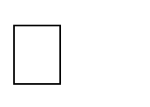
- Classification by origin Foods of animal origin Foods of plant origin.

Classification by chemical composition
Protein
Fats
Carbohydrates Vitamins Minerals

Classification by predominant function
Body building foods: milk, meat, poultry, fish, egg, pulses, peanuts etc.,
Energy giving food: cereals, sugars, roots and tubers, fats and oils.
Protective foods: vegetables, fruits and milk.

Body's Energy Balance
The body requires energy to perform vital functions like breathing, circulating blood, and maintaining temperature. This energy comes from the food we consume, measured in calories. Energy balance is achieved when the number of calories consumed through food equals the number of calories the body uses for basic metabolism and physical activity.
Energy Intake: The calories consumed from carbohydrates, proteins, and fats. Each gram of carbohydrate and protein provides 4 calories, while each gram of fat provides 9 calories.

Energy Expenditure: The number of calories burned through basic bodily functions (basal metabolic rate or BMR) and physical activity. Maintaining energy balance helps to sustain a healthy weight.
If the energy you consume equals the energy your body uses, you are in
energy balance. This balance is crucial for maintaining a healthy weight:
Positive energy balance (eating more calories than you use) can lead to weight gain.
Negative energy balance (using more calories than you eat) results in weight loss.

The energy content of food is measured in calories (kilocalories)
Carbohydrate = 4 kcal/gm: it means that 1gm of carbohydrate produce 4 kcal of energy.
Protein= 4 kcal/gm Fat = 9 kcal/gm
Acceptable macronutrients distribution range for adult CHOS: 45-65%
Protein: 10-35 %
Fats: 20- 35%
The Six Essential Nutrients
Nutrients are substances in food that provide energy, support growth, and help regulate body functions. There are six essential nutrients that our body needs to function properly:

Carbohydrates
Primary energy source for the body, especially for the brain and muscles. Found in foods like grains, fruits, vegetables, and legumes.
Types include simple sugars (like glucose) and complex carbs (like starch and fiber).

Proteins
Made up of amino acids and are the building blocks for tissues, muscles, enzymes, and hormones.

Important for growth, repair, and maintaining tissues. Sources include meat, fish, eggs, beans, and nuts.

Fats (Lipids)
Provide energy, support cell growth, protect organs, and help the body absorb certain vitamins.
Includes healthy fats (unsaturated fats) found in nuts, seeds, and oils, and less healthy fats (trans and saturated fats).

Vitamins
Organic compounds essential for various bodily functions, including immune support, bone health, and vision.
Categorized into fat-soluble (A, D, E, K) and water-soluble (B-complex, C) vitamins.

Minerals
Inorganic elements like calcium, potassium, and iron that play critical roles in bone health, muscle function, and fluid balance.
Found in a variety of foods, including dairy, vegetables, fruits, and meats.

Water
Vital for life, making up 60% of the human body.
Regulates body temperature, transports nutrients, removes waste, and is essential for most body processes.

The Digestive Process: How Nutrients Are Absorbed
The body‘s ability to extract and use nutrients from food involves a complex system known as the digestive system. Here‘s how it works:
Ingestion: The process begins with eating food.
Digestion: Mechanical digestion (chewing) and chemical digestion (enzymes) break down food into smaller components.
Absorption: Nutrients are absorbed primarily in the small intestine into the bloodstream for use by the body‘s cells.
Metabolism: Once absorbed, nutrients are metabolized to provide energy, build tissues, and regulate bodily functions.

Elimination: Waste products are excreted from the body.

Role of nutrition in maintaining health
Nutrition is a basic element of health. Nutrition influence the health from birth to death.
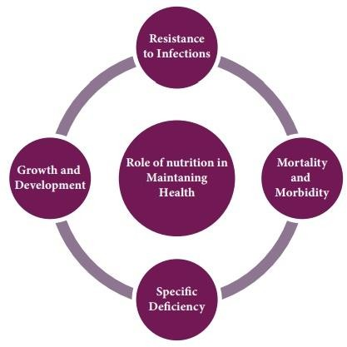

Growth and development
Good nutrition is essential for attainment of normal growth and development during fetal life and childhood. Physical growth, intellectual development, learning and behavior are affected by malnutrition.
Adequate nutrition is needed for adult life maintenance for optimum health and efficiency.
Elder people needs special nutrition due to their physiological and chronological changes. Pregnant and lactating mothers require more proteins and nutrients to prevent abortion, growth retardation and low birth weight babies and provide adequate breast feeding for their babies.

Specific deficiency diseases
The most common deficiencies find in Indians are Protein energy malnutrition, blindness, goiter, anemia, beriberi, rickets etc. There is increased incidence of abortion, prematurity, still birth and low birth weight babies in malnourished mothers.

Hence, good nutrition is essential to prevent nutritional deficiency diseases, promotion of health and treatment of deficiency diseases.
Resistance to infection A well balanced nutrition prevents infections like tuberculosis. Good nutrition enhances wound healing. Improves resistance of an individual towards infections.
Mortality and morbidity Malnutrition leads to increased death rate, infant mortality rate, still births and premature deliveries. Prematurity is the major cause of deaths.
Over nutrition causes diseases like
Obesity, diabetes, hypertension, cardiovascular and renal diseases and causes death.

Factors affecting food and nutrition
The following factors affects food and nutrition Basal metabolic rate
Weight
Age
Sex

Climate and environment Physical activities Physiological state
Socio economic factors Cultural factors
- Life style and food habits
- Food fads
- Cooking practices
- Child rearing practices Religion
Traditional factors
Food production and distribution.

Nutrition and Lifespan
Nutritional needs vary at different stages of life:
Infants: Need high amounts of nutrients for rapid growth and development.
Children and Adolescents: Require nutrients to support growth, hormonal changes, and mental development.
Adults: Nutritional needs stabilize, but healthy eating is important to prevent chronic diseases.
Older Adults: Nutrient needs change with age, requiring attention to bone health, muscle maintenance, and immune support.
Discussion Questions
What are the key differences between macronutrients and micronutrients?
How do carbohydrates, proteins, and fats differ in terms of the energy they provide?
Why is maintaining energy balance important for health?

Element of nutrition
The nutritional science investigates the metabolic and physiological responses of the body to diet.

Definition:
Nutrition is the process by which consume food or liquids, digest and absorb them and use them for health and growth.
Nutrition can be defined as a three-part process i.e. consumption, digestion and circulation of the food.
Diet is the sum of food consumed by a person or other organism The dietary habits define as:
Dietary habits are the habitual decisions an individual or culture makes when choosing what foods to eat

Nutrition requirement
The human body consists of elements and compounds (ingested, digested, absorbed and circulated through the blood stream to feed the cell of the body.
The human body contains chemical compounds, such as water, carbohydrates (sugar, starch and fiber), amino acids in proteins, fatty acids in lipids and nucleic acids (DNA and RNA).
These compounds in turn consist of element such as carbon, hydrogen, oxygen, nitrogen, calcium, iron, zinc and so on, these entire chemical compounds and elements occur in various forms and combination.

Nutritional Assessment
A nutritional assessment provides insight into a person's nutritional status and is essential for:
- Identifying nutrient deficiencies (e.g., lack of vitamins, minerals).
- Preventing and managing diseases like diabetes, obesity, and cardiovascular conditions.
- Monitoring growth and development, especially in children and pregnant women.
- Creating personalized dietary plans to improve overall health and prevent malnutrition.

Components of Nutritional Assessment (The ABCD Approach)
Nutritional assessments can be broken down into four key areas, often referred to as the ABCD approach:

Anthropometric Measurements
These are physical measurements that assess the size, shape, and composition of the human body.

Common measurements:
Height and weight: Basic indicators of growth and development.
Body Mass Index (BMI): Weight (kg) divided by height (m²). Helps classify individuals as underweight, normal weight, overweight, or obese.
Waist circumference: Measures abdominal fat, which is linked to the risk of chronic diseases like heart disease and diabetes.
Skin fold thickness: Measures body fat by pinching and measuring specific skin-fold sites (e.g., triceps, abdomen).
Mid-upper arm circumference (MUAC): Used to assess malnutrition, especially in children.

Advantages:
Simple and inexpensive.
Provides quick indicators of body fat and muscle mass.

Limitations:
Does not always reflect nutritional status (e.g., muscle mass vs. fat mass).

Biochemical Tests
These are laboratory tests that measure nutrient levels in blood, urine, or tissues to detect deficiencies or imbalances.

Common tests:
Blood tests for glucose, cholesterol, iron, and vitamin levels (e.g., Vitamin D, B12).
Urine tests for protein levels, ketones, and electrolytes.

Lipid profile: Measures fats (cholesterol, triglycerides) in the blood to assess heart health.

Advantages:
Accurate and objective.
Can detect deficiencies before clinical symptoms appear.

Limitations:
Expensive and requires specialized equipment.
Results may be influenced by non-nutritional factors (e.g., hydration, infections).

Clinical Assessment
This involves a physical examination and a review of medical history to identify signs and symptoms of nutrient deficiencies or malnutrition.

Common signs to look for:
Pale skin: Indicative of iron or vitamin B12 deficiency (anemia).
Swollen gums or poor oral health: Linked to vitamin C deficiency (scurvy).
Dry, brittle hair or nails: May suggest protein, zinc, or biotin deficiency.
Muscle wasting or edema: Indicators of malnutrition or protein deficiency.

Advantages:
Provides direct, visible evidence of nutritional issues.
Helps detect underlying health conditions that impact nutrition.

Limitations:
Some signs may not appear until deficiency is severe. May require follow-up tests to confirm diagnoses.

Dietary Assessment
This involves collecting detailed information about a person‘s food and drink intake to assess the quality and quantity of their diet.

Common methods:
24-hour recall: The individual recalls all the foods and beverages consumed in the past 24 hours.
Food diary or food record: Individuals record their intake over several days (typically 3-7 days).
Food Frequency Questionnaire (FFQ): A survey that asks how often specific foods are consumed over a set period (e.g., weekly, monthly).
Diet history: A detailed interview to gather information about long- term dietary habits.

Advantages:
Can provide specific information on nutrient intake and dietary patterns.
Easy to administer, especially the 24-hour recall method.

Limitations:
Subject to recall bias and inaccurate reporting.
Does not account for seasonal variations or long-term intake.

Tools for Nutritional Assessment
Several tools and methods are available to enhance the accuracy of nutritional assessments:

Dietary Software and Mobile Apps
Programs like MyFitnessPal and Cronometer allow individuals to track their dietary intake and receive real-time nutrient analysis.
These tools can calculate calories, macronutrients (carbohydrates, protein, fat), and micronutrient intake (e.g., vitamins, minerals).

Food Labels
Food labels are a practical tool for assessing nutrient intake. They provide information on serving sizes, calories, macronutrients, and micronutrients, helping people make informed food choices.

Growth Charts (For Children)

Growth charts track a child's growth (weight, height, and head circumference) over time. The charts are used to assess whether a child is growing at a healthy rate compared to population standards.
Percentile rankings are used to indicate where the child falls compared to other children of the same age and sex.

Factors Affecting Digestion and Absorption Efficiency
- **Food Composition**
  - Protein, fat, and carbohydrate content affect digestion speed and nutrient absorption.
- **Enzyme Production**
  - Adequate digestive enzyme levels (e.g., amylase, protease, lipase) are essential for breaking down food into absorbable molecules.
- **Stomach Acid (HCl)**
  - Low stomach acid can impair the breakdown of proteins and hinder nutrient absorption.
- **Gastrointestinal Transit Time**
  - Fast transit (e.g., diarrhea) reduces absorption time, while slow transit may lead to nutrient fermentation.
- **Gut Health**
  - Healthy intestinal villi and microvilli are crucial for nutrient absorption.
  - Gut disorders (e.g., celiac disease, Crohn's) can damage absorption surfaces.
- **Presence of Fiber**
  - Soluble fiber slows digestion and can improve nutrient absorption.
  - Insoluble fiber speeds up digestion, potentially reducing absorption time.
- **Antinutrients**
  - Compounds like phytates, oxalates bind to nutrients and reduce their bioavailability.
- **Age**

  - Aging reduces digestive enzyme production and can impair nutrient absorption.
- **Hormonal Regulation**
  - Hormones like insulin, gastrin, and secretin regulate digestive processes and nutrient absorption.
- **Hydration Status**
  - Adequate water is necessary for digestion and nutrient transport, while dehydration slows these processes.
- **Meal Composition and Timing**
  - Balanced meals aid in efficient digestion, while overeating or unbalanced diets may overwhelm digestive systems.
- **Medications and Health Conditions**
  - Certain medications (e.g., antacids, antibiotics) and conditions (e.g., IBS, diabetes) affect digestive efficiency and absorption rates.

Classes of nutrition
The nutrient classes can be categorized as:
Macronutrients (needed in relatively large amounts includes carbohydrates, fats, protein and water).
Micronutrients (needed in smaller quantities includes minerals and vitamins).

Clinical signs of altered nutrition
General appearance, weight, nervous system control, GIT function, cardiovascular function, hair, skin (general), lips, mouth, oral membranes, gums, tongue, eyes, neck (glands), nails, legs, feet, skeleton.

Manifestations of altered nutrition
- Overweight
- Obesity
- Underweight
- Recent significant weight gain or loss
- Decreased energy

- Al tered bowel patterns
- Altered skin, teeth, hair and mucous membranes
- Impact on activities of daily living

Altered nutrition less than body requirements
- weight loss with adequate food intake
- weight loss due to less than recommended food intake
Note: Body weight of 20% or more under the ideal may be critical

Altered nutrition more than body requirements
- Excessive intake in relation to metabolic need
- Difficulty swallowing
- Constipation
- Diarrhea

Elements of Nutrition
- Carbohydrates
- Protein
- Lipids
- Vitamins
- Minerals
- Water
  - Carbohydrates: Main source of energy (fuel for the body) and provide 4 kcal of energy per gram
Two major types: Simple and Complex
Simple: Also called simple sugars-monosaccharides and disaccharides include sugars e.g. white sugar, fruit, milk, honey
Complex: Also called complex sugars and starches –polysaccharides include grain
products (bread, pasta, rice), potatoes

Protein:

Vital to growth, development, normal functioning and provide 4 kcal of energy per gram
Complete: Contains the 9 essential amino acids to maintain body tissues and to promote growth. Includes meat, fish, chicken, milk, eggs
Incomplete: Lack one or more of the essential amino acids. Includes peas, lentils, beans, vegetables and nuts
Complementary: Pairs of incomplete proteins, that when combined supply a total protein source e.g. vegetables with nuts, beans with corn.

Main functions of protein include:
Growth maintenance and repair of body tissues Forms muscles, skin and hair
Maintains fluid balance, blood clotting Energy

Lipids
Also called fats. Protects vital organs in the form of padding; Component of all body
cells; ideally about 20% of body weight and provides 9kcal per gram. It gives our
body protection and energy
Two types Saturated Unsaturated 4- Vitamins7
Fat soluble: Vitamins A, D, E and K
Water-soluble: B-complex vitamins, Vitamin C

Minerals:
Inorganic elements build body tissue and regulate metabolism like: Calcium, Iron,
Sodium, Potassium, Iodine and Fluoride

Water:

Necessary to maintain cell function
Water constitutes 60% - 70% of total body weight Fluids = liquids, fresh fruit and vegetables

Food Pyramid
The Food Pyramid is a visual guide designed to help individuals make healthy food choices by illustrating the recommended proportions of different food groups for a balanced diet. Introduced by the USDA in 1992, it provides a hierarchical structure of foods, from those that should be consumed most frequently (at the base) to those that should be eaten sparingly (at the top). Although the food pyramid has evolved into MyPlate in recent years, it remains a helpful educational tool for understanding nutrition basics.

Structure of the Food Pyramid
The traditional food pyramid is divided into five major food groups stacked in layers. The size of each section represents the recommended amount of each food group relative to the others

Base of the Pyramid: Grains
Whole Grains (Bread, Rice, Pasta, Cereal)
This is the largest section at the base of the pyramid, indicating that grains should form the foundation of the diet.
Serving recommendation: 6-11 servings per day.
Focus on whole grains like whole wheat bread, brown rice, and oatmeal as they provide essential carbohydrates, fiber, vitamins (especially B vitamins), and minerals.
Key nutrients from grains: Complex carbohydrates (energy) Dietary fiber (for digestion)
B vitamins (for metabolism)

Second Row: Vegetables and Fruits
Vegetables
Vegetables occupy the second-largest section of the pyramid and are crucial for a nutrient-dense diet.
Serving recommendation: 3-5 servings per day.
Include a variety of vegetables such as leafy greens, root vegetables, and legumes for maximum nutritional benefit.
Fruits
Like vegetables, fruits provide essential vitamins, minerals, and fiber. Serving recommendation: 2-4 servings per day.
Choose whole fruits over fruit juices to ensure higher fiber intake and avoid added sugars.

Key nutrients from vegetables and fruits:
Vitamins (A, C, K, etc.) Minerals (potassium, folate) Fiber (supports digestive health)
antioxidants (protect against chronic diseases)

Middle Row: Proteins and Dairy
Proteins (Meat, Poultry, Fish, Eggs, Beans, and Nuts)
This group provides essential amino acids that are the building blocks of body tissues.
Serving recommendation: 2-3 servings per day.
Include plant-based proteins like beans and lentils in addition to lean animal sources such as poultry, fish, and eggs.
Dairy (Milk, Yogurt, Cheese)

Dairy products are a primary source of calcium, which is vital for bone health.
Serving recommendation: 2-3 servings per day.
Choose for low-fat or fat-free dairy products to reduce saturated fat intake.

Key nutrients from proteins and dairy:
Proteins (for muscle and tissue repair) Calcium (for bone health)
Vitamin D (supports calcium absorption) Iron and zinc (for blood and immune health)

Fourth Row: Fats, Oils, and Sweets (Use Sparingly)
Fats and Oils
This group is at the top of the pyramid, indicating the need to consume fats and oils in moderation.
Focus on healthy fats like unsaturated fats from nuts, seeds, avocados, and olive oil.
Limit the intake of saturated fats and trans fats found in butter, fatty meats, and processed foods, as they contribute to heart disease.
Sweets
Foods high in sugar, such as candy, cakes, and soft drinks, should be consumed sparingly.
Excessive sugar consumption is linked to obesity, diabetes, and tooth decay.
Key nutrients (to limit): Saturated fats
Added sugars

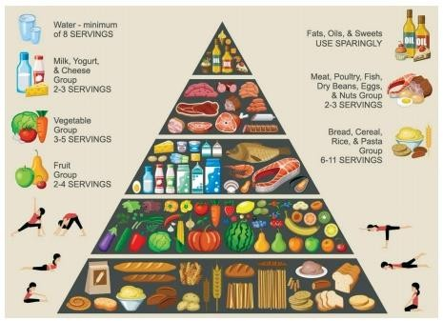

The pyramid emphasizes three key principles:
- Balance
Ensure that all food groups are represented in daily meals to provide a broad range of nutrients.
For example, a balanced meal might include whole grains, vegetables, a source of protein, and a serving of dairy.

Variety
Eating a wide variety of foods within each food group ensures a broader intake of nutrients.
For example, instead of always eating spinach as your vegetable, mix in carrots, broccoli, and bell peppers.

Moderation
Fats, sugars, and refined grains should be consumed in limited amounts, as excess intake can lead to health issues such as obesity, heart disease, and diabetes.

Criticisms of the Original Pyramid

Generalized servings: The original pyramid was criticized for giving broad serving recommendations without considering age, gender, or activity level.
Misleading fats: All fats were grouped together, not distinguishing between healthy fats (e.g., olive oil) and harmful fats (e.g., trans fats).
Carbohydrate emphasis: Placing grains at the base led people to prioritize carbohydrate-rich foods, sometimes in excess.

B. Updated Versions
MyPyramid (2005): Introduced a more personalized approach to healthy eating, with colored vertical stripes representing different food groups and an emphasis on physical activity.
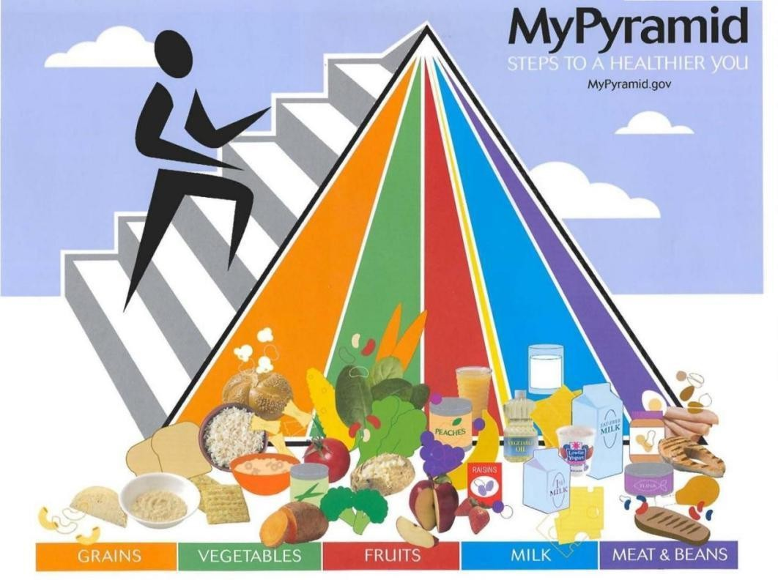
MyPlate (2011): Replaced the pyramid with a simpler, plate-based model showing proportions of food groups on a plate, making it easier for people to visualize balanced meals.

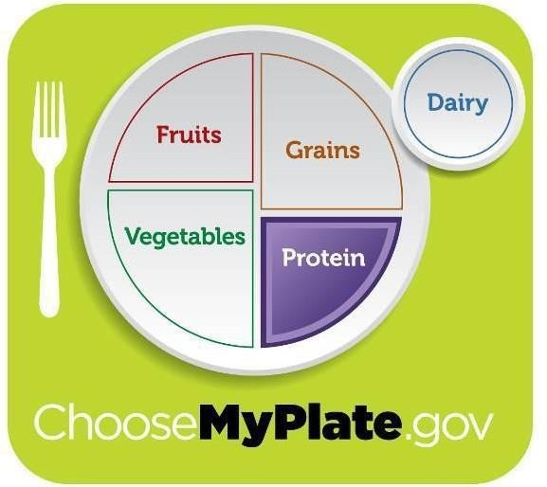

Practical Tips for Using the Food Pyramid
A. Plan Balanced Meals
Use the pyramid as a guide to plan meals. Start by filling half your plate with fruits and vegetables, add a source of whole grains, and include lean proteins or dairy.

B. Portion Control
The pyramid highlights the importance of portion sizes. For example, a serving of grains might be 1 slice of bread or ½ cup of rice, not an entire bowl.

C. Choose Whole Foods
Prioritize unprocessed or minimally processed foods. Whole grains, fresh fruits, and vegetables are more nutrient-dense than refined or processed options.

D. Stay Active
Though primarily a food guide, the pyramid (especially in later versions) also emphasizes the role of physical activity in maintaining a healthy lifestyle.

My Plate
My Plate is a visual guide developed by the United States Department of Agriculture (USDA) to help people create balanced meals. It divides the plate into five food groups:
Fruits: Recommended as part of every meal. Fresh, frozen, or dried fruits are good options, but fruit juice should be limited.
Vegetables: Emphasis on including a variety of vegetables—dark greens, red and orange vegetables, beans, peas, and starchy vegetables.
Grains: Half of the grains consumed should be whole grains, such as whole wheat, oats, and brown rice.
Protein: A variety of protein sources, including lean meats, poultry, fish, beans, peas, nuts, and seeds.
Dairy: Low-fat or fat-free milk, yogurt, or cheese, or fortified plant-based alternatives.

Key Concepts of My Plate:

Balance: Encouraging all food groups in appropriate portions. Moderation: Controlling portion sizes to avoid overeating.
Variety: Choosing different foods within each food group.

B. WHO Dietary Guidelines
The World Health Organization (WHO) provides global guidelines focusing on healthy eating patterns to prevent malnutrition and reduce the risk of diseases like diabetes, heart disease, and cancer.

WHO Key Recommendations:
Limit added sugars: Less than 10% of total daily energy intake should come from added sugars.
Reduce sodium intake: Sodium intake should be less than 5 grams (or 1 teaspoon) per day to reduce the risk of high blood pressure and heart disease.
Healthy fats: Promote the consumption of unsaturated fats (e.g., fish, avocado, nuts) and limit saturated fats and trans fats.
Increase fruit and vegetable intake: At least 400 grams of fruits and vegetables daily.
Physical activity: Combine a balanced diet with regular physical activity for overall health.

Carbohydrates
Carbohydrates are organic compounds made up of carbon, hydrogen, and oxygen atoms. They are one of the three macronutrients (along with proteins and fats) that provide energy to the body. Carbohydrates are found primarily in plant-based foods and are classified into three main types based on their chemical structure and how the body processes them:
Simple carbohydrates: These are sugars that consist of one (monosaccharides) or two (disaccharides) sugar units.
Complex carbohydrates: These include starches and fiber, which are made up of longer chains of sugar molecules.
Fiber: A type of complex carbohydrate that the body cannot fully digest, but it plays a vital role in digestive health.

Types of Carbohydrates
- Simple Carbohydrates
Simple carbohydrates are often referred to as "sugars." They are found naturally in fruits, vegetables, and dairy, but they are also added to many processed foods.
Monosaccharides: The simplest form of sugar that cannot be broken down further. Common examples:
Glucose: The primary energy source for the body and brain.
Fructose: Found naturally in fruits and honey.
Galactose: Found in milk products. Disaccharides: Made up of two monosaccharides. Common examples:
Sucrose: Common table sugar, made from glucose and fructose.
Lactose: The sugar found in milk, composed of glucose and galactose.
Maltose: Formed from two glucose units, found in grains.

Complex Carbohydrates

Complex carbohydrates are made up of long chains of sugar molecules (polysaccharides). They take longer to break down and digest, providing a more sustained energy release.
Starch: The most common form of complex carbohydrate found in foods like grains (rice, wheat, corn), legumes, and starchy vegetables (potatoes, peas).
Glycogen: The storage form of glucose in animals and humans, stored in the liver and muscles.

Dietary Fiber
Fiber is a type of carbohydrate that the body cannot digest, and it is found in plant-based foods. There are two types of fiber:
Soluble fiber: Dissolves in water and forms a gel-like substance, helping lower cholesterol and control blood sugar. Found in oats, legumes, fruits, and vegetables.
Insoluble fiber: Adds bulk to stool and aids in digestion by promoting regular bowel movements. Found in whole grains, nuts, seeds, and vegetables.

Function of carbohydrates

Production of energy:
Our bodies can only absorb mono saccharides. Once absorbed through small Intestine into portal vein and then circulate into the blood stream through the liver as Blood glucose
- Spare protein from its use as a source for energy production
- Prevent ketosis through complete oxidation of fat and prevent the development of ketone bodies.
- Sweetening of foods and improve palatability

Functions of Dietary Fibers
  - Prevent constipation& its complications as diverticulitis & hemorrhoids.
  - Reduce the occurrence of obesity. They adsorb fat of the diet andprevent its absorption and give the sensation of fullness.
  - Reduce the risk of hypercholesterolemia. They reduce absorption ofcholesterol from the intestine.
  - Reduce the risk of gall bladder stones. They reduce absorption ofbile acids and cholesterol

- Slow down the glucose absorption from the intestine with subsequent decrease in insulin release. So they help in control of diabetes mellitus.
- Reduce the risk of cancer. They prevent constipation and reduce theabsorption of harmful fats.

Sources of Carbohydrates
Healthy Sources of Carbohydrates
Whole grains: Brown rice, oats, quinoa, barley, and whole wheat products.
Fruits and vegetables: Apples, oranges, berries, carrots, spinach, and sweet potatoes.
Legumes: Beans, lentils, chickpeas, and peas.
Nuts and seeds: Almonds, flaxseeds, and chia seeds.

Unhealthy Sources of Carbohydrates
Refined grains: White bread, white rice, and pastries made from refined flour.
Sugary foods and beverages: Soft drinks, candy, cookies, and cakes often contain added sugars.
Highly processed foods: Packaged snacks and ready-to-eat meals that may contain unhealthy fats, refined sugars, and additives.

The Glycemic Index (GI)
The glycemic index (GI) is a ranking of carbohydrates based on how quickly they raise blood sugar levels after consumption. Foods are classified as having a:
Low GI (55 or less): These foods cause a slow, gradual rise in blood glucose. Examples include oats, lentils, and most fruits.
Moderate GI (56-69): These foods cause a moderate increase in blood glucose. Examples include whole wheat bread and brown rice.
High GI (70 or above): These foods cause a rapid spike in blood glucose. Examples include white bread, white rice, and sugary cereals.
Choosing low-GI foods can help maintain steady blood sugar levels, reduce hunger, and lower the risk of developing type 2 diabetes and heart disease.

Carbohydrates and Health
- Benefits of Carbohydrates
Energy for daily activities: Carbohydrates fuel physical and mental activities.
Supports brain function: The brain relies primarily on glucose for optimal function.
Improved digestion: Dietary fiber improves digestive health and promotes a healthy gut microbiome.
Weight management: Whole foods high in complex carbohydrates can help with weight control by promoting satiety and reducing overeating.

Risks of Excessive Carbohydrate Consumption
Weight gain: Excess intake of simple sugars and refined carbohydrates can lead to weight gain and obesity due to rapid digestion and increased calorie intake.
Blood sugar spikes: Frequent consumption of high-GI foods can lead to insulin resistance, increasing the risk of developing type 2 diabetes.
Heart disease: Diets high in added sugars and refined carbohydrates are linked to higher risks of heart disease due to increased triglyceride levels and inflammation.

Low-Carbohydrate Diets
Low-carb diets, such as the ketogenic diet, restrict carbohydrate intake to encourage the body to burn fat for energy. While these diets can promote short-term weight loss, they may lack essential nutrients and fiber if not balanced properly. Long-term effects on heart health and overall well- being are still being studied.

Recommendations for Carbohydrate Intake Daily Intake
The Dietary Guidelines for Americans recommend that 45-65% of total daily calories should come from carbohydrates. For someone consuming 2,000 calories per day, this translates to about 225 to 325 grams of carbohydrates per day.

Healthy Carbohydrate Choices
Choose whole grains over refined grains.

Incorporate a variety of fruits, vegetables, and legumes into your diet.
Limit foods with added sugars, opting for natural sources of sweetness like fruit.

Discussion Questions
  - What are the key differences between simple and complex carbohydrates?
  - How does dietary fiber contribute to digestive health?
  - How can the glycemic index be used to make healthier food choices?
Proteins
Proteins generally comprises about 10-15% of dietary energy. It is the major functional and structural component of all the cells of the body. Adequate supply of dietary proteins is essential to maintain cellular integrity and function and for health and reproduction.
At 3 months of age, protein intake represents approximately 5-6% of totalenergy intake compared with about 10-15% in adolescents.
- They are nitrogenous compounds, composed of amino acids (AA).

Chemistry of dietary protein
- There are 20 different amino acids. Nine of these 20 amino acids need to be provided in the diet because the body cannot make these amino acids. They are therefore called essential amino acids. The remaining 11 amino acids can be made from the 9 essential amino acids. Any dietary protein provides a mixture of the 20 amino acidsin different proportions.

Sources of proteins

Animal foods:
- Milk, cheese and yogurt.
- Eggs: yolk and white.
- Meat, poultry, fish& organ meat (liver, kidney, spleen, brain).

Plant foods:
  - Pulses (dried beans, peas, lentils) the main (richest) sources.
  - Cereals (grains, flour, and rice).
  - Nuts.

Essential& Nonessential amino acids

Essential amino acids (9) | Nonessential amino acids (12)
*cannot be synthesized by the body, and so must be provided by the diet. | *They are neither non-essential nor of lower value than the essential, but  when missing in the diet they can be synthesized by the body.

Proteins can be classified as either complete or incomplete. Complete proteins provide adequate amounts of all nine essential amino acids. Animal proteins, such as meat, fish, milk, and eggs are good examples of complete proteins. Incomplete proteins do not contain adequate amounts of one or more of the essential amino acids. For example, if a protein doesn't provide enough of the essential amino acid. most grains are low in lysine, whereas beans are low in methionine.
By eating beans and grains together, the strengths of one makes up for the deficiencies of the other, creating a complete protein.

To improve the biological value of plant protein, take a variety of plant protein foods every day.
Importance of Protein

Formation of cells:
*Building up of new cells during growth, and pregnancy.
*Maintenance & repair of cells.

Formation of essential biological compounds:
Hormones, enzymes, immunoglobulin Hemoglobin and others.
- Regulation of fluid movement between blood and tissues
- Regulating the acid-base balance:

- Supporting the immune system:

Production of energy
Daily Requirements of protein

  - Adult males and females: 1gram per Kg body weight
  - Pregnant woman: 1.1gram per Kg body weight
  - Lactating woman: 1.3gram per Kg body weight
  - Infants and young children: 1.5-2 grams per Kg body weight

3. FATS
Provides energy

can cause weight gain

than 10% of daily calories are from saturated fats.

*All animal fats are solid, except fish liver oil used for pharmaceuticalpurposes.
*All plant oils are liquid, except cocoa butter used for medicinal, cosmetic, food purposes, and peanut butter.
Hard fats contain a relatively high proportion of the long- chain saturatedfatty acids or saturated and trans-fatty acids.
Oils contain a large proportion of highly unsaturated fatty acids.

Functions of fats

- Combustion, for energy one gram gives9.3 calories.
- Provide fat - soluble vitamins A, (D, not significant), E and K.
- Provide essential F.As.needed for maintenance of skin in children.
- for preparation and cooking of food, to become more palatable.
- Prolong emptying time of stomach, &give sense of satisfaction .
- Form the normal subcutaneous fat depot, for insulation.
- Give support to viscera and some organs.
Vitamins
The name vitamin comes from Casimir Funk, who in 1912 thought vital amines (NH3) were responsible for preventing what we know now are vitamin deficiencies. He coined the term vitamins to describe these compounds.
Vitamins are classified as either fat-soluble or water-soluble. The fat-soluble vitamins are:

Vitamin A Vitamin D Vitamin E Vitamin K
When taken as supplements in doses greatly exceeding human needsvitamins A and D are toxic.
They are absorbed with dietary fat&reach blood stream via lymphaticsystem.
They are stored mostly in the liver and fatty tissues.
The water-soluble vitamins are vitamin C and the B vitamins, which areshown in the table below.

Common Name | Vitamin
Thiamin | B1
Riboflavin | B2
Niacin | B3

Pantothenic Acid | B5
Pyridoxine | B6
Biotin | B7
Folate | B9
Cobalamin | B12

Carbohydrates
Composition, Classification, daily allowances, Dietary sources, Functions, Digestion, absorption and storage, metabolism of carbohydrates, Deficiencies

Carbohydrates
Carbohydrates are the main source of energy for daily activities. Carbohydrates (primarily starches) are the least expensive, the most available, easily obtainable and readily digestible form of nutrient.

Composition of Carbohydrates
Carbohydrates are organic compounds of carbon, hydrogen and oxygen with the latter elements in the ratio of 2: 1. The general formula is C₆H₁₂O₆. Carbohydrates are widely distributed in plants. Foods which contain carbohydrates are called energy foods.

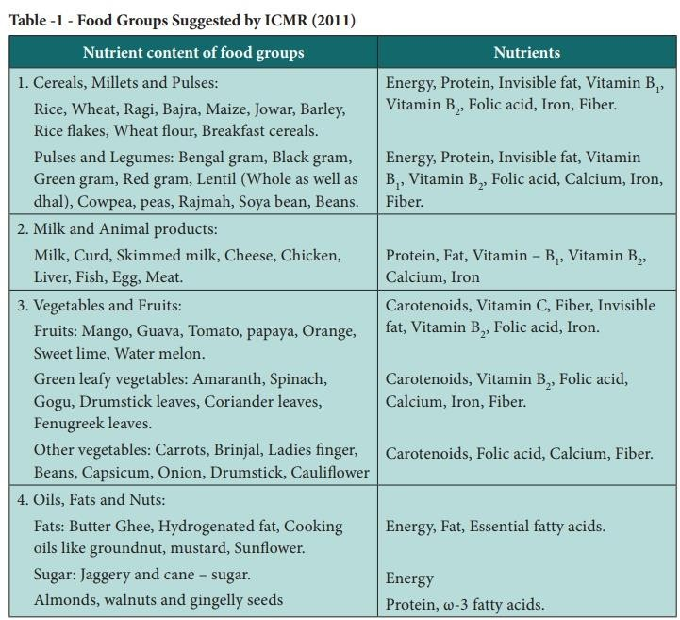

Classification of Carbohydrates
Carbohydrates are classified according to the number of saccharide (sugar) groups present. They are broadly classified as simple carbohydrates and complex carbohydrates. The simple carbohydrates include monosaccharides (Single sugar) and disaccharides (Double sugars). Complex carbohydrates include starch, glycogen and fibers. The classification of carbohydrates is schematically represented below:

Recommended daily allowances
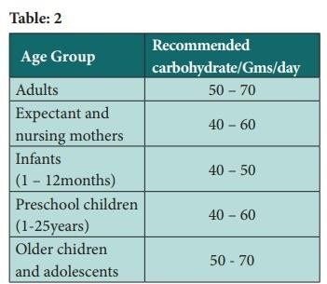
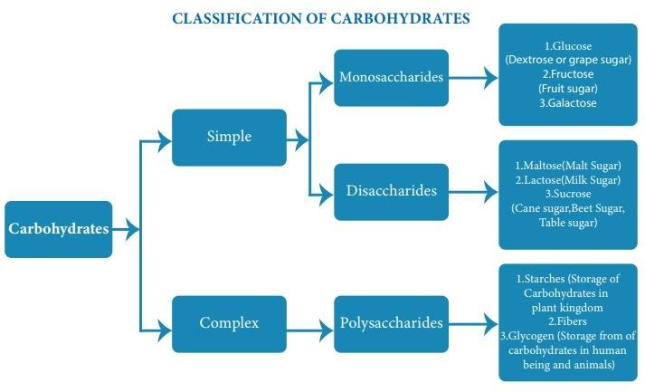

Dietary sources
The important sources of carbohydrates in the diets are cereals, millets, roots, tubers pulses, sugar and jaggery.

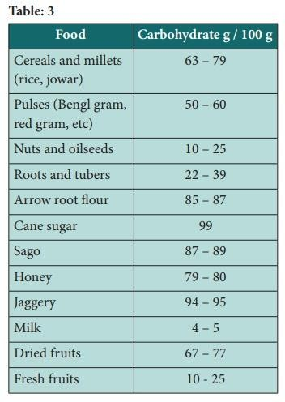

Functions
Supply energy for body functions and for doing work. Each gram of carbohydrate yield 4 kcal of energy.
Essential for the oxidation of fats Exert a sparing action on proteins.
Provide carbon skeleton for the synthesis of some non – essential amino acids.
Add flavor to the diet.

Digestion, absorption and storage, metabolism of carbohydrates
The first stage of digestion takes place in the mouth while the food is chewed. In saliva the enzyme called alpha – amylase which is called as

amylase acts on starch. The enzyme acts on starch splitting it into dextrin and maltose. As soon as the food reaches the stomach it mixes with acidic gastric juices for digestion. The main digestion takes place in the intestines.
The final products of digestion of carbohydrates are glucose, fructose and galactose, these products are absorbed in the intestines. The non – digestible carbohydrates present in the food such as cellulose, hemicelluloses, pentosans, galactans, fructosans etc add bulk to the contents of large intestine and are excreted in the faeces.

Storage, metabolism of carbohydrates
Glucose, galactose and fructose absorbed in the intestines pass through the portal circulation to the liver. In the liver a part of the glucose and the entire galactose and fructose are converted into glycogen. A portion of glucose enters into the general circulation and to the various tissues for being oxidized and used as energy. A small portion of the glucose is stored in liver and muscle as glycogen and some portion of the glucose is converted into fat and stored in adipose tissue. The oxidation of glucose in the tissues occurs in two stages as indicated below;
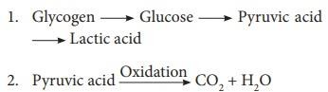
The first stage is called ‗glycolysis. The oxidation of pyruvic acid takes place through a series of reactions known as tricarboxylic acid cycle (Krebs‘s cycle).

Deficiencies
A deficiency of carbohydrates makes the body to utilize fats for energy, if it is not rectified it leads to ketone bodies formation which occurs due to oxidation of fats.

Excessive carbohydrates
Excessive consumption of carbohydrates leads to heart disease, diabetes, and obesity.

Fat

Fat
The name fat may make it sound like something you shouldn't eat. But fat is an important part of a healthy diet. Fat from your diet gives you energy. As a bonus, fat in food helps you feel full, so you don't eat too much.
Some foods, including most fruits and vegetables, have almost no fat. Other foods have plenty of fat. They include nuts, oils, butter, and meats like beef.
The lipids are a heterogeneous group of substances found in plant and animal tissues, which share the property of being relatively insoluble in water, and soluble in organic solvents, such as ether, chloroform and benzene. Fat contain 9 kcal per gram.

Functions of fats
They are the chief energy stores of the body, which form an important source of energy during starvation or other emergencies.
Fats play a role in the absorption of fats soluble vitamins like vitamins A, D, E and K.
Fats are the constituents of cell membrane structure and regulate the membrane permeability.
Subcutaneous fat acts as an insulator and helps in retaining body heat.
Fats are important as cellular metabolic regulators (Steroid hormones and prostaglandin).
Fat is the main energy store in the body and the most concentrated source of energy in the diet – 1 g of fat provides 37kJ (9Kcal), more than double that provided by either protein or carbohydrate (4Kcal).

Classification of lipids
Lipids are classified into 4 categories as follows:

On the basis of chemical composition
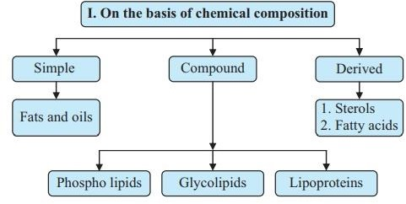

  - On the basis of sources
Fats are divided into 2 types based on their source, namely visible and invisible fats.

On the basis of fatty acids
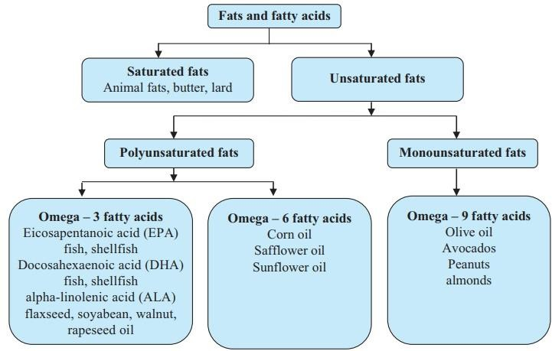

  - On the basis of requirement
Fatty acids are of 2 types:
Essential fatty acids: Fatty acids which are essential to be taken in our diet because they cannot be synthesized in our body are known as essential fatty acids. (eg.) Linoleic, linolenic and arachidonic acids.
Non-essential fatty acids: Non-essential fatty acids are those which can be systhesized by the body and which need not be supplied through the diet. Palmitic acid, oleic acid and butyric acid are examples of non-essential fatty acids.

Digestion, absorption and storage metabolism
Fats are not digested in the stomach. Fats delay emptying of the stomach. Fats are hydrolyzed by the pancreatic and intestinal lipases in the intestines into diglycerides, monoglycerides and fatty acids. Bile is essential for the digestion and absorption of fats.
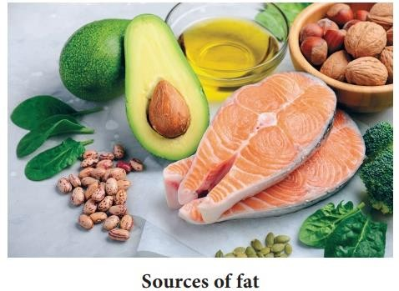

Storage of fats
Fat is stored in the adipose tissues. In normal human beings adipose tissue constitutes of 10 – 15% of the body weight.

Applied Nutrition for National Faculty of Nursing

Fat metabolism
Fatty acids are oxidized by certain enzymes in the tissues to carbon dioxide and water. The oxidation takes place through the tricarboxylic acid cycle.

Deficiencies
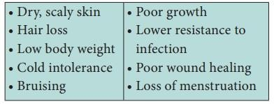
Over consumption
Over weight Obesity
Coronary heart disease Cancer
High cholesterol
Proteins
Proteins are made of amino acids linked together by peptide bonds.

Proteins
Proteins are made of amino acids linked together by peptide bonds. Amino acids can be divided into essential amino acids and non – essential amino acids. Proteins and carbohydrates contain 4 kcal per gram.

Composition
Proteins are chemical compounds that contain the same atoms as carbohydrate and lipid – carbon (C), hydrogen
(H) an oxygen (O) – but proteins are different in that they also contain nitrogen (N) atoms. These nitrogen atoms gives the name ‗amino‘

(nitrogen containing) to the amino acids that are the links in the chains referred to as proteins.

Classification of proteins
Proteins are large molecules formed by the combination of a number of aminoacids. About 20 amino acids have been found to occur in proteins and are important from the point of view of human nutrition.

Table 4
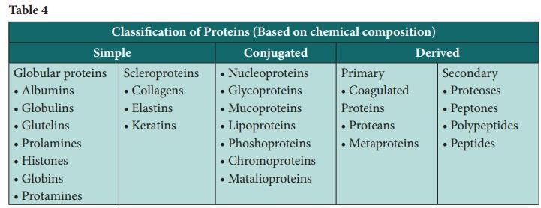
Sources of protein
Excellent sources of protein include tuna, shrimp, turkey, and
cod.
Very good sources of protein include snapper, venison, halibut,
salmon, scallops, chicken, lamb, beef, calf ‘s liver, spinach, tofu, mustard greens, mushrooms, soybeans, and mozzarella cheese.
Good sources of protein include eggs, milk, collard greens, cauliflower and many legumes including lentils, split peas, kidney beans, black beans, pinto beans and garbanzo beans.

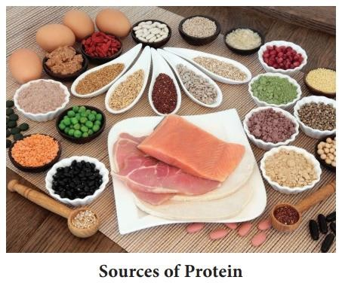

Table 5
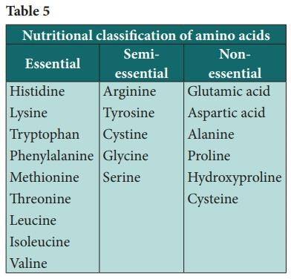

Functions of protein
Production and maintenance of structural proteins Production of enzymes and hormones Production of transport proteins and lipoproteins
Production of antibodies
Maintenance of proper fluid balance Maintenance of proper acid – base balance.
Protein deficiency diseases – Maras muss and kwashiorkor

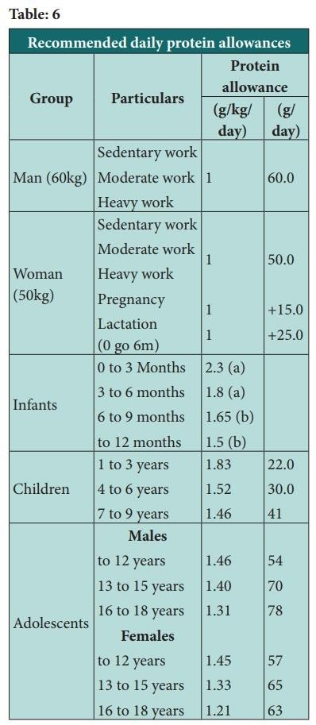
Table: 6

Vitamins
Vitamins are essential organic, compounds that are needed in small amounts in the diet both to prevent deficiency diseases and to support optimal health. The term vitamin (vital amines) was coined by Casmir Funk. The term vital denoting essential for life and amines because these compounds contained an amine functional group.

Characteristics of vitamins
Vitamins are vital, organic, dietary substance that is necessary in only very small amounts to perform a specific metabolic function or prevent an associated deficiency disease.
Vitamins are not synthesized by the body and therefore must be supplied through food.
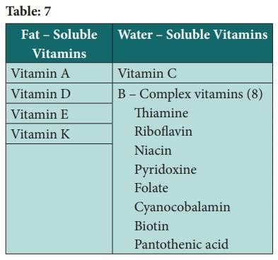

Functions of Vitamins
Each vitamin has its specific metabolic task. However the general functions are:
Function as control agents in cell metabolism

Components of body – tissue construction.
Prevent specific nutritional deficiency disease, which is considered as a result of their primary role in cell metabolism.

Classification of Vitamins
Thirteen (13) recognized vitamins classified in two groups, based on their solubility in fat or in water are as follows:

Fat – soluble vitamins
The four fat – soluble vitamins – vitamins A, D, E and K are often present in the fat portion of foods, they are not easily lost from foods or destroyed by exposure to water, heat, air, or light.

Vitamin A (retinol and beta – carotene)
Vitamin A and carotene can be obtained from either animal or vegetable sources. The animal form is divided between retinol and dehydroretinol whereas the vegetable carotene can be split into four very potent groups– alpha– carotene, beta–carotene, gamma carotene and crypto– carotene.

Function
Vitamin A has a variety of functions in the body. It is required for the synthesis of rhodopsin and other light – receptor pigments in the eye and thus is essential for vision. Vitamin A is needed for normal growth and development to occur in the body, including the formation of bone and cartilage.
Healthy epithelial or skin cells, which line surfaces inside and outside the body, require vitamin A. Vitamin A plays a role in reproduction, metabolism, and immune system function also.

Digestion and absorption
Retinol esters in food are hydrolyzed by pancreatic and intestinal enzymes to form free retinol. After absorption, the retinol, is reesterified and transported to blood.
Carotenes are split in the intestines to form retinaldehyde, which is then reduced to retinol.

Table 8: A summary of the fat soluble vitamins

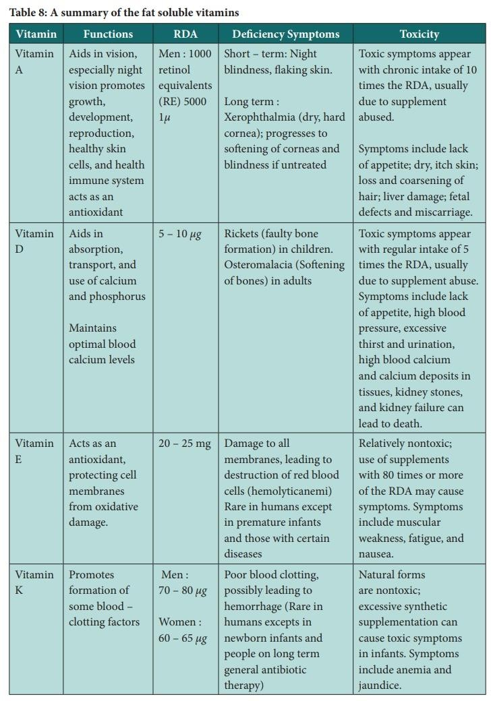

Some carotene may be absorbed intact and later converted to vitamin ‗A‘ in the liver or kidney. Bile is necessary for the absorption of vitamin A and carotene. Vitamin E in the intestinal tract prevents oxidation of the vitamin. Mineral oil hinders absorption since it dissolves the vitamin but is not absorbed.

Food sources
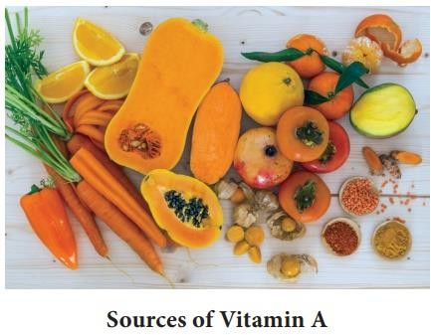
Liver, milk, egg – yolk, carrots, dark green leafy vegetables and yellow fruits are high in vitamin A or beta – carotene.

Deficiency
A diet deficient in vitamin A for several months may lead to night blindness and flaking skin.
A long – term vitamin A deficiency leads Xerophthalmia, major symptom of which is dry, hard cornea. If this condition is left untreated, damage to the cornea progresses, leading to a softening of the cornea and eventually total blindness.
Vitamin A deficiency also affects the skin, causing it to become dry and rough.

If xerophthalmia and the underlying vitamin A deficiency are treated at an early stage, blindness can be prevented.

Vitamin D (Calciferol)
The human body can produce vitamin D from cholesterol present in the skin. This conversion depends on exposure of the skin to the ultraviolet rays in sunlight and yields inactive vitamin D. Both inactive vitamin D formed in the kin and vitamin D absorbed from dietary sources are transported through the bloodstream to the liver, where they are stored.

Functions
Vitamin D helps with the absorption, transport and use of calcium.
Vitamin D assists in bone growth and the integrity of bone and promotes strong teeth.
It also helps to regulate the amount of phosphorus in the body as well as assisting in a healthy heart and nervous system.

Food sources
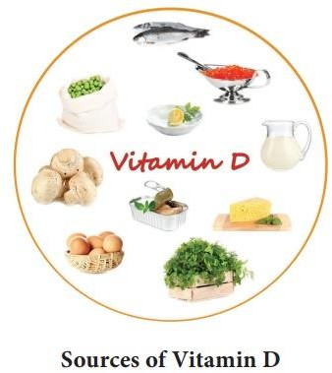

Vitamin D is present in fatty fish like kipper, sardines, salmon, tuna and mackerel, liver, egg yolk and butter. Smaller amounts are also present in dark leafy vegetables.

Absorption
Dietary vitamin D is absorbed along with dietary fats in the small intestines and transported to the lymph system. Bile is essential for the absorption of this vitamin Excess vitamin is stored in the body.

Deficiency
Vitamin D deficiency affects the mineralization of bones and teeth.
-Rickets, osteomalacia

Vitamin E (Tocopherol)
Vitamin E is an essential, fat – soluble vitamin that includes eight naturally occurring compounds in two classes designated as tocopherols and tocotrienols.
Vitamin E is an effective chain – breaking, lipid – soluble antioxidant in biological membranes, and aids in membrane stability.
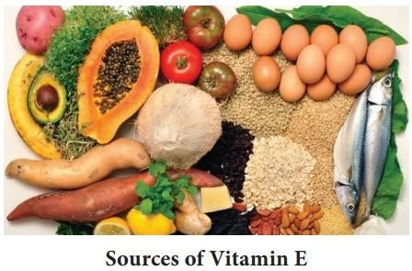

Function
Vitamin E is a powerful antioxidant.
Antioxidant capability helps to prevent degenerative diseases.
Vitamin E is also useful in preventing blood clots forming and promotes fertility.
An increase in stamina and endurance is also attributed to vitamin E. Vitamin E is also used to great effect for skin treatments.

Deficiency of vitamin E
Deficiency of vitamin E is a not common, and the symptoms not very clear cut, but may include fatigue, inflamed varicose veins, slow wound healing, premature ageing and sub – fertility.

Vitamin K
Vitamin K can be produced in the intestines and this function is improved with the presence of cultured milk, like yogurt, in the diet.

Functions
The major function of vitamin K is to promote coagulation of blood after injury, thereby preventing haemorrhage.
Vitamin K is necessary for the synthesis of prothrombin, an inactive form of thrombin.
It is involved in the formation of prothrombin.
It is also involved in bone formation and repair.

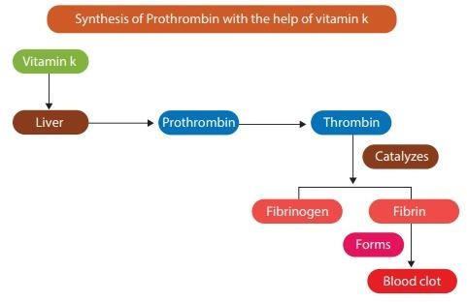

Food Source
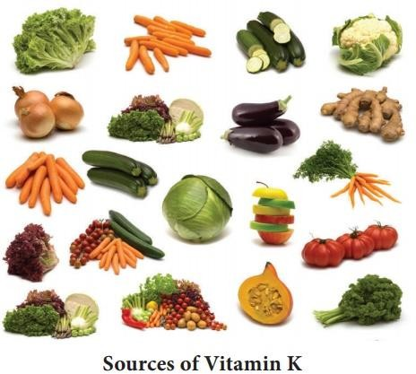
The best dietary sources of this vitamin are green leafy vegetables, cheese and liver.

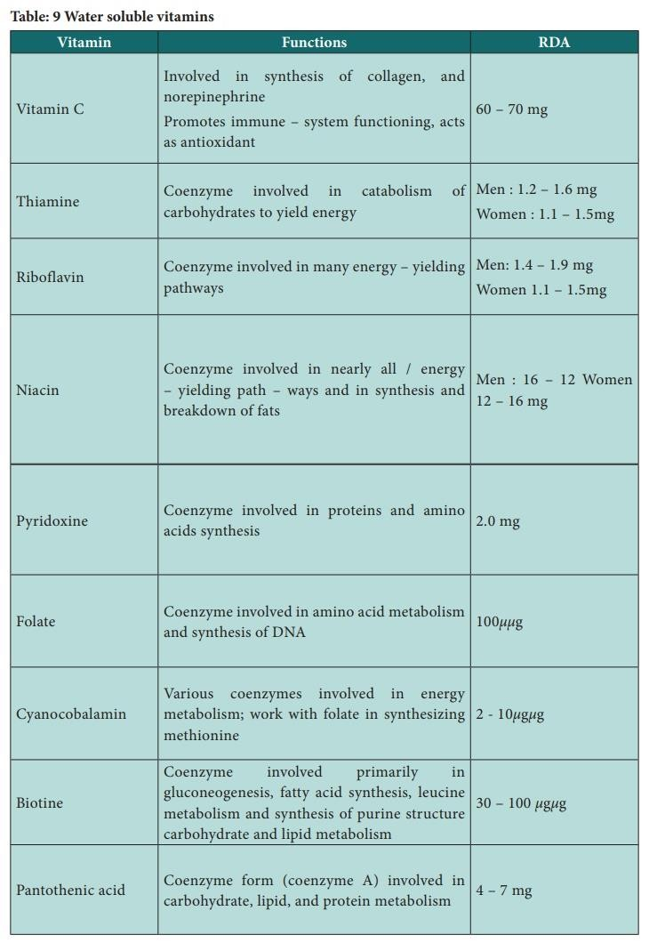

Deficiency
Increased tendency to haemorrhage defective blood clotting

Table: 9 Water soluble vitamins

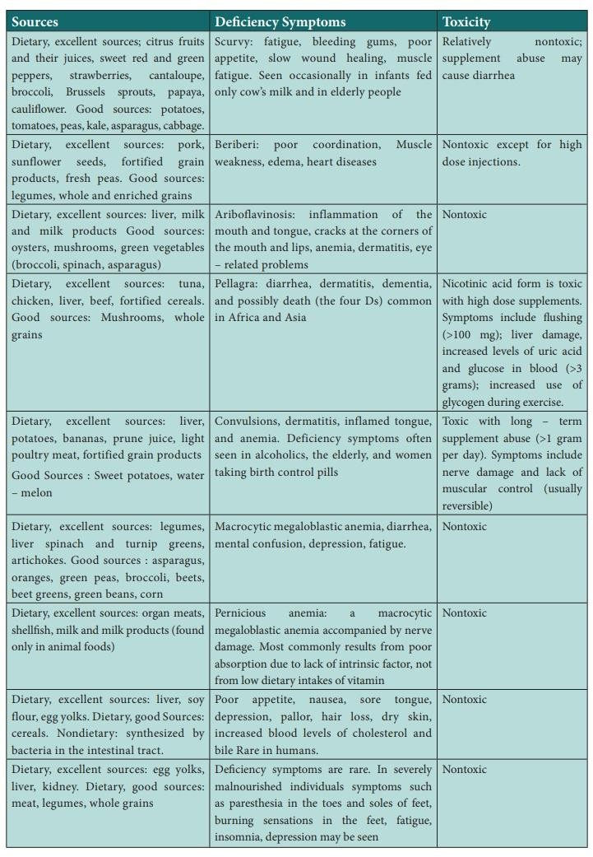

- Water – soluble vitamins
Water – soluble vitamins are essential of health, and each one has its own function in the body and due to its solubility in water. It is normally easily lost in urine. The water soluble vitamins include vitamin C and 8 B complex vitamins – thiamine, riboflavin, niacin, pyridoxine, folate, cyanocobalamin, biotin and pantothenic acid. Most of these are unstable and thus easily destroyed by exposure to water, heat, air or light.

Vitamin C
Many fruits and vegetables are rich in vitamin C, also known as ascorbic acid. To ensure optimal physiological functioning and to prevent subclinical deficiencies, a person needs to consume a good source of vitamin C every day because the body normally stores only small amounts of Vitamin C.
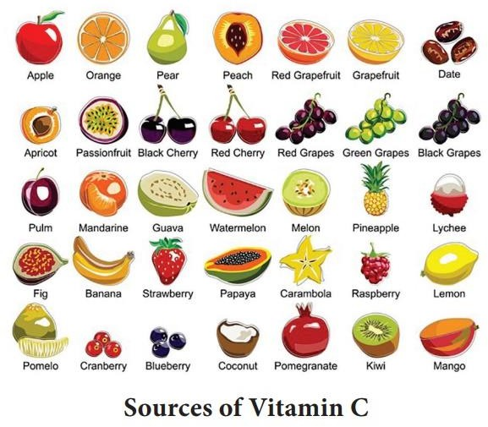

Functions
Vitamin C is required in the synthesis of collagen in connective tissue, steroid hormones, carnitine, etc.

Vitamin C is required for the conversion of cholesterol to bile acids. It enhances iron bioavailability.
Ascorbic acid is a great antioxidant and helps to protect the body against pollutants.
Ascorbic acid also promotes healthy cell development.
Vitamin C is essential for the formation and maintenance of intercellular cement substances such as bone matrix, cartilage dentine, collagen, connective tissue, etc.
Vitamin C is needed for healthy gums and to protect against infection.

Food sources
Good sources of vitamin C are green leafy vegetables, berries, citrus fruits, guavas, tomatoes, melons, papayas, etc.

Deficiency
In infants and children, vitamin C deficiency results in defective bone formation leading to retardation of growth.

B – complex vitamins
The eight B – complex vitamins include thiamine (B1), riboflavin (B2), niacin (B3), pyridoxine (B6), cyanocobalamin (B12), folic acid, biotin (B7), and pantothenic acid. The B vitamins are easily lost in cooking water because they are water soluble. With the exception of niacin, all other B vitamins lose some activity when exposed to heat, oxygen, light, or alkaline conditions.

Thiamine (Vitamin B1)
Thiamine also called B1 is used in many different body functions and deficiencies may have far reaching effects on the body, yet very little of this vitamin is stored in the body and depletion of this vitamin can happen within 14 days. Thiamine is integrally involved as a coenzyme in the catabolism of carbohydrates to yield energy.

Functions
It is also required for the health of the nervous system.

It is used in the manufacture of hydrochloric acid, and therefore plays a part in digestion.
In children it is required for good appetite and proper growth.

Food sources
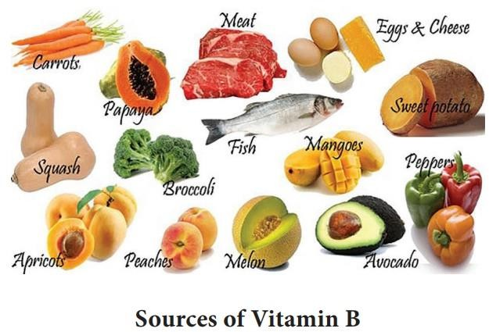
Sunflower seeds, peanuts, wheat bran, beet liver, pork, seafood, egg – yolk, beans whole grains and yeast contain good amounts of thiamine.

Deficiency
Beriberi occurs in two forms, wet beriberi and dry beriberi, whose prominent symptoms differ.

Riboflavin – (Vitamin B2)
Riboflavin is another B – complex vitamin involved as a coenzyme in the metabolism of carbohydrates, as well as of fats and proteins. The adult RDA for riboflavin has been established at a minimum of 1.2 milligrams per day.

Functions

It is required by the body to use oxygen and the metabolism of amino acids, fatty acids, and carbohydrates.
It is a used for red blood cell formation, antibody production, cell respiration, and growth.
It may be helpful in the prevention and treatment of cataracts.

Food sources
Organ meats, nuts, cheese, eggs, milk and lean meat are best sources of riboflavin. It is also available in good quantities in green leafy vegetables, fish, legumes, whole grains, and yogurt.

Deficiency
A dietary deficiency of riboflavin leads to ariboflavinosis.

Niacin (B3)
Niacin also called nicotinic acid or niacin amide and can be manufactured by body. Niacin is derived from two compounds – nicotinic acid and niacin amide.

Functions
Niacin functions as a coenzyme in nearly all the metabolic pathways yielding energy from carbohydrates, fats, proteins, and alcohol.
Niacin also plays a role in tissue respiration.
It is involved in the synthesis and breakdown of fats, and helps to maintain healthy skin.

Food sources
Liver, lean meat, fish, nuts, cereals, legumes, asparagus, milk, green leafy vegetables and fish. A cup of coffee also provides 3 milligrams of niacin.

Deficiency
A deficiency of niacin is known as pellagra, which means rough skin (from the Italian words pelle for skin and Agra for rough).

Pyridoxine (Vitamin B6)
Pyridoxine is part of the B group vitamins and is water – soluble and is required for both mental and physical health.

Functions
Pyridoxine is required for the balancing of hormonal changes in women. It is essential for the metabolism and proteins, fats and carbohydrates. It assists in the maintenance of serum level of sodium and potassium It helps to promote red blood cell production.
It is linked to cancer immunity and fights the formation of the toxic chemical homocysteine.

Food sources
Good sources to obtain pyridoxine are brewer‘s yeast, egg, chicken, carrot, fish, liver, kidney, pea, wheat germ and walnuts. Roots and tubers, cabbage, legumes, molasses, whole grains, etc., contain moderate amount of this vitamin.

Deficiency
Irritability, nervousness, insomnia, anemia, general weakness, skin changes such as dermatitis.

Folic acid (Vitamin B9) – folic acid, folacin, folate
Folic acid is also referred to as folacin or folate. Its chemical name is pteroylglutamic acid. This vitamin can be produced by the body and be stored in the liver.

Functions
Folic acid is required for DNA synthesis and cell growth and is important for red blood cell formation, energy production as well as the forming of amino acids.
Folic acid is essential for synthesizing heme, the iron containing substance in hemoglobin, crucial for oxygen transport.

Folic acid is very important in the development of the nervous system of a developing fetus.

Food sources
Fresh green vegetable such as spinach and broccoli contains folic acid. It is also found in fruit, starchy vegetables, beans, whole grains, liver, kidney, egg, yeast etc.

Deficiency
A deficiency of folate can lead to macrocytic, megaloblastic anemia, diarrhea, fatigue, depression, and mental confusion.

Cyanocobalamin (Vitamin B12)
Cyanocobalamin also known as cobalamin is referred to as the energy vitamin. It is a very widely researched vitamin, and used in supplementation to a very large degree.

Functions
Cobalamin is required in the metabolism of fats, proteins and carbohydrates.
It is needed in the manufacture of red blood cells and the maintenance of red blood cells.
It stimulates appetite and Promotes growth.

Food sources
Liver, organ meat, muscle meat, shellfish, egg, cheese and fish are rich sources of this vitamin. It can be manufactured in the body. Milk contains vitamin B ₁₂ however processing of milk may destroy the vitamin.

Deficiency
Vitamin B12 deficiency results in macrocytic, megaloblastic anemia (pernicious anemia) similar to that occurring with folate deficiency.

Biotin (Vitamin B7)
Biotin is also referred to as anti – egg white injury factor.

Biotin present in foods in not affected by exposure to light. Biotin is also produced by bacteria in the intestine.

Function
Biotin is involved in carbohydrate and lipid metabolism.
Biotin is also indicated for healthy hair and skin, healthy sweat glands, nerve tissue, and bone marrow.
Biotin is also helps in maintaining a steady blood sugar level.

Food sources
Biotin is widely distributed in both animal and plant foods. Liver, kidney, egg, yolk, milk, tomatoes are rich sources.

Deficiency
Dietary deficiency of biotin is rare. Symptoms of biotin deficiency include lack of appetite, nausea, an enlarged tongue, mental depression, pallor, loss of hair.

Pantothenic acid (vitamin B6)
Pantothenic acid referred to as the ―anti – stress vitamin‖ is part of the B group vitamins. This vitamin can be produced in the body by the intestinal flora.

Functions
Pantothenic acid plays an important role in the secretion of hormones, such as cortisone because of the role it plays in supporting the adrenal gland.
Pantothenic acid is also used in the release of energy as well as the metabolism of fat, protein and carbohydrates.
It is used in the synthesis of lipids, neurotransmitters and haemoglobin.

Food sources
Beef, brewer‘s yeast, egg, fresh vegetables, kidney, legumes, liver, mushrooms, nuts, pork, royal jelly, saltwater fish, torula yeast, whole rye flour, and whole wheat contain this vitamin.

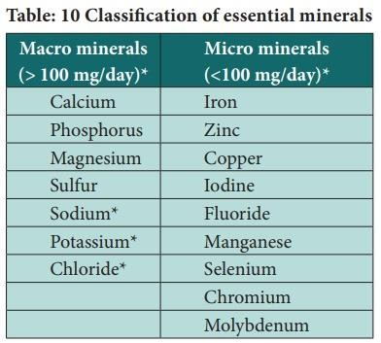
Deficiency
Symptoms of a pantothenic acid
deficiency though rare, may occur in severely malnourished individuals and include fatigue, irritability, low blood pressure upon standing, lack of appetite, constipation, and tingling and numbness in both the feet and hands.

Minerals
The essential minerals are classified according to their recommended intake. Macro minerals, also called major minerals, are needed in amounts greater than 100 milligrams per day. Micro minerals, also called trace minerals or trace elements, are needed in less than 100 milligrams per day.

Table: 10 Classification of essential mineral
Macro minerals
There are seven macro minerals; calcium, phosphorus, magnesium, sulfur, sodium, potassium, and chloride. As well as being needed in amounts greater than 100 milligrams per day, each of the macro minerals makes up more than 0.01% of the body‘s weight.

Calcium
Calcium is by far the most prevalent mineral in the body. About 98% of the 1200 grams (2.5 pounds) of calcium in the average adult body is found in the bones. Small amounts of calcium (1%) are also found in the extracellular fluid, certain intracellular structures, and cell membranes.

Function
Calcium is one of the minerals needed for the growth and strength of the bones.
Calcium is needed for muscle contraction Calcium ions are essential for blood clotting.
Calcium is needed for the functioning of neuro transmitters.

Food sources
Milk and milk products are among the best sources of calcium, other sources of calcium includes leafy greens, firm tofu, and small fish with bones, such as sardines.

Deficiency
A severe deficiency of calcium leads to the condition hypocalcemia resulting in rickets in children and osteomalacia in adults.

Phosphorus
Approximately 85% of the 700 grams of phosphorus in the adult body is present in the bones. The ratio of calcium to phosphorus in the bones is 2: 1. After calcium, phosphorus is the second most common mineral in the body by weight.

Function
Phosphorus is involved in a variety of chemical reactions in the body, many of which are related to energy metabolism.
Mineralization of bones and teeth Facilitation of energy transaction Absorption and transport of nutrients Regulation of protein activity
Component of essential body compounds.

Food sources
In general, good sources of protein are also good sources of phosphorus. Meat, poultry, fish and eggs are rich in phosphorus. Milk and milk products, nuts, legumes, cereals and grams are good sources.

Deficiency
A phosphorus deficiency is characterized by weakness, lack of appetite, fatigue and muscle pain.
Magnesium
About 60% of the body‘s magnesium is contained in the bones; most of the remaining magnesium is present in the muscles and other tissues, with about 1% circulating extracellular fluids.

Function
The activity of hundreds of enzymes depends on magnesium Magnesium also helps maintain calcium and potassium homeostasis.

Food sources
Nuts, legumes, dark green leafy vegetables, soya beans and milk are good sources.

Deficiency
Symptoms of magnesium deficiency include weakness, confusion, lack of appetite, nausea, and lack of coordination.

Sulfur
Because sulfur is part of the essential amino acid methionine and the nonessential amino acid cysteine, it is present in the body‘s proteins. Interactions among sulfur atoms in cysteine helps to give proteins their three dimensional shape.

The Electrolytes
Three of the macrominerals – Sodium, potassium and chloride are the body‘s main electrolytes. The major function of the electrolytes is to

maintain the proper distribution of water inside and outside cells. If this water balance is not maintained, cells will shrink or swell beyond their normal size. Sodium and chloride are found in the extracellular fluid; potassium is found in the intracellular Fluid (ICF).

Sodium
Sodium is the principal cation of extracellular fluid. Human body has approximately 1.8 g of sodium per kilogram of body weight. The body regulates the sodium concentration in the extracellular fluid within narrow limits.

Function
In addition to its role in maintaining the body‘s water balance, sodium functions in maintaining extracellular fluid volume and in regulating the body‘s acid – base balance.

Food sources
The major dietary source of sodium is sodium chloride, more commonly called table salt. One teaspoon of table salt supplies 2132 milligrams of sodium.

Deficiency
Excessive sodium loss, not a low dietary intake; is the usual cause of sodium deficiency. Trauma, long – term diarrhea, vomiting and kidney disease may also lead to excessive sodium losses.
A sodium deficiency, with fluid levels remaining constant or increasing, leads to a decrease in the extracellular sodium concentration. As a result, water migrates into cells, leading to water intoxication. Water intoxication causes loss of appetite, muscle twitching, mental apathy, coma, and seizures.

Potassium
The electrolyte potassium is found mainly in the intracellular fluid

Functions
The main function of potassium, like sodium, is to maintain water balance.

Potassium is required for maintaining a normal heartbeat.

Food sources
This mineral is widely distributed in foods, but fruits and vegetables are generally the most nutrient – dense sources of potassium.

Deficiency
As with sodium, deficiencies of potassium are usually caused by excessive losses, not low intakes. Losses occur primarily via the urine; lesser amounts are lost in sweat. Excessive potassium losses via the kidneys may result from use of potassium – depleting diuretics, which are often prescribed to treat high blood pressure. High levels of activity in hot, humid climates may lead to excessive potassium losses via perspiration. Much potassium can also be lost through long-term vomiting or prolonged diarrhea.
Symptoms of a potassium deficiency include weakness, loss of appetite, nausea, listlessness, apprehension, fatigue, irrational behavior, muscle weakness, and muscle cramping. A severe deficiency may cause an abnormal heartbeat and possibly death.

Chloride
The electrolyte chloride is found primarily in the extracellular fluid.

Functions
- Chloride‘s major functions are maintaining the body‘s water and electrolyte balance.
Chloride is mainly a component of hydrochloric acid, which is secreted in the stomach and helps in the digestion of protein.

Food sources
The main dietary sources of chloride is sodium chloride, that is, table salt. Chloride is also found in many processed food that contain added salt.

Deficiency
As with the other two electrolytes, chloride deficiency rarely results from poor dietary intake. Rather, chloride deficiencies are typically caused by

excessive losses due to diarrhea or vomiting, heavy perspiration, trauma, or kidney disease.

Micro minerals
We require intakes of the essential trace minerals, or micro minerals, in amounts of less than 100 milligrams per day. The essential trace minerals are iron, zinc, copper, iodine, manganese, fluoride, chromium, selenium, and molybdenum.

Iron
About 30% of the iron in the body is stored in the spleen, liver, and bone marrow. Iron is a constituent of haemoglobin and myoglobin, which are iron-binding proteins found in red blood cells and muscle, respectively. Iron also function as a cofactor for a number of enzymes and is required for their activity.

Deficiency
Iron deficiency develops in stages; the last stage is iron-deficiency anemia.

Zinc
Most zinc in the body is found in the bones and muscles. This trace mineral is necessary for optimal activity of many enzymes and for various bodily processes, including the following:
Protein metabolism, wound healing, and growth Metabolism of DNA, the genetic material Development of sexual organs and bones Immune responses
Memory formation Alcohol metabolism
Particularly high needs for zinc occur during growth and development.

Food sources
Meat, fish, eggs, milk and nuts are rich sources.

Deficiency
A zinc deficiency impairs protein synthesis, collagen formation, and energy production; it also decreases alcohol tolerance.

Copper
The trace mineral copper is required for proper use of iron by the body and for the activity of certain enzymes. This trace mineral also aids in the production of connective tissue, blood vessels, phospholipids, and melanin (a skin pigment).

Food sources
The main dietary sources of copper are shellfish, whole grains, legumes, and nuts.

Deficiency
Symptoms include decreased blood levels of copper, fewer white blood cells, anemia, bone demineralization, deterioration of the nervous system.

Iodine
The micro mineral iodine is a necessary component of two hormones produced by the thyroid gland (thyroxine and triiodothyronine). These thyroid hormones are critical in regulating the body‘s metabolic rate.

Food sources
The amount of iodine present in a particular food depends on the amount of iodine in the environment in which that food was raised. Therefore, food from the sea lobsters, oysters, sardines etc.

Deficiency
A prolonged deficiency of iodine causes enlargement of the thyroid gland, known as goiter.

Fluoride
Although some scientists have doubted that fluoride is an essential nutrient for humans, this trace mineral is currently considered essential. The main function of fluoride is to harden the bones and teeth.

Food sources
The only good dietary sources of fluoride are fluoridated water, seafood, seaweed, and tea. Some natural water sources are also high in fluoride.

Deficiency
Deficiency of fluoride results in the development of dental caries.

Manganese
The trace mineral manganese is required for normal brain function. This micro mineral also aids in the synthesis of collagen, urea, fatty acids, and cholesterol. Manganese is involved in bone growth and is required for the digestion of protein.

Food sources
Manganese is present in many vegetable foods, and our diets supply plenty to meet the requirement, which is minimal.

Deficiency
For the above reason, deficiency of this trace mineral has not been observed in humans, although it can be induced in experimental animals.

Selenium
The best understood role of the micro mineral selenium is its involvement in an enzyme system that helps to protect cell membranes against oxidative damage. Thus selenium has an effect similar to that of the antioxidant vitamin E.

Food sources
Selenium is widely distributed in both animals and plant foods.

Deficiency
Deficiency resulting from low dietary intake is unlikely because of its wide distribution in animals and plant foods.

Chromium
The trace mineral chromium is involved in the normal use of glucose and blood lipids and in the functioning of insulin. The active form of chromium in the body is called the Glucose Tolerance Factor (GTF).

Molybdenum
Molybdenum is required for several enzyme systems in the body. One of these enzyme systems involved in the formation of uric acid, a waste product of protein metabolism is excreted in the urine.

Food sources
The molybdenum of plant foods depends on the type of soil in which they are grown. (Neutral or alkaline soil).

Deficiency
Molybdenum deficiency has not been observed in human beings or any other species.

Ultra trace mineral
Seven minerals present in foods and in human bodies have been found to be essential nutrients for animals and may be essential for humans, but nutritional requirements for them have not yet been clearly defined. This group of minerals sometimes called ultra-trace minerals, includes arsenic, boron, cobalt, nickel, silicon, tin, and vanadium.

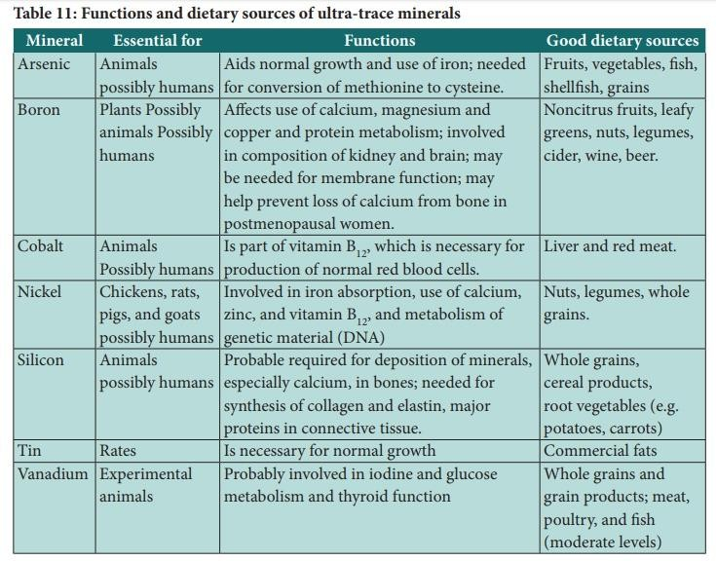

Vegetarian Diet
A vegetarian diet primarily consists of plant-based foods, including fruits, vegetables, grains, legumes, nuts, and seeds, while excluding meat, poultry, and fish. Some variations may allow dairy products, eggs, or both. With growing awareness about health, the environment, and ethical considerations, vegetarian diets have become more popular globally.

Vegetarianism can be divided into several types based on which animal products are included or excluded:
Lacto-vegetarian: Includes dairy products but excludes eggs. Ovo-vegetarian: Includes eggs but excludes dairy products. Lacto-ovo vegetarian: Includes both eggs and dairy products.
Vegan: Excludes all animal products, including dairy, eggs, and often honey.

Nutritional Benefits of a Vegetarian Diet
A well-planned vegetarian diet can provide most of the essential nutrients required by the human body. It has several health benefits, including:
Lower risk of heart disease: Vegetarian diets tend to be lower in saturated fat and cholesterol, which can reduce the risk of cardiovascular issues.
Improved digestion: High fiber content from fruits, vegetables, and whole grains promotes healthy digestion and regular bowel movements.
Weight management: Vegetarians tend to have lower body mass index (BMI) due to a diet that is lower in calories but higher in fiber and nutrients.
Reduced risk of certain cancers: Studies have shown that vegetarians have a lower risk of colorectal and other cancers due to the high intake of antioxidants and phytochemicals from plant-based foods.
Lower blood pressure: Plant-based diets are naturally rich in potassium and lower in sodium, which can help regulate blood pressure.

Key Nutrients in a Vegetarian Diet
Though a vegetarian diet can be nutritionally adequate, some nutrients are more challenging to obtain. The following nutrients need special attention:

Protein: Plant-based sources like beans, lentils, tofu, tempeh, quinoa, and nuts can provide adequate protein. Combining different sources, such as legumes and grains, helps ensure a complete amino acid profile.
Iron: Non-heme iron found in plants is less easily absorbed by the body than heme iron from animal products. To boost absorption, include iron-rich foods (spinach, lentils, fortified cereals) with vitamin C-rich foods (citrus fruits, bell peppers).
Vitamin B12: This vitamin is primarily found in animal products. Vegetarians, especially vegans, need to rely on fortified foods (such as plant- based milks or cereals) or take B12 supplements to prevent deficiency.
Calcium: While dairy is a rich source of calcium, plant-based sources include fortified plant milks, tofu, kale, broccoli, and almonds.
Omega-3 Fatty Acids: These essential fatty acids are abundant in fish, but vegetarians can consume flaxseeds, chia seeds, walnuts, and algae-based supplements for an alternative source.
Zinc: Found in whole grains, nuts, and seeds, zinc absorption may be lower in a vegetarian diet, so it's important to consume enough zinc-rich foods.

Health Considerations for Specific Groups
Children: A well-balanced vegetarian diet can support healthy growth and development in children. Parents need to ensure that children receive adequate protein, fats, and key vitamins and minerals, such as calcium and iron.
Pregnant and Lactating Women: During pregnancy and lactation, the need for certain nutrients, like iron, calcium, and vitamin B12, increases. Special care should be taken to include fortified foods or supplements to meet these higher nutritional demands.
Athletes: For physically active individuals, protein and calorie intake must be carefully managed to ensure adequate energy levels and muscle repair. Plant-based proteins such as beans, lentils, and soy can meet the higher protein requirements of athletes.

Challenges of a Vegetarian Diet
While a vegetarian diet can be healthy and nutritionally adequate, some challenges include:

Social and Cultural Challenges: In many cultures, meat is a staple, and finding vegetarian options in social settings or restaurants can be difficult.
Nutritional Deficiencies: Poorly planned vegetarian diets can lead to deficiencies in key nutrients like vitamin B12, iron, and omega-3 fatty acids. It's important to focus on a diverse range of plant foods to meet all nutritional needs.
Misconceptions: Some may assume that simply eliminating meat leads to a healthier diet. However, replacing meat with highly processed vegetarian options (like mock meats or junk foods) can result in an unbalanced diet.

Practical Tips for a Balanced Vegetarian Diet
Variety is Key: Include a wide range of vegetables, fruits, grains, legumes, and healthy fats to ensure that you get all the necessary nutrients.
Focus on Whole Foods: Choose whole grains, unprocessed legumes, and fresh produce over highly processed vegetarian products.
Use Fortified Foods: Incorporate foods fortified with key nutrients like calcium, vitamin D, and vitamin B12 into your diet.
Meal Planning: Plan your meals to ensure they are nutritionally balanced. Use plant-based protein sources like beans, lentils, and quinoa, and complement them with nutrient-dense vegetables and grains.

Therapeutic Diets Modification of nutrients in therapeutic Diets
The general principles of nutrition related to health apply also to the treatment of patient
s suffering from various diseases. Diet in disease must be planned as part of the complete care of the patient many modifications may have to be made according to the disease and the condition of the patient, but there are certain general principles which may be used for guidance.

Principle of Therapeutic Diets
Carbohydrates are usually well – tolerated and are necessary to maintain the stores of liver glycogen.
The tolerance of fats varies in different individuals and this nutrient should not be forced if there is nausea and vomiting.
In illness, there is usually an increased demand for proteins, due to wasting and this should be given in easily digestible forms such as milk, egg, chicken and fish.
The requirements of calcium and iron must be maintained during illness and it is necessary to check.
Fat – soluble vitamins often need to be added as concentrates if a patient has to be on a fat – restricted diet for a long time. The demand for Vitamin C is greatly increased in fevers, and it is especially necessary for the healing of wound after surgery.
Roughage: Excessive bulk hinders the penetration of the digestive juice, but it may be necessary to include foods with a moderately high residue content to produce daily bowel action.
Fluids are very important to prevent dehydration which is common in conditions of fevers, diarrhea and vomiting. In such condition 2,500 –3,000 ml must be given in 24 hours with as much variety as possible, both in appearance and in taste.
- Diabetes Mellitus

Diabetes mellitus is a condition in which the secretion of insulin by the islets of Langerhans in the pancreas is deficient or absent. It is characterized by hyperglycemia, and glycosuria accompanied by polyuria, polydipsia, polyphagia, and if untreated for a long time by loss of weight.
Table 12: Diabetes Mellitus
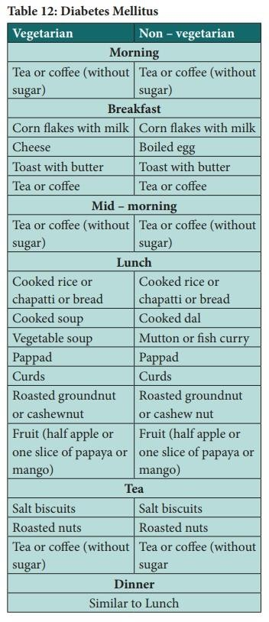

Table 13: Daily menu for high blood pressure
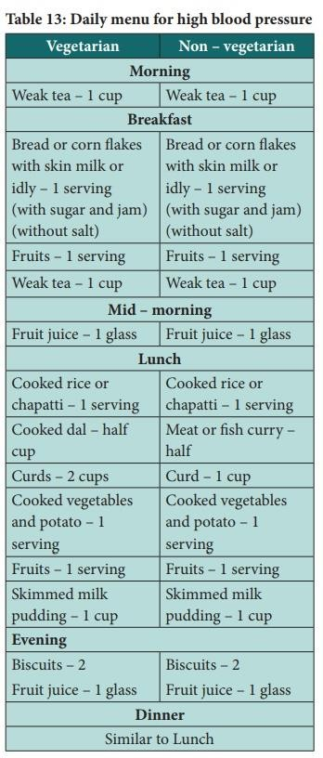

- Hypertension
Hypertension develops due to some reason, there is increased resistance to the normal circulation of blood. This may be temporary, as the result of exercise, pregnancy, or menopause; it may be permanent, associated with atherosclerosis, cardiac failure or chronic kidney disease.

Notes
- Salt should not be added in cooking
- One multivitamin tablet providing the daily requirements of all essential vitamins should be included along with the diet
- Strong coffee is not permitted.

Table 14: Daily menu for Hypertension
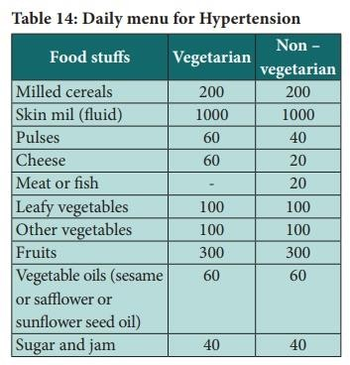
- Coronary Heart Diseases
A majority of coronary heart diseases are due to coronary antheroma (A fatty deposit in the inner lining of an artery) and atherosclerosis, are used to denote conditions in which lipid is deposited in the intima of the blood vessels.
Calories – 1800 – 2000 Kcal; Fat (rich in essential fatty acids) – 60 gm; Proteins – 50 – 60 gm
Note: one multivitamin tablet providing the daily requirements of all essential vitamins should be given daily.
Table 15: Daily menu for coronary heart disease

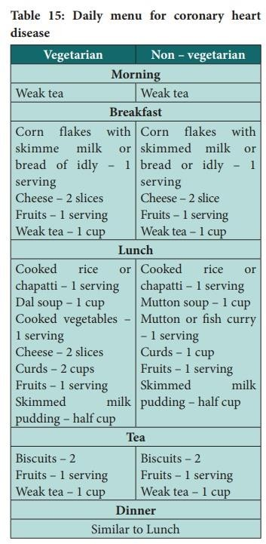

Chronic Renal Failure
Chronic Renal Failure occurs in glomerulone phritis,and chronic pyelonephritis. In this condition,the glomeruli and tubules are heavily damaged.

Diet
The diet in chronic uratemia (presence of abnormal of uric acid salts in the blood) should be below in protein depending on the urea content of blood. The pattern of diet and the daily menu for an adult suffering from chronic renal failure are given in Tables 16 and 17.

Table: 16 Diet for an adult suffering from chronic renal failure
(Calories 1500 – 2000 Kcal; Proteins 15 – 20 gm; Fat 40 – 50 gm, Carbohydrates 300 – 40 gm; Salt free)
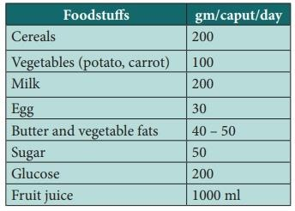

Table 17: Daily menu for chronic renal failure
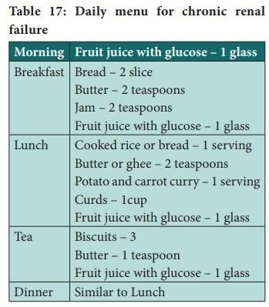
Note: Common salt should not be added during or after cooking. One multivitamin tablet providing the daily requirements should be taken

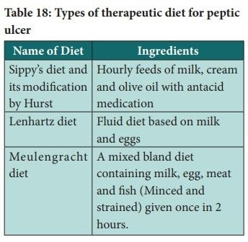
- Peptic Ulcer
Chronic ulcer formed in the region of the gastrointestinal tract where the gastric juice comes in direct contact with the mucous membrane is known as peptic ulcer. Such ulcers usually occur in the duodenum (duodenal ulcer) and in the stomach (gastric ulcer). Duodenal ulcer is associated with hyperacidity while gastric ulcer is not.

Table 18: Types of therapeutic diet for peptic ulcer Diet in Peptic Ulcer
The diet is the most important factor in the treatment of peptic ulcer. Three main types of diets have been used in the treatment of peptic ulcer
Sippy‘s diet consisting of milk and olive oil was used widely. Since it is monotonous and not adequate to meet the calorie needs, it has been replaced by a bland diet containing large quantities of milk.

Table 19: Diet for adult suffering from peptic ulcer (gm/caput/day)

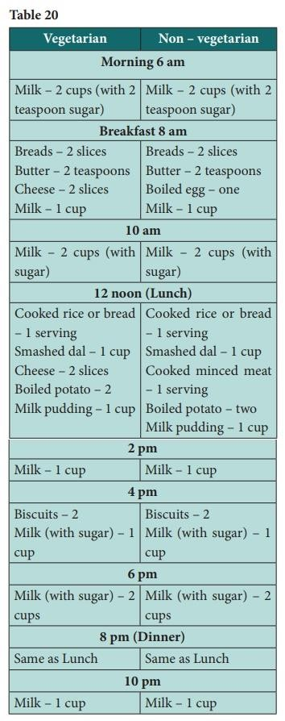

Note: One vitamin C tablet (100mg) may be taken once daily.

Table 20

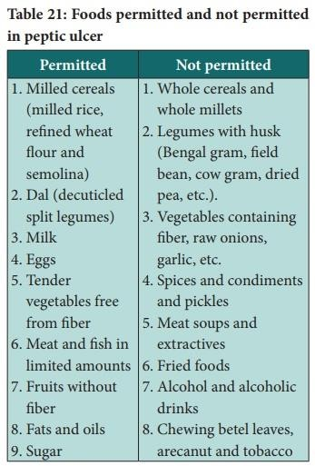

Table 21: Foods permitted and not permitted in peptic ulcer

Adulteration of Food Additives
Food additives are defined as non-nutritious substances which are added intentionally to food generally in small quantity, to improve its appearance, flavor, texture or storage properties.

Adulteration of Food Additives
Food additives are defined as non-nutritious substances which are added intentionally to food generally in small quantity, to improve its appearance, flavor, texture or storage properties.
Food additives may be classified into two categories. Additives of the first category includes:
Coloring agents, e.g. saffron, turmeric Flavoring agents, e.g. vanilla essence Sweeteners, e.g.saccharin
Preservatives, e.g.ascorbic acid, sodium benzoate Acidity imparting agents, e.g. citric acid, acetic acid, etc.
These agents are generally considered safe for human consumption. Additives of the ―Second category‖ are, strictly speaking, contaminants incidental through packing, processing steps, farming practices (insecticides) or other environmental conditions.
Uncontrolled or indiscriminate use of food additives may pose health hazards among consumers. For example, certain preservatives such as nitrites and nitrates can lead to the production of toxic substance, e.g. nitrosamines that have been implicated in cancer etiology.

Food Fortification
Fortification of food is a public health measure aimed at reinforcing the usual dietary intake of nutrients with additional supplies to prevent / control some nutritional disorders.
WHO has defined ―Food fortification‖ as the process whereby nutrients are added to foods (in relatively small quantities) to maintain or improve the quality of the diet of a group, a community or a population.‖ For example,

Foods artificially fortified with vitamin ‗D‘ e.g. milk, margarine, Vanaspati and infant foods.
Foods fortified with vitamin ‗A‘ e.g. margarine, milk, Vanaspati.

Adulteration of Food
Adulteration of food is an age – old problem. It is done through a large number of practices:
Mixing Substitution Abstraction
Concealing the quality
Putting up decomposed foods for sale Misbranding or
Giving false labels and Addition of toxicants.
Food adulteration practices vary from one part of the country to another, and from time to time.
The types of adulteration commonly found in India are as follows:
Milk: Addition of water, removal of fat and addition of starch to make the milk thicker are the common forms of milk adulteration.
Ghee: This is adulterated with dalda and animal fats such as pig‘s fat.
Rice and wheat: These are mixed with stone chips and mud to increase the bulk
Flour: Wheat flour is mixed with soap stone powder and cheaper flours such as singhada flour.
Pulses: Chemical substances are added to old stocks to improve the appearance.
Tea and coffee: Tea leaves are adulterated with old tea leaves; leather and saw dust, coffee is adulterated with chicory

Honey: This is adulterated with sugar or jaggery and boiled with empty beehives.
Medicines: Even drugs are adulterated.

The prevention of Food Adulteration Act 1954
Any food that does not confirm to the minimum standards is said to adulterated standards. Provisions have been laid down under this Act for various foods.
In 1954, the Government of India enacted a Central Prevention of Food Adulteration Act. The act has been amended several times, the latest amendment is that of 1976 and in lately in 1986 to make the Act more stringent.
Although it is a Central Act, its implementation is largely carried out by the local bodies and State Governments.
- Food Standards
FAO/WHO formulates food standards for international market. Codex Alimentarius commission which is the principal organ of the joint FAO/ WHO food standards programme. The standards in India are based on the standards of the Codex Alimentarius.

PFA Standards
Under the Prevention of Food Adulteration Act, 1954 standards have been established which are revised from time to time by the ―Central Committee for Food standards‖.
The purpose of PFA standards is to obtain a minimum level of quality of foodstuffs attainable under India conditions.

The Agmark Standards
These standards are set by the Directorate of Marketing and Inspection of the Government of India.
- Bureau of India Standards

Applied Nutrition for National Faculty of Nursing
The ISI mark on any article of food is a guarantee of food quality in accordance with the standards prescribed by the Bureau of Indian Standards (BIS) for that commodity.

Health Diet
A healthy diet is one that helps maintain or improve general health.
It is important for lowering many chronic health risks such as, obesity, heart disease,diabetes, hypertension and cancer.
WHO makes the following five recommendations with respect to both population andindividuals:
- Achieve an energy balance and a healthy weight
- Limit energy intake from total fats consumption
- Increase consumption of fruits and vegetables
- Limit the intake of simple sugar
- Limit salt consumption

The Food Pyramid – A Guide to a Balanced Diet

The Healthy Eating Food Pyramid
Balanced diet is a key to stay healthy. Follow the "Healthy Eating Food Pyramid" guide as you pick your food. Grains should be taken as the most. Eat more fruit and vegetables. Have a moderate amount of meat, fish, egg, milk and their alternatives. Reduce fat/ oil, salt and sugar. Trim fat from meat before cooking. Cook with low-fat methods such as steaming, stewing, simmering, boiling, scalding or cooking with non-stick frying pans. Also reduce the use of frying and deep-frying. These can help us achieve a balanced diet and promote health.
How much of different kinds of food should I eat to stay healthy?

Eat the Right Food
Since different foods have different nutritional values, it is not possible to obtain all the nutrients we need from a single food. According to the Healthy Eating Food Pyramid, we have to eat a variety of foods among all food

groups as well as within each group in order to get different nutrients and meet our daily needs.
Eat the Right Amount
Neither eating too much nor too little is good for our health. Every day, we need a specific amount of nutrients to maintain optimal health. If we do not eat enough, malnutrition or symptoms of nutrient deficiency are likely to develop. In contrast, excessive intake can result in over-nutrition and obesity. Therefore, we have to eat the right amount of food to stay healthy.
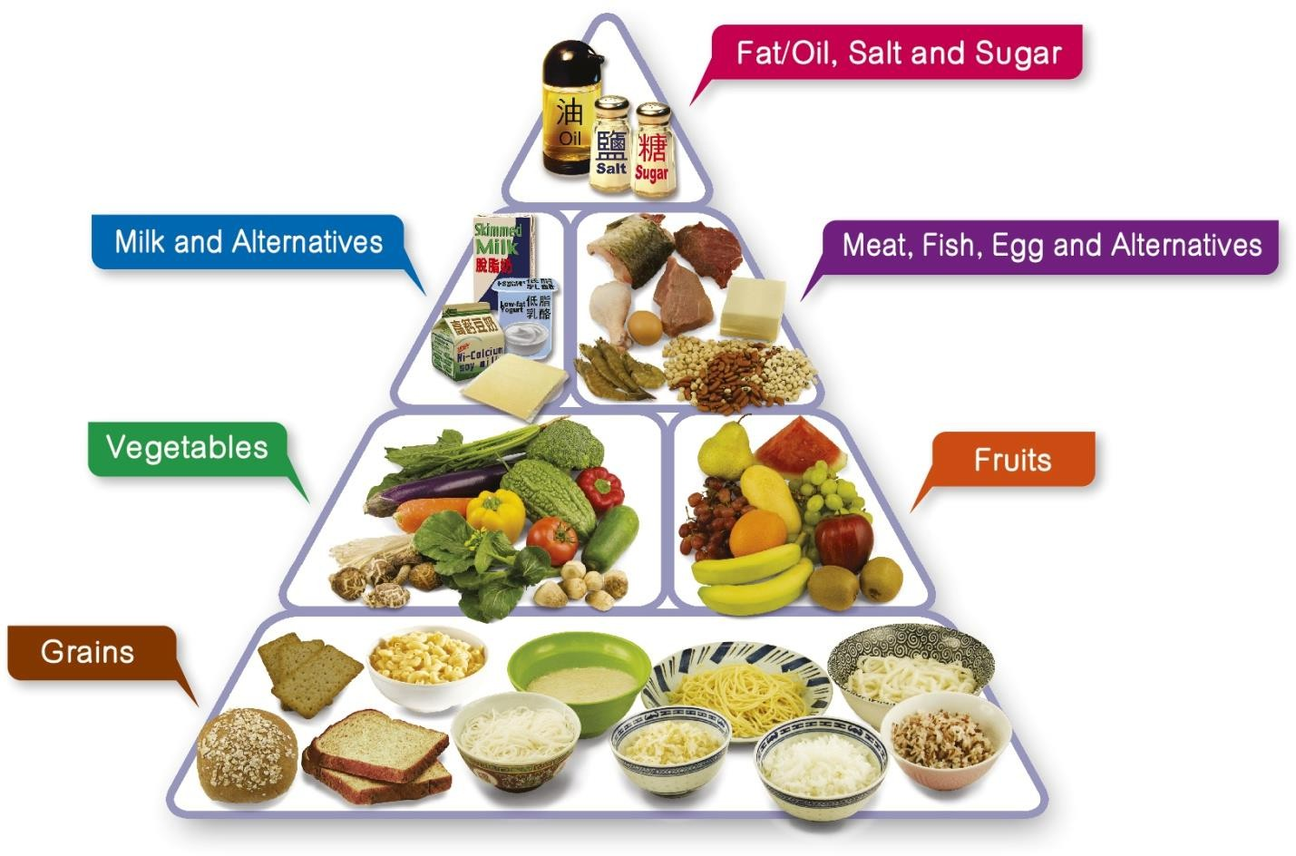
Healthy Eating Food Pyramid
- Eat Most - Grains
- Eat More - Vegetables and fruits
- Eat Moderately - Meat, fish, egg and alternatives (including dry beans) and milk and alternatives
- Eat Less - Fat/ oil, salt and sugar

- Drink adequate amount of fluid (including water, tea, clear soup, etc) every day
Healthy Eating Food Pyramid for Children (aged 2 to 5)
- Grains: 1.5 - 3 bowls
- Vegetables: at least 1.5 servings
- Fruits: at least 1 serving
- Meat, fish, egg and alternatives: 1.5 - 3 taels
- Milk and alternatives: 2 servings
- Fat/oil, salt and sugar: eat the least
- Fluid: 4 - 5 glasses
Healthy Eating Food Pyramid for Children (aged 6 to 11)
- Grains: 3 - 4 bowls
- Vegetables: at least 2 servings
- Fruits: at least 2 servings
- Meat, fish, egg and alternatives: 3 - 5 taels
- Milk and alternatives: 2 servings
- Fat/oil, salt and sugar: eat the least
- Fluid: 6 - 8 glasses
Healthy Eating Food Pyramid for Teenagers (aged 12 to 17)
- Grains: 4 - 6 bowls
- Vegetables: at least 3 servings
- Fruits: at least 2 servings
- Meat, fish, egg and alternatives: 4 - 6 taels
- Milk and alternatives: 2 servings
- Fat/oil, salt and sugar: eat the least
- Fluid: 6 - 8 glasses
Healthy Eating Food Pyramid for Adults
- Grains: 3 - 8 bowls

- Vegetables: at least 3 servings
- Fruits: at least 2 servings
- Meat, fish, egg and alternatives: 5 - 8 taels
- Milk and alternatives: 1 - 2 servings
- Fat/oil, salt and sugar: eat the least
- Fluid: 6 - 8 glasses
Healthy Eating Food Pyramid for Elderly
- Grains: 3 - 5 bowls
- Vegetables: at least 3 servings
- Fruits: at least 2 servings
- Meat, fish, egg and alternatives: 5 - 6 taels
- Milk and alternatives: 1 - 2 servings
- Fat/oil, salt and sugar: eat the least
- Fluid: 6 - 8 glasses Food Exchange List:
1 bowl of grains is equivalent to:
- Cooked rice, 1 bowl
- Cooked rice noodles, 1 bowl
- Bread, 2 slices

1 serving of vegetables is equivalent to:
- Cooked vegetables, ¹⁄₂ bowl
- Raw vegetables, 1 bowl

1 serving of fruit is equivalent to:
- Medium-sized apple, 1 piece
- Kiwifruit, 2 pieces (small-sized)
- Fruit cuts, ¹⁄₂ bowl

1 tael of meat is equivalent to:
- Cooked meat, 4-5 slices
- Egg, 1 piece
- Firm tofu, ¹⁄₄ block
1 serving of milk and alternatives is equivalent to:
- Low-fat milk, 1 cup
- Low-fat cheese, 2 slices
- Low-fat plain yogurt, 1 pot (150g)

Remarks
- 1 tael is approximately equivalent to 40 grams (raw meat).
- 1 bowl is approximately equivalent to 250-300ml
- 1 cup is approximately equivalent to 240ml
- The above recommendations are intended for healthy individuals only. Those with chronic diseases and specific nutritional needs should consult their family doctors and dietitians for individualised dietary recommendations.

Malnutrition
- It is the state resulting from eating inadequate diet.
- Qualitatively: deficient or excess of one or more nutrient.
- Quantitatively: consumed in amounts less or more than required.

ASSESSMENT OF NUTRITIONAL STATUS
Evaluation of the nutritional status of individuals, groups, community orthe whole country.
Objectives of nutritional assessment
- To determine pattern of food consumed (Quality& Quantity)
- To find out deficient or excess intake of nutrients and energy.
- To identify the major malnutrition problem(s).
- To plan for prevention and control of malnutrition.

Methods of nutritional assessment
Direct (ABCDs)

  - Anthropometric measurements.
  - Biochemical tests, laboratory investigations
  - Clinical examination
  - Dietary Studies:
- Dietary survey
- National food consumption and food balance sheet
Indirect
- Assessment of ecological factors
- Study of statistical indices. DIRECT METHODS
A. Anthropometric Measurements
1 .Weight: it is the most important, commonly used measure.

- Weight for age: This method is used for developing the growth curve in the MCH Centers*Underweight when the child weight is low by more than 2 SD compared to the WHO reference value.
- Height for Age for children: occurs in chronic malnutrition.
*Stunted child : when the child height is low by more than 2 SD compared to the WHO reference value .

Weight for Height for children:
*Wasted children : Child weight is low by more than 2 SD compared tothe WHO reference value .

Height for Weight for adults:
Relative weight = Body weight in Kg X 100 Standard weight (Kg)
- Body Mass Index (BMI) = weight (Kg) ÷ Height in (meters)2
- Waist Circumference (WC)
- Mid Upper Arm Circumference (MAC)
- Triceps Skin Fold Thickness (TSF)
B. Biochemical and laboratory investigations
- Blood hemoglobin:
Regular examination for vulnerable groups.

Serum or urine:
To assess nutrients for at-risk individuals.
- Total proteins or amino acids
- vitamin A & carotene, vitamineC, D, B12
- Iron, serum Fe &transferritin, iodine
- Stools for intestinal parasites.

- Physiological tests: e.g. Dark adaptation test, muscle activity .

C. Clinical Assessment I. Head and neck:
- Face color if Pale it indicates iron deficiency anemia

Eyes
  - Bitot‘s spots, conjunctival xerosis, corneal xerosis, keratomalacia, and angular palpebritis : vitamin A deficiency.
  - Corneal and circumcorneal vascularization; B2 deficiency.
  - Pale conjunctiva; iron deficiency.

Mouth:
  - Lips: Angular stomatitis, cheilosis: B2 deficiency.
  - Gums: Bleeding, spongy gums; vitamin C deficiency,
  - Teeth: Mottled enamel in case of excess fluoride intake, dental caries due to deficiency of bone - forming nutrients & fluoride.
  - Tongue: magenta tongue, fissuring or atrophic papillae B2 &niacin .
- Neck: enlarged thyroid in iodine deficiency.

II. |  | Musculoskeletal
1. |  | Muscle wasting in PEM.
2. |  | Epiphyseal enlargement and delayed closure of fontanel.
3. | 4. | Craniotabes, beading of ribs as in rickets.  Knock knees or bow legs, rachitic thorax ,
head deformities &contracted pelvis.
- Skin, subcutaneous tissue, Hairs, Nails
  - Follicular hyperkeratosis: vitamin A deficiency.
  - Dermatitis: pellagra
  - Peticheal hemorrhage: kwashiorkor, hypoproteinemia, vitamin C

  - Excess sub-cutanueos fat: obesity.
  - Loss of subcutaneous fat: marasmus.
  - Odema: kwashiorkor, hypoproteinaemia & B deficiency.
  - Nails, flat or spooning, brittle, ridged: iron deficiency

- Nervous Manifestation
  - Polyneuritis and sensory loss: B1 deficiency
  - Psychoneurosis dementia; niacin deficiency.
  - Neurologic changes: B12 deficiency.

D. Dietary Studies

Dietary Survey:

Objectives:
1-provide information about the quality and quantity of food consumed. 2-To what extent-consumed food satisfies nutritional requirements
judged by the available standards.
3-Recommendations can be given to improve nutritional status.

Methods:
- Weight of raw foods for 7 days: practical and fairly accurate.
- Weight of cooked foods for 7 days: not easily accepted .
- Oral questionnaire For the quality & quantity of foods eaten in theprevious day.
Advantages: large number -quick - reliable -simple -less costly
Disadvantages: cannot be used for elderly whose memory may belimited.
- The collected data is analyzed for:

- The mean intake of foods cereals, pulses, vegetables, fruits, meat,milk, fish and eggs
- The mean intake of energy and nutrients (proteins, fats, carbohydrates, vitamins and minerals) provided by consumed foods, using special ―Food Consumption Tables‖.
- Average nutrients and energy provided / capita of family or group / day can then be calculated, assuming that every member has an equal share. The results are valuable to show the general pattern of food consumed.
- To know whether nutrition is adequate, deficient, or in excess.Referring to tables of ―Recommended Dietary Allowances‖.
- National Food Consumption & Food balance sheet:
  - Total food consumption =
(Food produced locally + food imported) – (food exported + foodspoiled).
  - Average food consumed / capita /day = Total food consumed Midyear population ×36
- Food balance sheet:
  - Show the average daily per capita intake from the different food item in a given year (e.g. meat, milk, fish).
  - The foods are analyzed into their component nutrients and energy supply using a special food composition table.
- Illustrates the overall national food supply & pattern ofConsumption.
- It does not demonstrate the nutritional status of individuals orgroups.

The characteristics of food balance sheet for Egypt:
  - Cereals (bread) form a good bulk of diet and provide the greater part ofEnergy, proteins, iron and B-vitamins.
  - Energy intake exceeds energy requirements.
  - Animal food (meat, poultry, milk and eggs) is relatively low.

  - Protein content is largely from plant source (animal protein forms asmall percent of total protein).
  - Iron intake is cereals & characterized by low absorbability.
Indirect Methods

Statistical Indices 1. Morbidity
Incidence of acute diseases and prevalence of chronic diseases, which contribute to, or interact with malnutrition, as Diarrhoeal disease of children & parasitic diseases.
- Mortality
  - Stillbirth rate, prenatal mortality rate, and neonatal mortality rate.
  - Nutritional status during pregnancy influences the outcome. Example; LBW may be responsible for 50% of neonatal mortality.
Below 5 years mortality, infant mortality rate, and child 1-4 yearmortality rate.
  - Malnutrition of these children is responsible for impaired health, Lowered body resistance & interaction with infection increasingmortality.

Assessment of the Ecological factors
Host, Agent & Environmental Factors. Health and Educational Services

Factors affecting prevalence and incidence of mal nutrition Ecological factors of malnutrition
- Host factors
      - Socioeconomic: low level due to big family size, low percapita income.
      - Educational: illiteracy, faulty traditions and nutrition ignorance.
      - Morbidity: especially chronic may predispose to malnutrition by:

  - Anorexia: e.g.: pulmonary T B, malignancy and anorexia nervosa.
  - Diarrhea & vomiting e.g.:G.I., parasitic infection, hyperemesis.
  - Impaired digestion and absorption: e.g.: pancreatic& hepatic dysfunction, malabsorption syndrome.
  - Chronic blood loss: gastrointestinal, urinary, and gynecologic.
  - Parasitic diseases: cause anorexia, chronic blood loss, impaired digestion & absorption, consumption of nutrients by parasite.
  - Prolonged oral brood spectrum antibiotic may inhibit the intestinal flora and interfere with biosynthesis of B vitamins and vitamin K.
- Agent (food) factors
  - Food production& availability in each country.
  - Market prices of food especially the staple.
- Environmental factors
Through endemicity of diseases due to unsanitary conditions.
  - Both infection and malnutrition interact e.g. PEM & diarrhea.

Health and other related services
Lack of adequate planning, implementation and evaluation of nutrition programs could result indifferent types of malnutrition, especially amongvulnerable groups.

Factors influencing food choices and behavior
Food choice factors also vary according to life stage and the power of one factor will vary from one individual or group of people to the next. Thus, one type of intervention to modify food choice behavior will not suit all population groups. Rather, interventions need to be geared towards different groups of the population with consideration to the many factors influencing their decisions on food choice

Major determinants of food choice
The key driver for eating is of course hunger but what we choose to
eat is not determined solely by physiological or nutritional needs. Some of the other factors that influence food choice include:

Biological determinants such as hunger, appetite, and taste Economic determinants such as cost, income, availability Physical determinants such as access, education, skills (e.g.cooking) and time
Social determinants such as culture, family, peers and mealpatterns
Psychological determinants such as mood, stress and guilt Attitudes, beliefs and knowledge about food

-Biological determinants of food choice

Hunger and satiety
Satiety is defined as either a feeling of fullness or the cessation of physical hunger sensations following the ingestion of food. Hunger, or
the physiological drive to eat, is equally complex. True hunger is not selective; any food will serve the need.
The macro-nutrients i.e. carbohydrates, proteins and fats generate
satiety signals of varying strength. The balance of evidence suggests that fat has the lowest satiating power, carbohydrates have an intermediate effect and protein has been found to be the most satiating.

Palatability
Palatability is proportional to the pleasure someone experiences when eating a particular food. It is dependent on the sensory properties of the food such as taste, smell, texture and appearance. Sweet and high-fat foods have an undeniable sensory appeal. There is an increase in food intake as palatability increases, but the effect of palatability on appetite in the period following consumption is unclear.

Sensory aspects
Taste is consistently reported as a major influence on food
behavior. In reality „taste‟ is the sum of all sensory stimulation that is produced by the ingestion of a food. This includes not only taste per se but also smell, appearance and texture of food. These sensory aspects are thought to influence, in particular, spontaneous food choice.
- -Economic and physical determinants of food choice Money, values, and consumer skills all affect what a person purchases. The price of a food, however, is not an indicator of its

nutritional value. Cost is a complex combination of a food's availability,status, and demand.

Cost and Accessibility
There is no doubt that the cost of food is a primary determinant of food choice. Whether cost is prohibitive depends fundamentally on a person's income and socio-economic status. Low-income groups have a greater tendency to consume unbalanced diets and in particular have low
intakes of fruit and vegetables. However, access to more money does not automatically equate to a better quality diet but the range of foods from which one can choose should increase.
Political factors also influence food availability and trends. Food laws and trade agreements affect what is available within and across countries, and also affect food prices. Food labeling laws determine what consumers know about the food they purchase
Accessibility to shops is another important physical factor influencing food choice, which is dependent on resources such as transport and geographical location. Healthy food tends to be more expensive when available within towns and cities compared to supermarkets on the outskirts.

Education and Knowledge
Studies indicate that the level of education can influence dietary behavior during adulthood .In contrast, nutrition knowledge and good dietary habits are not strongly correlated. This is because knowledge about health does not lead to direct action when individuals are unsurehow to apply their knowledge

-Social determinants of food choice

Influence of social class
What people eat is formed and constrained by circumstances that are essentially social and cultural. Population studies show there are clear differences in social classes with regard to food and nutrient intakes. Poor diets can result in under- (micronutrients deficiency) and over-nutrition (energy over consumption resulting in overweight and obesity); problems that face different sectors of society, requiring different levels of expertise and methods of intervention. A person's membership in particular peer, work, or community groups impacts food behaviors. For example, a young

person at a basketball game may eat certain foods when accompanied by friends and other foods when accompanied by his or her teacher.

Cultural influences
Cultural influences lead to the difference in the habitual consumption of certain foods and in traditions of preparation, and in certain cases can lead to restrictions such as exclusion of meat and milk from the diet. Cultural influences are however amenable to change: when moving to a new country individuals often adopt particular food habits of the local culture. A cultural group provides guidelines regarding acceptable foods, food combinations, eating patterns, and eating behaviors.
Religious proscriptions range from a few to many, from relaxed to highly restrictive. This will affect a follower's food choices and behaviors. For example, in some religions specific foods are prohibited, such as pork among Jewish and Muslim adherents. Within Christianity, the Seventh-day Adventists discourage "stimulating" beverages such as alcohol, which is not forbidden among Catholics.

Social setting
Although the majority of food is eaten in the home, an increasing proportion is eaten outside the home, e.g. in schools, at work and in restaurants. The venue in which food is eaten can affect food choice, particularly in terms of what foods are on offer. The availability of healthy food at home and 'away from home' increases the consumption of such foods. However, access to healthy food options is limited in many work/school environments. This is particularly true for those with irregular hours or with particular requirements, e.g. vegetarian.

-Meal patterns
People have many different eating occasions daily, the motivations for which will differ from one occasion to the next. Most studies
investigate the factors that influence habitual food choice but it may be useful to investigate what influences food choice at different eating occasions. The effects of snacking on health have been debated widely. Evidence shows that snacking can have effects on energy and nutrient intakes but not necessarily on body mass index.

-Psychological factors

Stress

Psychological stress is a common feature of modern life and can
modify behaviors that affect health, such as physical activity, smoking or food choice. The influence of stress on food choice is complex not least because of the various types of stress one can experience. The effect of stress on food intake depends on the individual, the stressor and the circumstances. In general, some people eat more and some eat less than normal when experiencing stress.

Mood
Hippocrates was the first to suggest the healing power of food; however, it was not until the Middle Ages that food was considered a tool to modify temperament and mood. Today it is recognized that food influences our mood and that mood has a strong influence over our choice of food. As much as food can affect our mood, our mood can also affect our food choices.

Eating disorders
Eating behavior, unlike many other biological functions, is often subject to sophisticated cognitive control. One of the most widely practiced forms of cognitive control over food intake is dieting. Many individuals express a desire to lose weight or improve their body shape and thus engage in approaches to achieve their ideal body mass index. The etiology of eating disorders is usually a combination of factors including biological, psychological, familial and socio-cultural.

Consumer attitudes, beliefs, knowledge and optimistic bias

Consumer attitudes and beliefs
In both the areas of food safety and nutrition, our understanding of consumers‟ attitudes is poorly researched. A better understanding of howthe public perceive their diets would help in the design and implementation of healthy eating initiatives.
Attitudes and beliefs can and do change; our attitude to dietary fat has changed in the last 50 years with a corresponding decrease in the absolute amount of fat eaten and a change in the ratio of saturated tounsaturated fat.

Barriers to dietary and lifestyle change

Focus on cost

Household income and the cost of food is an important factor influencing food choice, especially for low-income consumers. The potential for food wastage leads to reluctance to try „new‟ foods for fear the family will reject them. In addition, a lack of knowledge and the loss of cooking skills can also inhibit buying and preparing meals from basic ingredients. Education on how to increase fruit and vegetable consumption in an affordable way such that no further expense, in money or effort, is incurred has been proposed as a solution).

Time constraints
Lack of time is frequently mentioned for not following nutritional advice, particularly by the young and well educated. People living alone or cooking for one seek out convenience foods rather than cooking from basic ingredients. This need has been met with a shift in the fruit and vegetables market from loose to repacked, prepared and ready-to-cook products. These products are more expensive than loose products but people are willing to pay the extra cost because of the convenience theybring.

Other determinants of food choices
Media has a pervasive influence on children‟s food choices.
Children, including the very young, are heavily marketed by the food industry. Time spent watching television is directly related to children‟sfood requests. The most frequently advertised foods are high-sugar breakfast cereals, fast food restaurant products, sweetened beverages, frozen dinners, cookies, and candy. Fruits and vegetables are almost never advertised. Watching television during meals is associated with increased frequency of poor food choices and decreased frequency of good choices.osteomalacia), develops in some patients given TPN for > 3 mo. The mechanism is unknown. Advanced disease can cause severe per articular, lower- extremity, and back pain.
Adverse reactions to lipid emulsions (eg, dyspnea, cutaneous allergic reactions, nausea, headache, back pain, sweating, dizziness) are uncommon but may occur early, particularly if lipids are given at > 1.0 kcal/kg/h. Temporary hyperlipidemia may occur, particularly in patients with kidney or liver failure; treatment is usually not required. Delayed adverse reactions to lipid emulsions include hepatomegaly, mild elevation of liver enzymes, splenomegaly, thrombocytopenia, leukopenia, and, especially in premature infants with respiratory distress syndrome, pulmonary function

abnormalities. Temporarily or permanently slowing or stopping lipid emulsion infusion may prevent or minimize these adverse reactions.
Gallbladder complications include cholelithiasis, gallbladder sludge, and cholecystitis. These complications can be caused or worsened by prolonged gallbladder stasis. Stimulating contraction by providing about
20 to 30% of calories as fat and stopping glucose infusion several hours

Malnutrition diseases Most affected age groups
Women, infants, children, and adolescents are at particular risk of malnutrition. Optimizing nutrition early in life –including the 1000 days from conception to a child's second birthday – ensures the best possible start in life, with long-term benefits. Poverty amplifies the risk of, and risks from, malnutrition
Malnutrition is when a person‘s diet does not provide enough nutrients or the right balance for optimal health. Symptoms often involve weight loss, reduced appetite, tiredness, and irritability.

Causes of malnutrition include:

- unsuitable dietary choices
- having a low income
- difficulty obtaining food
- various physical and mental health conditions
Undernutrition is one type of malnutritionTrusted Source. It occurs when the body does not get enough food and enough necessary nutrients. It can lead to:

- delayed growth
- low weight
- wasting
If a person does not get the right balance of nutrients, they can also have malnutrition. It is possible to have obesity with malnutrition.

When a person has too little food, a limited diet, or a condition that stops their body from obtaining the right balance of nutrients, it can severely impact their health. In some cases, this can become life threatening.

This article looks at malnutrition in detail, including the causes, symptoms, and treatments.

What is malnutrition?

Malnutrition is an imbalance in dietary intake. It occurs when a person has too much or too little food or essential nutrients. A person with malnutrition may lack vitamins, minerals, and other essential substances that their body needs to function.

People may become malnourished if they do not eat enough food overall. However, people who eat plenty but do not have enough variation in their diet can also become malnourished.

Malnutrition can lead to:

- short- and long-term health problems
- slow recovery from wounds and illnesses
- a higher risk of infection

Some deficiencies can trigger specific health problems. For example:

Lack of vitamin A

Around the world, many children develop vision problemsTrusted Source due to a lack of vitamin A.

Lack of vitamin C

A lack of vitamin CTrusted Source can result in scurvy.

Scurvy is rare in the United States (U.S.), but it can develop if a person does not have a varied diet with plenty of fruits and vegetables. Fresh, frozen, and canned fruits and vegetables all contain vitamin C.

People who are particularly at risk of scurvy include:

- older adults
- young children
- those who consume a lot of alcohol
- some people with certain mental health conditions

An overall deficiency

Malnutrition can lead to marasmus, which is a severe form of malnutrition. Marasmus is a deficiency of protein and overall energy intake.

A person with marasmus will have very little muscle or fat on their body.

Over nutrition

Over nutrition is another type of malnutrition. It occurs when a person takes in more nutrients than they need. The result may be an accumulation of body fat from the excess nutrients, resulting in overweight or obesity.

Over nutrition has several health implicationsTrusted Source. People who have overweight or obesity are at greater risk of:

- heart disease
- high blood pressure
- diabetes
- cancer
- high cholesterol

The rate of over nutrition is growing worldwide. The World Health Organization (WHO) reports that in 2020, 5.7% of children under 5 were overweight, an increase from 5.4% in 2000.

In addition, the number of adults with obesity almost tripledTrusted Source worldwide from 1975 to 2016.

Symptoms

Some signs and symptoms of malnutrition include:

- weight loss
- a lack of appetite or interest in food or drink
- tiredness and irritability
- an inability to concentrate
- always feeling cold
- depression
- loss of fat, muscle mass, and body tissue
- a higher risk of getting sick and taking longer to heal
- longer healing time for wounds

Eventually, a person may also experience heart failure Trusted Source.

Symptoms in adults vs. children

Children may present with different malnutrition symptoms than adults. In children, there may be:
- a lack of growth and low body weight
- tiredness and a lack of energy
- irritability and anxiety

- slow behavioral and intellectual development, possibly resulting in learning difficulties

Treatment is possible. In some cases, however, malnutrition can have long- term effects.

Causes

Malnutrition can occur for various reasons. The sections below outline these potential causes in more detail.

Low intake of food

Some people develop malnutrition because there is not enough food available, or because they have difficulty eating or absorbing nutrients.

This can happen as a result of:

- cancer
- liver disease
- conditions that cause nausea or make it difficult to eat or swallow
- taking medications that make eating difficult — due to nausea, for example

Mouth problems such as poorly fitting dentures may also contribute to malnutrition.

Mental health conditions

Under nutrition or malnutrition can affect people with:

- depression
- dementia
- schizophrenia

- anorexia nervosa

Malnutrition
Malnutrition is an imbalance between the nutrients your body needs to function and the nutrients it gets. It can mean under nutrition or over nutrition. You can be malnourished from an overall lack of calories, or you might have a protein, vitamin or mineral deficiency. You might also have more excess calories than your body knows what to do with.

What is malnutrition?
Your body needs a variety of nutrients, and in certain amounts, to maintain its tissues and its many functions. Malnutrition happens when the nutrients it gets don‘t meet these needs. You can be malnourished from an overall lack of nutrients, or you may have an abundance of some kinds of nutrients but lack other kinds. Even the lack of a single vitamin or mineral can have serious health consequences for your body. On the other hand, having an excess of nutrients can also cause problems.

Nutritional history
Key Questions should become a routine part of the history:
- Has the patient‘s weight changed recently? How much and how rapidly?
- Has the patient‘s appetite changed? Is the appetite change caused by altered taste or smell, problems with chewing or swallowing, poorly fitting dentures, or depression?
- Who prepare meals for the patient, and has that changed recently? Who shops and pay for food?
- Are symptoms of gastrointestinal tract disease present?
- Does the patient consume alcohol, medications, or dietary supplements or herbal remedies?
- Is the patient on restricted diet of any sort?

Mechanism of nutrition deficiency

  - Inadequate intake
    - For all foods, should ask about weight loss, poverty, dental disease, taste changes, alcoholism, causing deficiency of:
Calories, protein, thiamine, niacin, folate, pyridoxine, and riboflavin
      - Fruit, vegetables, and grains, causing deficiency of: Vitamin C, thiamine, niacin, folate, and dietary fibers
Inadequate absorption
    - Meat, dairy products, eggs: Protein, vitamin B12 deficiency
    - Food idiosyncrasies, allergy: Lactose
    - Drugs (antacid, anticonvulsants, cholestyramine, laxative, neomycin, alcohol): Selected vitamins and minerals deficiency
    - Malabsorption (Diarrhea, weight loss, steatorrhea)
Vitamin A, D,and K, calories, protein, iron, calcium, magnesium, and zinc deficiency
      - Surgery (gastrectomy, resection of small intestine) Vitamin B12, iron, bile salts, and all nutrient if jejunal resection
  - Increased losses
- Blood loss: Iron deficiency
- Diabetes, poorly controlled: Calories deficiency
- Diarrhea: Protein, zinc, and electrolytes deficiency
- Draining abscesses, wounds: Protein deficiency
- Peritoneal dialysis or haemdialysis: protein, water-soluble vitamins, zincdeficiency
- Alcohol abuse: Magnesium, zinc, and phosphorus deficiency

D) Increased requirements
- Drugs (especially diuretics, laxative): potassium& magnesiumdeficiency
- Fever: caloriesdeficiency
- Hyperthyroidism: caloriesdeficiency
- Increased physiologic demands (infancy, adolescence, lactation): Various nutrients deficiency
- Surgery, trauma, burns, infection: Calories&protein deficienc

Types of Malnutrition Explained Malnutrition can take many forms.

Despite evidence noting the harmful effects of malnutrition, malnutrition is a common problem — affecting 1 in 3 older adults — and often goes unrecognized and undertreated.
Consensus Malnutrition Criteria for Acute Illness and Injury Cause
Severe Malnutrition
- Energy intake ≤ 50% of estimated energy requirement for more than ≥5 days
- Weight loss (percentage of usual body weight over time period)
  - >2% over 1 week
  - >5% over 1 month
  - >7.5% over 3 months
- Loss of body fat "Moderate"
- Loss of muscle mass "Moderate"
- Fluid accumulation "Moderate to severe"
- Hand grip strength "Measurably reduced"
Non-Severe Malnutrition
- Energy intake <75% of estimated energy requirement for >7 days
- Weight loss (percentage of usual body weight over time period)
  - 1% to 2% over 1 week
  - 5% over 1 month
  - 7.5% over 3 months
- Loss of body fat "Mild"
- Loss of muscle mass "Mild"
- Fluid accumulation "Mild"
- Hand grip strength "Not applicable"
Although most people think of malnutrition as undernutrition or low body weight, body weight alone doesn't tell the whole story. Even when you lose muscle, your body weight may not change. The types of malnutrition can take many forms, including:
  - Under nutrition
  - Inadequate intake of vitamins and minerals
  - Overweight/obesity

  - Nutrition-related noncommunicable disease
Malnutrition can mean under nutrition or over nutrition. It can also mean an imbalance of macro nutrients (proteins, carbohydrates, fats) or micro nutrients (vitamins and minerals).

Under nutrition
Under nutrition is what most people think of when they think of malnutrition. Under nutrition is a deficiency of nutrients. You may be undernourished if you don‘t have an adequate diet, or if your body has trouble absorbing enough nutrients from your food. Undernutrition can cause visible wasting of fat and muscle, but it can also be invisible. You can be overweight and undernourished.

Macro nutrient under nutrition
Also called protein-energy under nutrition, this is a deficiency of macro nutrients: proteins, carbohydrates and fats. Macro nutrients are the main building blocks of your diet, the nutrients that your body relies on to produce energy to maintain itself. Without them — or even just one of them — your body soon begins to fall apart, breaking down tissues and shutting down nonessential functions to conserve its low energy.

Micro nutrient under nutrition
Micro nutrients are vitamins and minerals. Your body needs these in smaller amounts, but it does need them, for all types of functions. Many people are mildly deficient in certain vitamins and minerals from a lack of variety in their diet. You might not notice a mild vitamin deficiency affecting you, but as micro nutrient under nutrition becomes more severe, it can begin to have serious and lasting effects.

Over nutrition
The World Health Organization has recently added overnutrition to its definition of malnutrition to recognize the detrimental health effects that can be caused by excessive consumption of nutrients. This includes the effects of overweight and obesity, which are strongly associated with a list of noncommunicable diseases (NCDs). It also includes the toxicity that can result from overdosing specific micro nutrients.

Macro nutrient over nutrition
When your body has an excess of protein, carbohydrate and/or fat calories to use, it stores them away as fat cells in your adipose tissue. But when your body runs out of tissue for storage, the fat cells themselves have to grow. Enlarged fat cells are associated with chronic inflammation and with a host of metabolic disorders that follow. These can lead to NCDs such as diabetes mellitus, coronary artery disease and stroke.

Micro nutrient over nutrition
You can actually overdose on vitamin and mineral supplements. More research is needed to explain how this happens and how much is too much of a certain vitamin or mineral. In general, micro nutrient over nutrition is uncommon and doesn‘t occur from diet alone. But if you take mega doses of certain supplements, it can have toxic effects. It‘s a good idea to check with your healthcare provider first
Malnutrition affects various aspects of life, such as quality of life, immune system health, healing capabilities and the ability to maintain independence. Understanding malnutrition is important to taking charge of your health and the health of your loved ones. Learn more about the populations at risk, the causes, signs and symptoms, and how to reduce the risk of malnutrition below.

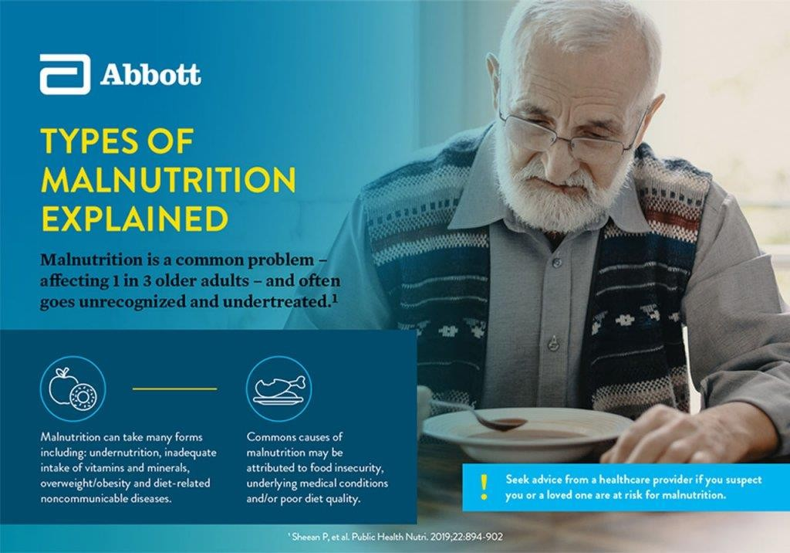

Populations at Risk of Malnutrition
Those who have limited access to nutritious, affordable, culturally relevant foods and those who experience digestion, absorption or certain metabolic issues are at risk of malnutrition. These are some high-risk populations:
  - Low-income families
  - People with a chronic illness or injury
  - Elderly people, who may lose their sense of taste as well as their ability to shop and cook

Causes of Malnutrition
Common causes of malnutrition include, but are not limited to:
  - Food insecurity. In 2021, over 10% of U.S. households were considered food insecure, meaning they reduced their food intake or changed their eating patterns due to a lack of money for food. Poverty is a double-edged sword. While it can lead to undernutrition, it can also lead to other forms of malnutrition, such as inadequate intake of

vitamins and minerals or becoming overweight or obese, since lower cost foods are often high in calories and low in key nutrients.

  - Underlying medical conditions. Hospitalized patients, those recovering from injury or illness, and those with chronic disease or metabolic issues affecting digestion or absorption will have greater nutritional needs because the demands on the body are higher. They may not be able to meet those needs, putting them at a higher risk of malnutrition. Underlying medical conditions may also affect one's ability to chew, swallow or tolerate food.

  - Poor nutrient quality. It's possible to get plenty of calories, but still have malnutrition in the form of micro nutrient deficiency. While micronutrients don't provide calories themselves, they help your body use energy from stored calorie sources and support overall health. High-caloric foods (eg, chips, candy, and soda) often contain low levels of micro nutrients. A person who eats these types of foods frequently will probably take in more calories than they need but not enough vitamins and minerals, resulting in a micro nutrient deficiency.

Signs and symptoms of malnutrition include:
  - Unintentional weight loss
  - Difficulty doing everyday tasks
  - Feeling tired from tasks that used to not be tiring
  - Thin arms and legs with swelling in the abdomen and face
  - Poor appetite
  - Hair loss
  - Dry skin or rashes
  - Frequent illness
  - Feeling cold frequently
  - High blood sugar (prediabetes) or diabetes type 2
  - Abnormal HDL, LDL and total cholesterol
  - Low or high blood pressure
Chronic diseases such as coronary heart disease, high blood pressure, stroke, diabetes type 2, overweight/obesity and micronutrient deficiency
can all be caused by poor nutrition. The Food and Drug Administration estimates that more than a million Americans die of nutrition-related health conditions each year, and research suggests 1 in every

5 premature deaths from cardiovascular disease can be prevented by improved nutrition.

How to Reduce the Risk of Malnutrition
Often, individuals with malnutrition may need extra nutritional care from their health care providers:
  - Food assistance programs. The US Department of Agriculture's Food and Nutrition Service offers several food-assistance programs — such as Women, Infants and Children (WIC), the Supplemental Nutrition Assistance Program (SNAP) and school meal programs — to help supplement the food budget of under-served families to support access to healthy food.
Oral nutritional supplements. These are an important nutritional care strategy that can fill the gaps in nutrition by providing much-needed calories, protein, vitamins and minerals. They are typically used in addition to meals when food alone is not enough to meet daily nutritional needs. Oral nutritional supplements are also important for those who have a low appetite and aren't eating enough food.
Good nutrition is the cornerstone of health. It plays a critical role in supporting recovery from diseases as well as your immune system, strength and ability to heal. If you or a loved one is concerned about a risk of malnutrition, speak with a health care provider.
List of types of malnutrition or list of nutritional disorders include diseases that results from excessive or inadequate intake of food and nutrients.

Over nutrition Metabolic
Obesity is caused by eating too many calories compared to the amount of exercise the individual is performing, causing a distorted energy balance. It can lead to diseases such as cardiovascular disease and diabetes. Obesity is a condition in which the natural energy reserve, stored in the fatty tissue of humans and other mammals, is increased to a point where it is associated with certain health conditions or increased mortality.

The low-cost food that is generally affordable to the poor in affluent nations is low in nutritional value and high in fats, sugars and additives. In rich countries, therefore, obesity is often a sign of poverty and malnutrition while in poorer countries obesity is more associated with wealth and good nutrition.
Other non-nutritional causes for obesity included: sleep deprivation, stress, lack of exercise, and heredity.
Acute overeating can also be a symptom of an eating disorder. Goitrogenic foods can cause goitres by interfering with iodine uptake.

Vitamins and micro nutrients
Vitamin poisoning is the condition of overly high storage levels of vitamins, which can lead to toxic symptoms. The medical names of the different conditions are derived from the vitamin involved: an excess of vitamin A, for example, is called "hypervitaminosis A".
Iron overload disorders are diseases caused by the over accumulation of iron in the body. Organs commonly affected are the liver, heart and endocrine glands in the mouth.

Deficiencies Proteins/fats/carbohydrates
  - Protein malnutrition
  - Kwashiorkor
  - Marasmus

Dietary minerals
  - Calcium
  - Osteoporosis
  - Rickets
  - Tetany
  - Iodine deficiency
  - Goiter
  - Selenium deficiency
  - Keshan disease
  - Iron deficiency

  - Iron deficiency anemia
  - Zinc
  - Growth retardation

Dietary vitamins
  - Thiamine (Vitamin B₁)
  - Beriberi
  - Niacin (Vitamin B₃)
  - Pellagra
  - Cobalamin (Vitamin B₁₂)
  - Vitamin B₁₂ deficiency anemia, and irreversible neurological changes
  - Vitamin C
  - Scurvy
  - Vitamin D
  - Osteoporosis
  - Rickets
  - Vitamin A
  - Night Blindness
  - Vitamin K
  - Haemophilia

- v t e

Malnutrition
Protein- energy malnutrition

Kwashiorkor Marasmus

B₁ Beriberi Wernicke–Korsakoff syndrome Wernicke's encephalopathy Korsakoff's syndrome
B₂ Riboflavin deficiency

Vitamin deficiency
B

vitamins

Other
B₃ Pellagra
B₆ Pyridoxine deficiency B₇ Biotin deficiency
B₉ Folate deficiency
B₁₂ Vitamin B₁₂ deficiency
A: Vitamin A deficiency Bitot's spots

Mineral deficiency

Growth General
C: Scurvy
D: Vitamin D deficiency Rickets Osteomalacia Harrison's groove
E: Vitamin E deficiency K: Vitamin K deficiency
Electrolyte imbalance (Calcium Chloride Magnesium Phosphate Potassium Sodium Iron Zinc
Manganese Copper Iodine Chromium Selenium Keshan disease Fluorine
Delayed milestone Failure to thrive Short stature Idiopathic Anorexia Weight loss Underweight

Nutritional Disorders
Out lines
 Introduction
 Importance of CKD program
 Nutritional assessment
 Elements of the Assessment:-
 Nursing role in nutritional assessment
 Definition of malnutrition.
 Classification of malnutrition diseases.
 Etiology of malnutrition diseases.
 Malnutrition diseases according to its severity.
- Kwashiorkor
- Marasmus
- Rickets
- Scurvy
- Obesity

Nutritional Disorders Introduction
Adequate nutrition is an essential component of growth and development, and continues to play an important part in promoting health and preventing health problems during childhood period. All children must assessed for nutritional status, followed by teaching or other interventions to health, because a reported incidence of under – nutrition about 39% of the world's preschool children and associated mortality in up to 20% of these children.
Nutrition: is the providing, to cells and organisms, of the materials necessary (in the form of food) to support life. Many common health problems can be prevented or alleviated with a healthy diet.

Purpose & aiming of nutritional assessment:-
- Early detection and treatment of nutrient deficiencies

- Facilitate caring and provide guide for the treatment of children with chronic disease, such as diabetes, hypertension, congestive heart failure, and chronic obstructive pulmonary disease.
- Nutritional assessment and screening has led to the development of new assessment tools, standards, and regulations.

Nursing role in nutritional assessment
  - The nurse plays an important role in assessing the diet for children and in seeking additional evaluation from dietitians and nutritionists in complex situations. The ability to assess a child's nutritional status using anthropometry, additional measurement that may include chest circumference, mid arm, and skin fold measurement. Also observation and history is vital, such as feeding history, but it is also as important for the nurse to have an understanding of the implications of information gained during an assessment.
  - Nurse provides the individuals who most often require ongoing nutritional counseling and intervention. Children with life- ending illnesses receiving palliative care have special nutrition support needs as well. The nutrition care of these subgroups of patients should be based on careful nutrition assessment.
  - Promoting the use of nutrition assessment in hospitals, nursing homes, and other facilities caring for children who are chronically ill.
  - Plays a role in caring for infants, children, and people who have health or dietary conditions such as anorexia, diabetes, severe food allergies, and obesity.

Nutritional Disorders Definition of malnutrition
    - A pathological state resulting from a relative or absolute deficiency or excess of one or more essential nutrients; clinically manifested or detected only by biochemical, anthropometric or physiological tests.
    - Malnutrition, defined as underweight, is a serious public-health problem that has been substantial linked to an increase in the risk of mortality and morbidity.

Classification of malnutrition diseases

- Acute malnutrition
- Chronic malnutrition
  - Specific or minor (vitamin deficiency):
e.g : Vit. C scurvy Vit. D rickets and tetany
minerals iron iron deficiency anemia

  - Non Specific or major (protein calories malnutrition)

Factors affecting malnutrition
- Improper and / or inadequate food intake
- Inadequate absorption of food
- Poor dietary habits
- Diseases
- Deficient supply of food
- Emotional factors
- Metabolic abnormalities

Calories Requirements
*First year… 110cal/kg/d
*1-3years 100cal/kg/d
*3-6years 90cal/kg/d
*6-9years 80cal/kg/d
*9-12years 70cal/kg/d

Protein:-
Requirements: *First year… 3,5gm/kg/d

*1-3years 3gm/kg/d
*3-6years 2,5gm/kg/d
*6-9years 2gm/kg/d
*9-12years 1gm/kg/d

Carbohydrates:
Requirements: - 1% of the body weight, i.e.10gm/kg/d

Ι-Vitamin and Mineral Deficiencies:
- Rickets
Rickets is a deficient disease of growing children due to a lack of fat- soluble vitamin D. Since vitamin D increases absorption of calcium and phosphorus from the gastrointestinal excretion of phosphate, lack of this vitamin leads to a disturbance of tract and decreases renal concentration of calcium, phosphorus in the blood and tissue fluids.

Predisposing factors to rickets
*Heredity: dark-skinned people living in temperate zones do not receive and adequate amount of vitamin D from the sun rays because dark is a jocks ultra –violet ray
*Age: rickets may occur at any time from 3 months to 3 years
*Artificial feeding: abreast fed infant is not likely to suffer rickets if the received adequate amount of milk
*Prematurely: premature predisposes to rickets because of the deposits of calcium and phosphorus at birth are inadequate for the infant`s exceptional rapid growth
*Lack of sunshine: window glass, clouds, fog and dust or smoke in the air filters out effective ultraviolet rays
*Season: the incidence of rickets is greatest in the later winter and early spring

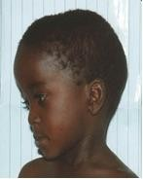

Thorax
Clinical manifestation Head
-The head appears enlarged and square
-The anterior fontanel is late in closing
-The cranial bones are soft make a cracking sound under pressure, this condition called craniotabes

-Pigeon chest (sharp –protrusion of sternum)
-Harrison`s groove (a bilateral depression at the sites where the diaphragm is attached to the ribs)
-When the infant is old enough to sit a dorsal kyphosis develops
-Scoliosis with deformities of the pelvis occur frequently

Extremities
-Bowlegs or knock knees accompanied with flat foot
-there is epiphyseal enlargement of the wrists and ankles
-Relaxation abdominal muscles and any may cause the child to be constipated
Diagnosis: investigation, clinical manifestation, history

Complications
If left untreated, rickets may lead to:
- Failure to grow
- Abnormally curved spine
- Skeletal deformities
- Dental defects
- Seizures

Treatment and prevention:
*treatment by oral administration of large dose of vitamin D, generally 1500-5000IU for about a month
*Both breast fed and bottle fed infants should receive supplemental vitamin D in maintenance of 400IU /day

Role of the nurse:
*Handle gently and turned frequently
*The diaper is applied loosely
*Put the child in correct position
*The child should be exposed to sunshine before 11am and after 3pm by 10 minute, increase frequently
*Give the child diet rich in vitamin D such as milk, butter, green vegetable; liver is good source of vitamin D
*Institute seizure precautions have 10%calcium gluconate available in case of tetany

Infantile nutritional tetany
Tetany is caused be deficiency in the intake and absorption of vitamin
D. It also result from a decrease in parathyroid activity the condition is associated with rickets, but not all the rachitic children have tetany.
Age: it occurs in age from 3months to 3 years
Clinical manifestation: are due to increased neuromuscular irritability. There are 2 stages in tetany: 1-Latent tetany 2-Manifested tetany
-In latent tetany: the child has low serum calcium level less than 7-15 mg/100ml but no obvious symptoms other than jitteriness or muscular irritability.

-In manifested tetany:

*The serum calcium level is often well under 7mg/100ml
*Muscular twitching the hand are abducted
*The wrists flexed the foot is expanded
*The toes are flexed and the sole of the foot is cupped
*The arms and legs may be abducted and flexed and there may spasm of the larynx
*Larynges spasm indicated by a high pitched cowing sound on inspiration due to spasm of the adductor muscles of the larynx to pull the vocal together if the spasm is server
*Respiration may decrease and cyanosis may occur with convulsions

Treatment:
The objective of treatment is raise the serum calcium level above that causing tetany, calcium chloride or calcium gluconate should not be given SC because of the danger of necrosis at the site of injection.
Convulsions may be controlled by therapy, sodium phenobarbital I.M.

Role of the nurses:
*Emergency intubations equipment if laryngospasm is prolonged
*Give the medication as ordered
*The nurse should be applied tongue blade available to prevent the child from biting his tongue
*Oxygen therapy should be ready in case of convulsion

Scurvy
Scurvy is due to a lack of the water –soluble vitamin C (ascorbic acid). The vitamin is destroyed by heat, alkaline solutions oxidation. Vitamin C is generally given to infant in the form of orange juice; should never be boiled. Vitamin C must come from the diet.

Etiology:
- More common 6-24 months
- May develop in breastfed infant if mother‘s diet deficient
- Improper cooking practices produce significant nutrient losses & faulty dietary habits

Clinical manifestations:
*Paralysis due to tenderness of limbs and pain produced on movements that result from sub periosteal hemorrhage
*Frog position: the hip and knees are semi flexed with feet rotated outward
*The infant becomes irritable, treat full and apprehensive
*Anemia develops due to anorexia and hemorrhage and the infant becomes pale
*There may be bluish –purple, swollen, bleeding gums and blood in vomitus and stools
*Hemorrhage may be seen in soft tissue around the eyes and petechial may appear in the skin

*Infection
Diagnosis: Through history and clinical manifestation

Complications of Scurvy
- Malabsorption of iron - because Vitamin C is important to iron absorption.
- Iron deficiency
- Anemia
- Iron deficiency anemia
- Internal bleeding
- Scorbutic dysentery (type of Dysentery)

Treatment and prevention:
In mild cases oral administration of vitamin C 50-100 mg/day may be sufficient. Normal requirement of vitamin C (old children 40mg/adolescent 45 to 60mg

In severe cases parental administration of vitamin C amounting to 200 mg or more daily is needed
Role of the nurses:
*Nursing care centers about the diet and medications
*Great gentleness in handling is necessary
*Prevention of infection is the most important
*Change the position frequently
*The mouth should be cleaned with water after each feeding
*In diapering: the infant`s buttocks may be elevated and the diaper slid under, from the side. Also, the buttocks should never be lifted by elevating legs as is customary with a well-child.


Kwashiorkor (KWO)
Decrease in sufficient quantity or quality of protein foods with adequate calories intake
Etiology:
1-Dietary cause

  - Faulty weaning

  - Poverty
  - Ignorance
2-Infections and infestation: due to a-Anorexia
- Excess catabolism
- Specific mechanisms of each disease
3-Psychological: maternal deprivation syndrome

Clinical picture:
- Constant findings:
  - Growth and development failure: weight loss may be marked by edema and excess subcutaneous fat
  - Psychosocial manifestations: apathy, misery and disinterest
  - Generalized edema: starts in the feet and spreads up till the face
  - Decreased muscle to fat ratio: due to muscle wasting and excess subcutaneous fat

Variable findings
  - Hair changes
-Light color -Straight
-Easily pluck able -Sparse 2-Skin changes
-Infection -Erythema -Hypopigmentation
-Fissures -Ulcers -Hemorrhage -Gangrene

GITmanifestations

-Anorexia -Vomiting -Diarrhea 4-Hepatomegaly: due to excess fat and glycogen deposition 5-Anemia:
-Dyshemopoietic, due to protein, iron and folic acid deficiency
-Hemorrhagic due to vitamin K deficiency
- Vitamin deficiencies: e.g. vitamins A, B2 and K

Infections: due to defects in body defenses
-Skin -Respiratory cilia -Immune system 8-Hypoglycemia and hypothermia, if severe anorexia occurs Treatment and prevention:-
- Feeding: (proteins required = 4-6gm/kg/d)

*Oral or tube feeding:
-Milk:
*Acidified skimmed, reinforced with casein or vegetable proteins
*Rich in protein, moderate CHO and low fat
*Easily digestible *Economic
*Once GIT tolerates, add vegetable oils gradually

Parenteral feeding:
*Amino acids *Plasma
*Blood (10mg/kg) in severe infection, anemia, hemorrhage or shock

Fluids and electrolytes

Correct dehydration and electrolyte imbalance, if present 3-Antibiotics
*Routinely, to eradicate hidden infections, or specifically, according to the present infection, if any
- Antiparastic: if needed
- Vitamins: A, B complex, K and Folic acid 6-Minerals: iron and zinc
- Warmth: to avoid hypoglycemia and hypothermia
- Hygiene: to avoid infections
Recent management guidelines of WHO using the high nutrient fluids

Signs of recovery:
- Alertness and interest in surroundings
- Appetite improvement
- Weight gaining
- Oedema resolution Complication and causes of death 1-Hypoglycemia
  - infection
  - Water and electrolyte imbalance
N.B. Pre – kwashiorkor: like KWO but, without edema Marasmus
Severe malnutrition in infant inadequate calories intake

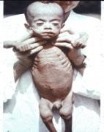
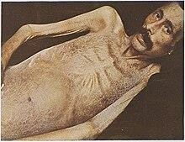
Etiology:
- Nutritional causes
*Scanty breast milk
*Diluted milk or food
*Excessive losses e.g. vomiting or diarrhea

Non Nutritional causes
*Congenital: as cleft palate, pyloric stenosis, and congenital cyanotic heart diseases
*Post corrosive stricture esophagus
*Infections and infestations
*Malignancies
*Metabolic: as diabetes mellitus and cystic fibrosis

Clinical picture:
- Hunger
*Crying, anxiety, poor sleep
*Hunger diarrhea

Growth and development retardation
Degrees: according to the degree of weight loss
* 15-25%
* 25-35%
* > 35%

Loss of subcutaneous fat
The skin is thin, wrinkled and redundant with bony prominences Degree: according to the site of weight loss
1-Abdomin 2-Buttocks and thighs 3-Cheeks (monkey face)
- Muscle wasting
- Others
*Anemia
*Peripheral cyanosis and weak pulse
*Hypoglycemia and hypothermia

Complications and causes of death: As kwashiorkor Treatment: As kwashiorkor
Obesity
Obesity is the state of being seriously overweight – to a degree that affects your health
Obesity in childhood is linked to many health complications and tends to indicate the child will be obese as an adult. It is very concerning as childhood obesity is increasing
Causes:
- Genetic factor.
- Environment factor.
- Psychological factor.
In organic obesity
- Cushing syndrome due to use of steroids.

Complications
- Type 2 diabetes.
- Metabolic syndrome.
- High cholesterol and high blood pressure.
- Asthma.
- Sleep disorders.
- Nonalcoholic fatty liver disease (NAFLD).
- Early puberty or menstruation.
Social and emotional
- Low self-esteem and bullying.
- Behavior and learning problems.
- Depression.
The effects of obesity include problems
-Joints and bones (such as slipped femoral epiphysis and bow legs)
-Intracranial hypertension that produces headaches and affects vision, hypoventilation(leading to drowsiness during the day, snoring and even heart failure), Gallbladder disease, polycystic ovary syndrome.
-High blood pressure and high levels of blood fats
-Obesity increases the risk of insulin resistance and type 2 diabetes which is normally a disease seen in later life in adults. However, increasingly children in their teens are presenting with type 2 diabetes as a consequence of being obese.
-Psychological effects leading to low self –esteem
Child's body mass index (BMI) is calculated using the same method as for adults – weight in kilograms divided by height in meters squared – but adult BMI must be not used to determine whether a child is overweight or obese. Specific age- adjusted charts are needed

Obesity treatments

If you are worried yours child is overweight, talk to your doctor and ask for help from a dietician. Avoid starting your child on an aggressive diet. Instead, make long – term changes to healthy eating for all the family and get your child involved in sport or exercise.
Aim to increase your child`s intake of fresh fruit and vegetables (they should be having at least five portions a day) and reduce fat intake. Try to find healthy snacks they like and sit down together at least once a day for a balanced meal

Iron deficiency anemia Overview
Iron deficiency anemia is a common type of anemia — a condition in which blood lacks adequate healthy red blood cells. Red blood cells carry oxygen to the body's tissues.

As the name implies, iron deficiency anemia is due to insufficient iron. Without enough iron, your body can't produce enough of a substance in red blood cells that enables them to carry oxygen (hemoglobin). As a result, iron deficiency anemia may leave you tired and short of breath.

You can usually correct iron deficiency anemia with iron supplementation. Sometimes additional tests or treatments for iron deficiency anemia are necessary, especially if your doctor suspects that you're bleeding internally.

Symptoms
Initially, iron deficiency anemia can be so mild that it goes unnoticed. But as the body becomes more deficient in iron and anemia worsens, the signs and symptoms intensify.

Iron deficiency anemia signs and symptoms may include:
- Extreme fatigue
- Weakness
- Pale skin
- Chest pain, fast heartbeat or shortness of breath
- Headache, dizziness or lightheadedness
- Cold hands and feet

- Inflammation or soreness of your tongue
- Brittle nails
- Unusual cravings for non-nutritive substances, such as ice, dirt or starch
- Poor appetite, especially in infants and children with iron deficiency anemia

When to see a doctor
If you or your child develops signs and symptoms that suggest iron deficiency anemia, see your doctor. Iron deficiency anemia isn't something to self-diagnose or treat. So see your doctor for a diagnosis rather than taking iron supplements on your own. Overloading the body with iron can be dangerous because excess iron accumulation can damage your liver and cause other complications.

Causes
Iron deficiency anemia occurs when your body doesn't have enough iron to produce hemoglobin. Hemoglobin is the part of red blood cells that gives blood its red color and enables the red blood cells to carry oxygenated blood throughout your body.

If you aren't consuming enough iron, or if you're losing too much iron, your body can't produce enough hemoglobin, and iron deficiency anemia will eventually develop.

Causes of iron deficiency anemia include:
- Blood loss. Blood contains iron within red blood cells. So if you lose blood, you lose some iron. Women with heavy periods are at risk of iron deficiency anemia because they lose blood during menstruation. Slow, chronic blood loss within the body — such as from a peptic ulcer, a hiatal hernia, a colon polyp or colorectal cancer — can cause iron deficiency anemia. Gastrointestinal bleeding can result from regular use of some over-the-counter pain relievers, especially aspirin.
- A lack of iron in your diet. Your body regularly gets iron from the foods you eat. If you consume too little iron, over time your body can become iron deficient. Examples of iron-rich foods include meat, eggs, leafy green vegetables and iron-fortified foods. For proper growth and development, infants and children need iron from their diets, too.

- An inability to absorb iron. Iron from food is absorbed into your bloodstream in your small intestine. An intestinal disorder, such as celiac disease, which affects your intestine's ability to absorb nutrients from digested food, can lead to iron deficiency anemia. If part of your small intestine has been bypassed or removed surgically, that may affect your ability to absorb iron and other nutrients.
- Pregnancy. Without iron supplementation, iron deficiency anemia occurs in many pregnant women because their iron stores need to serve their own increased blood volume as well as be a source of hemoglobin for the growing fetus.

Risk factors
These groups of people may have an increased risk of iron deficiency anemia:
- Women. Because women lose blood during menstruation, women in general are at greater risk of iron deficiency anemia.
- Infants and children. Infants, especially those who were low birth weight or born prematurely, who don't get enough iron from breast milk or formula may be at risk of iron deficiency. Children need extra iron during growth spurts. If your child isn't eating a healthy, varied diet, he or she may be at risk of anemia.
- Vegetarians. People who don't eat meat may have a greater risk of iron deficiency anemia if they don't eat other iron-rich foods.
- Frequent blood donors. People who routinely donate blood may have an increased risk of iron deficiency anemia since blood donation can deplete iron stores. Low hemoglobin related to blood donation may be a temporary problem remedied by eating more iron-rich foods. If you're told that you can't donate blood because of low hemoglobin, ask your doctor whether you should be concerned.

Complications
Mild iron deficiency anemia usually doesn't cause complications. However, left untreated, iron deficiency anemia can become severe and lead to health problems, including the following:
- Heart problems. Iron deficiency anemia may lead to a rapid or irregular heartbeat. Your heart must pump more blood to compensate for the lack of oxygen carried in your blood when you're anemic. This can lead to an enlarged heart or heart failure.

- Problems during pregnancy. In pregnant women, severe iron deficiency anemia has been linked to premature births and low birth weight babies. But the condition is preventable in pregnant women who receive iron supplements as part of their prenatal care.
- Growth problems. In infants and children, severe iron deficiency can lead to anemia as well as delayed growth and development. Additionally, iron deficiency anemia is associated with an increased susceptibility to infections.

Prevention
You can reduce your risk of iron deficiency anemia by choosing iron- rich foods.

Choose iron-rich foods
Foods rich in iron include:

- Red meat, pork and poultry
- Seafood
- Beans
- Dark green leafy vegetables, such as spinach
- Dried fruit, such as raisins and apricots
- Iron-fortified cereals, breads and pastas
- Peas
Your body absorbs more iron from meat than it does from other sources. If you choose to not eat meat, you may need to increase your intake of iron-rich, plant-based foods to absorb the same amount of iron as does someone who eats meat.

Choose foods containing vitamin C to enhance iron absorption
You can enhance your body's absorption of iron by drinking citrus juice or eating other foods rich in vitamin C at the same time that you eat high-iron foods. Vitamin C in citrus juices, like orange juice, helps your body to better absorb dietary iron.

Vitamin C is also found in:
- Broccoli
- Grapefruit
- Kiwi
- Leafy greens

- Melons
- Oranges
- Peppers
- Strawberries
- Tangerines
- Tomatoes

Preventing iron deficiency anemia in infants
To prevent iron deficiency anemia in infants, feed your baby breast milk or iron-fortified formula for the first year. Cow's milk isn't a good source of iron for babies and isn't recommended for infants under 1 year. After age 6 months, start feeding your baby iron-fortified cereals or pureed meats at least twice a day to boost iron intake. After one year, be sure children don't drink more than 20 ounces (591 milliliters) of milk a day. Too much milk often takes the place of other foods, including those that are rich in iron.
Preventing And Managing Malnutrition Nutrition Notes
Undernourished children
Weigh young children regularly and advise on feeding: a healthy child is a growing child
Most children are at greatest risk of malnutrition from the age of about six months (when they are growing fast and breast-milk alone cannot cover nutrient needs) until they are 2-3 years old (when growth slows and they can feed themselves).
Families and health workers can find out if children are well nourished or malnourished by weighing them regularly and plotting their weights on growth charts (see Figure 14). A child may:
- gain weight at the healthy rate, which means the child is almost certainly eating well and is healthy;
- gain weight too slowly or not gain any weight, which signals that something is wrong. The child may be sick and/or not eating enough;
- lose weight, which is a very dangerous sign. The child is not eating enough and is almost certainly ill;

- gain weight faster than the healthy rate, which probably means the child is catching up weight lost during an illness but can also mean that the child has a health problem that could lead to obesity.
A child is severely malnourished if there is:
- severe wasting (thinness) and/or;
- oedema of both feet.
These children are dangerously ill and need in-patient treatment immediately. Make sure they are kept warm and fed while travelling to hospital.

Undernourished children need frequent nutrient-rich meals
Health workers need to work with the family of a malnourished child to:
- find out why the child is not growing well. Discuss the feeding pattern (amount, variety and frequency of meals), appetite, behaviour and illnesses; examine the child for infections or other medical conditions; try to find the underlying causes (e.g. family food shortages; poor feeding practices; child receives insufficient care). See Introduction, page 9;
- plan together how to help the child. A family will need to:
  - feed the child better. This may mean increasing breastfeeding, improving complementary feeding, feeding more frequently and/or giving more attention during meals (see Topics 6 and 7). Discuss family beliefs on child feeding and blocks to better feeding (e.g. lack of resources, such as food, cash, time or cooking facilities). Then decide together which improved feeding practices the family is able and willing to adopt;
  - take the child for treatment if sick and learn how to prevent childhood infections in the future.

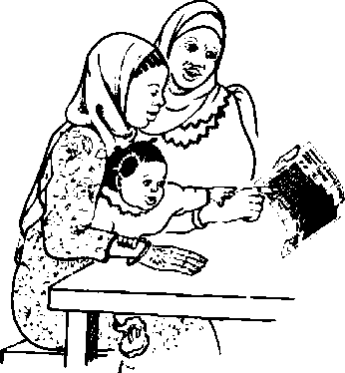

Checking that children are growing well by weighing them often
Health workers should monitor undernourished children‘s weights closely. If a family is unable to provide a healthy, balanced diet for a child, you may need to give food (enrol the child in a supplementary feeding programme) and micro nutrients (e.g. vitamin A and iron) for a while.
This must not prevent you from helping the family decide how they can feed the child better. Sometimes a family should be referred to a social worker, agricultural field worker or other community service to help deal with underlying reasons for poor nutrition.

Iron deficiency and anaemia
Advise anaemic people to eat iron-rich diets and give iron supplements if needed
Signs of anaemia are:

- low haemoglobin (<13 g/dL in men, <12g/dL in non-pregnant women and older children, <11 g/dL in pregnant women and young children and <11.5 g/dL in children aged 5-11 years);
- pale palms and inner eyelids. The main causes of anaemia are:
- lack of iron. This is often the commonest cause but other nutritional causes include lack of folate, vitamin B₁₂ and vitamin A;
- malaria, hookworm infection, other infections (such as HIV/AIDS), heavy bleeding and sickle-cell disease.
People with anaemia:
- need to know how to improve their diets so they get more iron. Improving diets means eating more iron-rich foods (especially meat, offal, poultry and fish) and foods such as fruit that increase iron absorption (see Box 6 in Topic 1). Appendix 1, Tables 1 and 3, list useful sources of iron.
- often need to be prescribed iron supplements and sometimes folate (as folic acid) and other micro nutrient supplements - in addition to a good diet. Help people to understand that they must take supplements regularly and for as long as prescribed. Explain the side effects of iron supplements, such as indigestion (which is overcome by taking supplements together with food) and black stools;
- may need treatment for other causes of anaemia, such as hookworm infection, malaria or other parasitic diseases, including schistosomiasis.

Treat all causes of anaemia
Explain to people with anaemia, or their families, how to prevent anaemia in the future by:
- having a diet rich in iron (and vitamin C, if the iron mainly comes from foods of plant origin). Iron supplements may be needed at certain times, such as during pregnancy, but these should never replace a good diet;
- preventing hookworm infection, malaria and other causes of anaemia.

Vitamin A deficiency disorders
Find out which vitamin A-rich foods are available and promote their use
Lack of vitamin A in the diet weakens the immune system, often causing people (especially children) to become ill and die. If the deficiency is severe, the eye is affected. One of the first eye signs is night blindness (inability to see at dusk and in dim light). There is likely to be a vitamin A deficiency problem in the area if the death rate for children under age 5 years is high (i.e. >50 deaths per 1 000 live births) and/or if many women were night blind during their last live pregnancy (i.e. at least 5 percent).
Families can prevent vitamin A deficiency by:
- eating foods rich in vitamin A (see Appendix 1, Tables 1 and 3). This is the best and only sustainable way to prevent vitamin A deficiency. In order to absorb vitamin A from plant foods well, the meal should contain some fat or oil. If people are unable to obtain a vitamin A-rich diet, it may be necessary to:
  - promote foods fortified with vitamin A (e.g. some oils and fats) if they are available and offer good value for money;
  - give vitamin A supplements to young children and to women within six weeks of giving birth according to national protocols. High doses of vitamin A supplements should never be given to any woman who could be pregnant because they may harm the unborn baby;
  - take children for routine immunizations to prevent infections such as measles. Children with measles often become vitamin A-deficient.
If there are eye signs of vitamin A deficiency, such as night blindness or conjunctival or corneal xerosis (dryness), the person needs urgent medical attention and vitamin A supplements.

Overweight and obesity
Overweight and obese people need less energy-rich foods, a healthy, balanced diet and more exercise

Overweight and obesity (being too fat) are other kinds of malnutrition; in both, the weight is ‗too high‘ in relation to the person‘s height. Box 18 shows how to determine if an adult‘s weight is normal.

· Body Mass Index
We use the Body Mass Index (BMI) to decide if an adult has a normal weight or is underweight, overweight or obese.
BMI = weight (kg) divided by height (m)².
For example, if a woman weighs 50 kg and is 1.5 m tall, her BMI is 50/(1.5 × 1.5) = 22.
Referring to the BMI below, 22 classifies her in the normal weight group.

Weight group BMI
Underweight less than 18.5
Normal weight 18.5-24.9
Overweight 25-29.9
Obese 30 and over
People who are overweight or obese are at risk of heart disease, hypertension and stroke, diabetes, certain types of cancers and gallbladder disease. It is most dangerous if a person has a ‗fat waist‘ (the waist is large compared to the hips).
People put on weight when they eat more food energy than they use. This usually is the case when people‘s normal lives (and work) do not involve much physical activity and their meals contain large amounts of energy-rich foods, such as fats and oils.
Although sugar is not a particularly energy-rich food (see page 21), people who are, or at risk of becoming, overweight or obese should limit the amount they eat. Sugary foods are often rich in fats and they

encourage overeating because they are sweet and therefore attractive to many people.
While overweight and obesity is normally seen as a problem of excessive food energy intake only, some health workers do not know that overweight people often also suffer from micronutrient deficiencies (in particular, vitamins A, E and C, and some B-group vitamins) because they often eat poor, unbalanced diets. This is important to note in order to advise overweight and obese people correctly (see Box 19). Not only do they need to reduce their energy intake (and/or increase their physical activity level), but they also must have healthy, balanced diets.
Obesity is a complicated, difficult-to-treat condition in which social norms and values (e.g. fat people are seen as rich people), and psychological factors also play an important role. This makes it more difficult to persuade people to change what they eat and to change their activity level.
Preventing And Managing Overweight And Obesity How to help people prevent overweight and obesity Explain the risks and causes of overweight and obesity.
Encourage people to be more physically active whenever possible (at work, play, sports). For example, to walk vigorously for at least 1/2 hour every day or to dig or dance for at least 1/2 hour three times a week.
Give advice on:
  - what to eat - plenty of fresh fruits and vegetables; lean, instead of fatty meat and fish; wholemeal cereals and pulses;
  - what not to eat - fatty and sugary foods and alcoholic drinks (e.g. 1 litre of beer provides about a tenth of a man‘s energy needs per day). Fat should supply only about a third of the energy needs; this can only be met if foods rich in fat are eaten only in smaller amounts. Remember that most of the fat in the diet is often ‗hidden‘ in foods like meat, groundnuts, milk and fried foods. The fat in plant foods and fish is usually healthier than fat in meat and milk (see Box 4 in Topic 1).

How to help fat people lose weight Explain that:
  - increasing physical activity is essential because regular exercise lowers the risk of heart disease even if there is no weight loss;
  - overweight and obese people must eat less food, especially less high- energy foods and drinks (i.e. fatty and sugary foods/drinks) at each meal. Water, instead of sugary beverages is the better choice. It is also important to eat only when hungry (e.g. avoid eating meals or snacks while watching TV). People who want to lose weight need a diet containing a variety of foods, especially plenty of vegetables and fresh fruits. Advise them to reduce the amount of beer they drink and to stop eating fatty or sugary snacks; recommend fresh fruits instead.
  - it is safer to lose weight gradually on a low-energy healthy, balanced diet than on a special slimming diet.
It is difficult for most overweight and obese people to lose weight. They need frequent, sympathetic encouragement. Never laugh at or be rude about obese people - these are serious conditions that need your help.

SHARING THIS INFORMATION ( how to assessment)
Before sharing this information with families, you may need to:
- Find out. What the common types and causes of malnutrition are, including overweight and obesity. Which types of families are most affected. What the local names and beliefs for poor growth, anaemia, vitamin A deficiency and obesity are. What type of treatment and care is given to people with different types of malnutrition by families and health workers.
- Prioritize. Decide which information is most important to share with different groups, families or individuals.
- Decide whom to reach. For example: parents and other caregivers of malnourished children; malnourished adults and their relatives; health staff and volunteers helping at clinics and with community-based growth monitoring activities.

- Choose communication methods. For example: group discussions with community groups and at clinics; feeding demonstrations; individual counselling at clinics and homes.

Examples of questions to start a discussion
(choose only one or two questions that deal with the information families need most)
If many local young children are growing slowly
How can we find out if our children are growing too slowly? Why do some children grow too slowly?
How can we help these children and their families?
What feeding advice should we share with the families of undernourished young children?
If many children and women have anaemia
Is anaemia (use local name) a problem in this place?
Do you know what causes anaemia? Emphasize the important local causes.
How can we prevent anaemia caused by hookworm, malaria, a poor diet?
Which local foods are rich in iron? How can we improve the amount of iron we absorb from food (see Topic 1, page 19)?
If many people have vitamin A deficiency disorders
What is vitamin A? What happens if a child or adult does not get enough vitamin A?
How can we prevent vitamin A deficiency disorders? Which local foods are rich in vitamin A?
If many people are overweight or obese

Which health problems are linked to overweight and obesity? How can we prevent ourselves from becoming overweight?
How can overweight and obese people lose weight? Is it easy?

Nutrition for Older Adults:
Preventing Malnutrition as the Body Ages

Although calorie needs may decrease with aging, the body‘s needs for certain nutrients can increase. Eating more nutrient-dense foods, such as kiwifruit, can help.

CONTENTS
- Key nutrients for older adults

- Changes in physical health and everyday life that affect nutrition status
- Nutrition and chronic disease
- Improving nutritional health with physical activity
- References

Our bodies need different amounts of nutrients at each stage of life for growth, maintenance and repair. Older adults experience changes due to aging that present risks for
malnutrition. These changes can lead to fatigue, memory loss, fractures, frailty and other health problems.
This guide discusses:
- Nutrients of concern for adults who are 60 and older.
- The bodily changes and physical limitations that can affect the nutritional status of older adults.
- Strategies that can help reduce risks for nutrient deficiencies.

People in this age group experience a wide variety of health conditions and physical abilities. To meet those needs, this guide includes information for a wide range of circumstances.
This information offers general guidance. For personal advice, talk with your primary care provider. Some people may also consult specialists such as registered dietitian nutritionists, physical therapists and occupational therapists.

Key nutrients for older adults Calories
Calories from fat, protein and carbohydrates provide the energy older adults need to maintain basic bodily functions and be active. As adults get older, energy needs usually decrease. This is attributed mostly to a decline in physical activity and changes in metabolism.
Some changes that come with age may make it harder to get enough calories to support energy needs. These include changes in mobility, difficulty with chewing and swallowing, and general loss of appetite.
Not getting enough calories can lead to malnutrition, nutrient deficiencies and frailty.
Although calorie needs may decrease with aging, the body‘s needs for some nutrients increase or stay the same. This can make it challenging for older adults to get all the nutrients needed without consuming too many calories.

Eat more: nutrient-dense foods
Nutrient-dense foods have higher vitamins, minerals and fiber per calorie. These foods include:
- Fruits and vegetables.
- Whole grains like oatmeal, barley and brown rice.
- Milk, yogurt and cheese.
- Seafood and lean meats.
- Poultry and eggs.
- Legumes such as beans, peas and lentils.
- Nuts and seeds.

Eat fewer: empty calories
Eat fewer foods that are high in calories and low in nutrients. These foods include:
- Sugar-sweetened drinks.
- Desserts with added sugars.
- Foods high in saturated fat like pizza and french fries.
- Refined grains.

Protein
Getting enough protein can be challenging for older adults.
Some people can't afford the high cost of meat and seafood. Others suffer dental or oral health issues that make it hard to chew or swallow. Some people experience a decreased appetite.
People who don't get enough protein can suffer from edema or decreased muscle mass. Other effects include dull skin and dry or brittle hair.
Another concern for older adults is sarcopenia, which is the loss of muscle mass. This condition can impair activities of daily living and increase the risk of falls. It is important for older adults to consume enough protein to maintain muscle.
Foods high in protein are meat, poultry, fish, shellfish, eggs, milk, cheese and yogurt. Protein is also found in grains, nuts, seeds and legumes such as beans, peas and lentils. To find out how much protein is in these foods, look at the nutrition facts labels on food packaging. Adults need
0.8 grams of protein for every 1 kilogram of body weight, or 0.36 grams for every 1 pound of body weight.
Older adults may need more protein than other adults because of changes due to aging, recovery from surgery and wound healing. Research suggests that older adults who eat protein with every meal have lower risks for protein deficiency and sarcopenia. For those reasons, older adults should try to eat 20–30 grams of protein at every meal. Table 1 includes examples of meals that have 20 grams of protein.

Calculating protein needs
Someone who weighs 160 pounds would calculate their protein needs this way:

160 pounds x 0.36 grams of protein per pound = 58 grams of protein per day

Fiber
Fiber is a type of carbohydrate. But unlike other carbohydrates, it cannot be digested. Fiber helps:
- Move food through the digestive system.
- Reduce constipation
- Improve blood glucose control
- Improve blood cholesterol levels.
Men older than 50 need 28 grams per day. Women older than 50 need 22 grams per day. Foods high in fiber include fruits, vegetables, nuts, whole grains and legumes such as beans, peas and lentils. Older adults who are not accustomed to consuming fiber should increase the amount slowly over time. Sudden increases in fiber intake can lead to gas, diarrhea and discomfort.

Fiber-rich recipes
For recipes featuring foods rich in fiber, see Food Hero resources for older adults.

Vitamin D and calcium
Vitamin D and calcium are important nutrients for older adults because of their roles in supporting bone health. People who don't get enough vitamin D and calcium can suffer from osteopenia and osteoporosis. These disorders weaken bones and increase the risk of fractures. Older adults can struggle to get enough calcium from food alone, so taking supplements may be useful for some people.
Dairy foods including milk, yogurt and cheese are the best sources of calcium. Other calcium-rich foods are broccoli, bok choy, collard greens, kale and calcium-processed tofu. Some beverages are fortified with calcium, such as fruit juices and plant-based beverages like almond milk and soy milk.
Our bodies are able to make vitamin D when our skin is exposed to sunlight. In the Pacific Northwest, older adults may not make enough from sun exposure alone. Older adults may need to get vitamin D from food and supplements.

Vitamin D occurs naturally in only a few foods such as egg yolks and fatty fish like tuna, salmon, mackerel. It is also found in fortified foods like milk, breakfast cereals and juices.
Getting too much calcium and vitamin D from supplements is harmful, so it is important not to exceed the amounts needed. Obtain these nutrients from food rather than supplements, if possible. If using supplements, take no more than 2,000 mg of calcium per day and 100 micro-grams of vitamin D per day.
Older adults taking supplements should speak with a health care provider or registered dietitian nutritionist. The provider can talk about the dose amount and interactions with other medications.

Vitamin B-12
Research estimates that up to 15% of older adults are deficient in vitamin B-12 and another 20% are at risk for deficiency. B-12 deficiency leads to macrocytic anemia and neurologic complications. Symptoms include fatigue, pale skin, loss of appetite, tingling and numbness in the limbs, gait disturbances, difficulty concentrating, memory loss, disorientation and dementia. Research also indicates that B-12 deficiency may contribute to depression, dementia and cardiovascular disease.
Many older adults lose the ability to absorb B-12, a condition called pernicious anemia. Pernicious anemia can also be caused by atrophic gastritis. This condition involves a weakening of the stomach lining and a drop in acid production, which is required for B-12 absorption.
B-12 occurs naturally in foods that come from animals, including meat, poultry, fish, shellfish, eggs, milk, cheese and yogurt. B-12 can also be found in some nutritional yeasts and fortified breakfast cereals. The amount of B-12 that can be absorbed from food during one meal is limited, so try to eat foods rich in B-12 at every meal.
People who do not consume foods that come from animals should consult a health provider. A registered dietitian nutritionist can provide information about supplements and other treatments.

Antioxidants
During normal cellular processes, compounds called free radicals can cause damage to DNA, cells and tissues. Antioxidants are substances

that neutralize free radicals in our bodies to prevent them from doing harm. Research links antioxidants to protection against cancer, heart disease and other chronic illnesses.
Vitamin C, vitamin E, copper, zinc, selenium and manganese are examples of antioxidant nutrients. Other plant-based compounds called phytochemicals act as antioxidants. These include carotenoids (beta- carotene, zeaxanthin, and lutein) and flavonoids.
Some studies have shown that antioxidant nutrients and carotenoids may help reduce the risk for or delay the progression of cataracts and age- related macular degeneration. But there is not enough evidence for supplements. Taking too much of these substances in supplements can have serious negative effects.
Deficiencies in antioxidant vitamins (vitamins C and E) and minerals (copper, zinc, selenium and manganese) can lead to cognitive impairment and potentially worsen conditions like Alzheimer‘s disease.
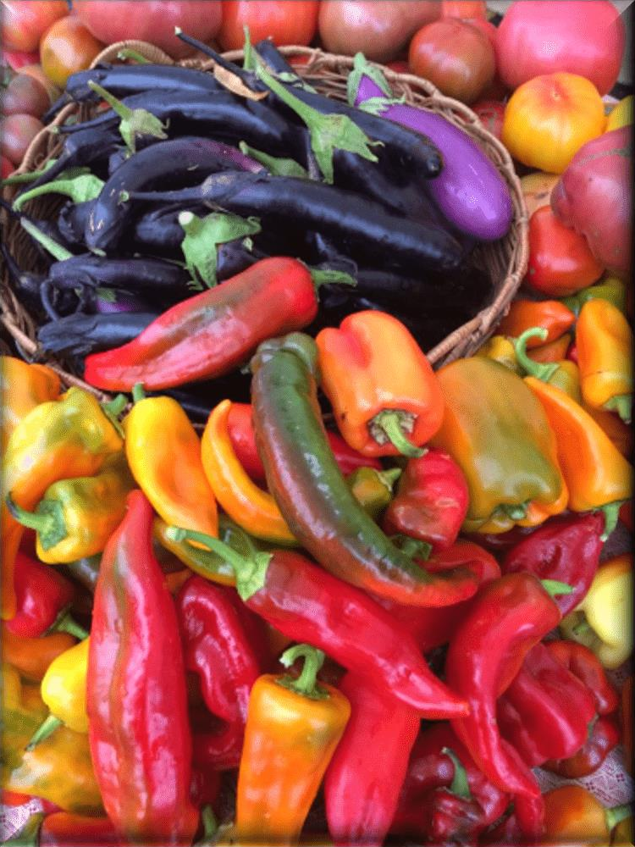
Fruits and vegetables that are red, orange and purple have high levels of antioxidants.



Fruits and vegetables that are red, orange, yellow and purple tend to be high in antioxidant phytochemicals and vitamin C. Good sources of vitamin E are whole grains, nuts, fruits and meats. Antioxidant minerals are found in meat, seafood, whole grains, fruits and vegetables.
Consuming 3–5 cups of fruits and vegetables every day will provide older adults enough antioxidant nutrients and phytochemicals. Taking additional supplements is of limited benefit, research shows.

Water
Dehydration can be an issue for older adults, especially those 85 or older. Causes include:
- Decreases in thirst sensation.
- Changes in kidney function.
- Alterations in hormone function.
- Side effects from medications.
- Prior stroke.
- Uncontrolled diabetes.
Sometimes older adults do not drink enough water because they fear arthritis pain or incontinence.
The effects of dehydration can range in severity from constipation or fecal impaction to impaired mental function, inability to maintain blood pressure and death.
Water needs vary greatly from person to person, so there is no specific recommendation for the amount of water to drink each day. One of the best indicators of
hydration is urine color — it should be light yellow to golden in color (Figure 1). If the color is dark yellow, drink more water. Urine may appear more yellow with certain medications or when taking multivitamins.
In addition to drinking water, people can get water from other beverages and food. Choose beverages low in added sugars and low in sodium. Nutrient-rich beverages like smoothies and milk also contain water. It

was once thought that people should avoid coffee and tea because of the diuretic effects of caffeine. But recent research suggests consuming these beverages in moderation supports hydration. Foods that are good sources of water include fresh fruits and vegetables, as well as soups and stews.
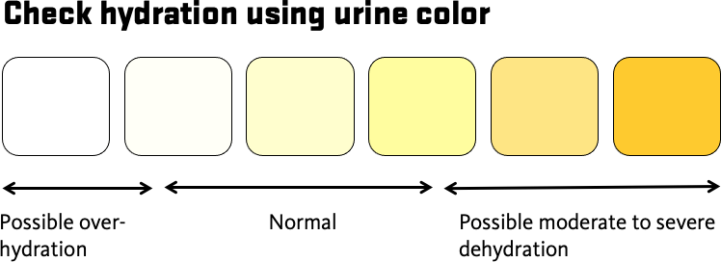

Changes in physical health and everyday life that affect nutrition status
With aging come physiological changes in body systems. A loss of muscle mass and reduced energy needs may contribute to changes in dietary needs, physical functioning and mobility. There are several strategies older adults can use to reduce the risk of malnutrition.

Difficulty chewing and swallowing
Oral conditions common in older adulthood — such as tooth loss, gum disease, ill-fitting dentures and pain from tooth decay — can create issues with chewing. Some conditions can affect the ability to swallow. These include dehydration, certain medications and loss of muscle control due to Parkinson‘s disease or dementia.
Issues with chewing and swallowing can lead people to avoid certain foods. This causes a monotonous diet and malnutrition. People commonly avoid meat and vegetables due to difficulty chewing. This can lead to numerous nutrient deficiencies.
Those who experience difficulty chewing and swallowing can choose soft protein foods like yogurt; soft-cooked or scrambled eggs; soup; smoothies; and meats that are ground, stewed and braised.

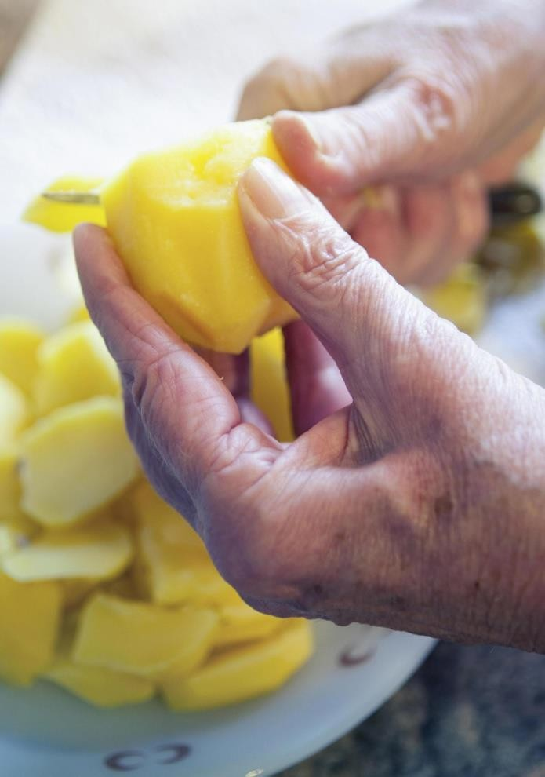

For easier swallowing, add moisture and fats such as gravy, salad dressing, olive oil and avocado. Prepare foods high in moisture like smoothies, soups and stews.

Diminishing taste and smell
Changes in smell and taste can influence the type and amount of food eaten by older adults. This diminished sense of smell and taste has been associated with a reduced interest in eating and less variation in foods. Some medications can also affect the sense of taste. This can lead to a decreased desire to eat and risk of nutrient deficiency.
Herbs and spices can boost the flavors and aromas of food. Add oregano, mint, sage, basil, rosemary, chili powder, coriander, cumin or cinnamon to enhance the eating experience. Lemon juice or other citrus can also brighten flavors. If you are limiting your sodium intake, choose herb and spice blends that do not contain salt or sodium.

Changes in mobility
Some people experience changes in physical mobility due to cognitive changes, injury, arthritis, and the loss of vision and hearing, among other conditions. This can put older adults at risk
for nutrient deficiency. They could have difficulty shopping, preparing food, cooking and eating.
Arthritis pain and other mobility limitations can make it hard to prepare food. These strategies can help:
- Use pre-cut frozen or canned vegetables.
- Prepare foods while sitting at a table.
- To fill pots for boiling, set the pot on the stove and use smaller containers to fill it.
- Use an electric can opener.
If tremors make it challenging to eat, try weighted utensils and cups to increase stability. Occupational therapists can help identify useful tools and other potential solutions.

Social isolation
Changes in mobility, limited income and other factors can lead to isolation. Isolation can increase risks for malnutrition and other health issues.
Eat with friends, neighbors or family members to stay socially engaged and support your nutritional health. Contact area agencies on aging or places of worship about home visits and congregate or delivered meals. If visiting in person is not possible, enjoy a meal with someone while talking on the phone or a video call.

Changes in digestion
Some health conditions and medications can affect digestion, including constipation, increased gas, bloating and loss of muscle control that slows the movement of food through the digestive system.
Increasing physical activity is key to a healthy gastrointestinal system. Being more active can improve function and ease symptoms. Changing your food intake to lessen symptoms can lead to nutrient deficiency. Older adults who are experiencing problems with gastrointestinal function should consult with a primary care physician or registered dietitian nutritionist to discuss strategies that can help.

Nutrition and chronic disease
Another major health concern for older adults is chronic disease, including heart disease, cancer and diabetes. Research shows that following healthy eating patterns that focus on increasing fruits and vegetables, eating lean proteins, consuming dairy and eating whole grains can reduce the risk of chronic diseases.
MyPlate.gov is a resource with information about how to follow healthy eating patterns to reduce the risk for chronic disease. Older adults with chronic disease may need additional changes to support their health, so it is important to speak with a primary care physician or registered dietitian nutritionist.

Improving nutritional health with physical activity
Being physically active has numerous nutritional benefits for older adults. The extra calories burned during physical activity increase energy requirements. This can help stimulate appetite and increase food intake. Physical activity can also help improve digestion and symptoms of constipation.

Health experts recommend older adults be active for 150 minutes per week. Choose a mixture of aerobic, balance, flexibility and strength- building movement, such as Better Bones and Balance, StrongWomen and Walk with Ease.
Those beginning an exercise program should consult a physician and increase exercise gradually.

Healthy diet
Key facts
- A healthy diet helps to protect against malnutrition in all its forms, as well as noncommunicable diseases (NCDs), including diabetes, heart disease, stroke and cancer.
- Unhealthy diet and lack of physical activity are leading global risks to health.
- Healthy dietary practices start early in life – breastfeeding fosters healthy growth and improves cognitive development, and may have longer term health benefits such as reducing the risk of becoming overweight or obese and developing NCDs later in life.
- Energy intake (calories) should be in balance with energy expenditure. To avoid unhealthy weight gain, total fat should not exceed 30% of total energy intake .Intake of saturated fats should be less than 10% of total energy intake, and intake of trans-fats less than 1% of total energy intake, with a shift in fat consumption away from saturated fats and trans-fats to unsaturated fats , and towards the goal of eliminating industrially-produced trans-fats .
- Limiting intake of free sugars to less than 10% of total energy intake is part of a healthy diet. A further reduction to less than 5% of total energy intake is suggested for additional health benefits .
- Keeping salt intake to less than 5 g per day (equivalent to sodium intake of less than 2 g per day) helps to prevent hypertension, and reduces the risk of heart disease and stroke in the adult population .
- WHO Member States have agreed to reduce the global population‘s intake of salt by 30% by 2025; they have also agreed to halt the rise in diabetes and obesity in adults and adolescents as well as in childhood overweight by 2025.

Overview
Consuming a healthy diet throughout the life-course helps to prevent malnutrition in all its forms as well as a range of noncommunicable diseases (NCDs) and conditions. However, increased production of processed foods, rapid urbanization and changing lifestyles have led to a shift in dietary patterns. People are now consuming more foods high in

energy, fats, free sugars and salt/sodium, and many people do not eat enough fruit, vegetables and other dietary fibre such as whole grains.
The exact make-up of a diversified, balanced and healthy diet will vary depending on individual characteristics (e.g. age, gender, lifestyle and degree of physical activity), cultural context, locally available foods and dietary customs. However, the basic principles of what constitutes a healthy diet remain the same.

For adults
A healthy diet includes the following:
- Fruit, vegetables, legumes (e.g. lentils and beans), nuts and whole grains (e.g. unprocessed maize, millet, oats, wheat and brown rice).
- At least 400 g (i.e. five portions) of fruit and vegetables per day ,excluding potatoes, sweet potatoes, cassava and other starchy roots.
- Less than 10% of total energy intake from free sugars , which is equivalent to 50 g (or about 12 level teaspoons) for a person of healthy body weight consuming about 2000 calories per day, but ideally is less than 5% of total energy intake for additional health benefits .Free sugars are all sugars added to foods or drinks by the manufacturer, cook or consumer, as well as sugars naturally present in honey, syrups, fruit juices and fruit juice concentrates.
- Less than 30% of total energy intake from fats . Unsaturated fats (found in fish, avocado and nuts, and in sunflower, soybean, canola and olive oils) are preferable to saturated fats (found in fatty meat, butter, palm and coconut oil, cream, cheese, ghee and lard) and trans-fats of all kinds, including both industrially-produced trans-fats (found in baked and fried foods, and pre-packaged snacks and foods, such as frozen pizza, pies, cookies, biscuits, wafers, and cooking oils and spreads) and ruminant trans-fats (found in meat and dairy foods from ruminant animals, such as cows, sheep, goats and camels). It is suggested that the intake of saturated fats be reduced to less than 10% of total energy intake and trans-fats to less than 1% of total energy intake . In particular, industrially-produced trans-fats are not part of a healthy diet and should be avoided .
- Less than 5 g of salt (equivalent to about one teaspoon) per day (8). Salt should be iodized.

For infants and young children
In the first 2 years of a child‘s life, optimal nutrition fosters healthy growth and improves cognitive development. It also reduces the risk of becoming overweight or obese and developing NCDs later in life.
Advice on a healthy diet for infants and children is similar to that for adults, but the following elements are also important:
- Infants should be breastfed exclusively during the first 6 months of life.
- Infants should be breastfed continuously until 2 years of age and beyond.
- From 6 months of age, breast milk should be complemented with a variety of adequate, safe and nutrient-dense foods. Salt and sugars should not be added to complementary foods.

Practical advice on maintaining a healthy diet Fruit and vegetables
Eating at least 400 g, or five portions, of fruit and vegetables per day reduces the risk of NCDs and helps to ensure an adequate daily intake of dietary fibre.
Fruit and vegetable intake can be improved by:
- always including vegetables in meals;
- eating fresh fruit and raw vegetables as snacks;
- eating fresh fruit and vegetables that are in season; and
- eating a variety of fruit and vegetables.

Fats
Reducing the amount of total fat intake to less than 30% of total energy intake helps to prevent unhealthy weight gain in the adult population (1, 2, 3). Also, the risk of developing NCDs is lowered by:
- reducing saturated fats to less than 10% of total energy intake;
- reducing trans-fats to less than 1% of total energy intake; and

- replacing both saturated fats and trans-fats with unsaturated fats (2, 3) – in particular, with polyunsaturated fats.
Fat intake, especially saturated fat and industrially-produced trans-fat intake, can be reduced by:
- steaming or boiling instead of frying when cooking;
- replacing butter, lard and ghee with oils rich in polyunsaturated fats, such as soybean, canola (rapeseed), corn, safflower and sunflower oils;
- eating reduced-fat dairy foods and lean meats, or trimming visible fat from meat; and
- limiting the consumption of baked and fried foods, and pre-packaged snacks and foods (e.g. doughnuts, cakes, pies, cookies, biscuits and wafers) that contain industrially-produced trans-fats.

Salt, sodium and potassium
Most people consume too much sodium through salt (corresponding to consuming an average of 9–12 g of salt per day) and not enough potassium (less than 3.5 g). High sodium intake and insufficient potassium intake contribute to high blood pressure, which in turn increases the risk of heart disease and stroke
Reducing salt intake to the recommended level of less than 5 g per day could prevent 1.7 million deaths each year
People are often unaware of the amount of salt they consume. In many countries, most salt comes from processed foods (e.g. ready meals; processed meats such as bacon, ham and salami; cheese; and salty snacks) or from foods consumed frequently in large amounts (e.g. bread). Salt is also added to foods during cooking (e.g. bouillon, stock cubes, soy sauce and fish sauce) or at the point of consumption (e.g. table salt).
Salt intake can be reduced by:
- limiting the amount of salt and high-sodium condiments (e.g. soy sauce, fish sauce and bouillon) when cooking and preparing foods;
- not having salt or high-sodium sauces on the table;
- limiting the consumption of salty snacks; and
- choosing products with lower sodium content.

Some food manufacturers are reformulating recipes to reduce the sodium content of their products, and people should be encouraged to check nutrition labels to see how much sodium is in a product before purchasing or consuming it.
Potassium can mitigate the negative effects of elevated sodium consumption on blood pressure. Intake of potassium can be increased by consuming fresh fruit and vegetables.

Sugars
In both adults and children, the intake of free sugars should be reduced to less than 10% of total energy intake . A reduction to less than 5% of total energy intake would provide additional health benefits .
Consuming free sugars increases the risk of dental caries (tooth decay). Excess calories from foods and drinks high in free sugars also contribute to unhealthy weight gain, which can lead to overweight and obesity. Recent evidence also shows that free sugars influence blood pressure and serum lipids, and suggests that a reduction in free sugars intake reduces risk factors for cardiovascular diseases .
Sugars intake can be reduced by:
- limiting the consumption of foods and drinks containing high amounts of sugars, such as sugary snacks, candies and sugar-sweetened beverages (i.e. all types of beverages containing free sugars – these include carbonated or non‐ carbonated soft drinks, fruit or vegetable juices and drinks, liquid and powder concentrates, flavoured water, energy and sports drinks, ready‐ to‐ drink tea, ready‐ to‐ drink coffee and flavoured milk drinks); and
- eating fresh fruit and raw vegetables as snacks instead of sugary snacks.

How to promote healthy diets
Diet evolves over time, being influenced by many social and economic factors that interact in a complex manner to shape individual dietary patterns. These factors include income, food prices (which will affect the availability and affordability of healthy foods), individual preferences and beliefs, cultural traditions, and geographical and environmental

aspects (including climate change). Therefore, promoting a healthy food environment – including food systems that promote a diversified, balanced and healthy diet – requires the involvement of multiple sectors and stakeholders, including government, and the public and private sectors.
Governments have a central role in creating a healthy food environment that enables people to adopt and maintain healthy dietary practices. Effective actions by policy-makers to create a healthy food environment include the following:
- Creating coherence in national policies and investment plans – including trade, food and agricultural policies – to promote a healthy diet and protect public health through:
- increasing incentives for producers and retailers to grow, use and sell fresh fruit and vegetables;
- reducing incentives for the food industry to continue or increase production of processed foods containing high levels of saturated fats, trans-fats, free sugars and salt/sodium;
- encouraging reformulation of food products to reduce the contents of saturated fats, trans-fats, free sugars and salt/sodium, with the goal of eliminating industrially-produced trans-fats;
- implementing the WHO recommendations on the marketing of foods and non-alcoholic beverages to children;
- establishing standards to foster healthy dietary practices through ensuring the availability of healthy, nutritious, safe and affordable foods in pre-schools, schools, other public institutions and the workplace;
- exploring regulatory and voluntary instruments (e.g. marketing regulations and nutrition labelling policies), and economic incentives or disincentives (e.g. taxation and subsidies) to promote a healthy diet; and
- encouraging transnational, national and local food services and catering outlets to improve the nutritional quality of their foods – ensuring the availability and affordability of healthy choices – and review portion sizes and pricing.
- Encouraging consumer demand for healthy foods and meals through:
- promoting consumer awareness of a healthy diet;

- developing school policies and programmes that encourage children to adopt and maintain a healthy diet;
- educating children, adolescents and adults about nutrition and healthy dietary practices;
- encouraging culinary skills, including in children through schools;
- supporting point-of-sale information, including through nutrition labelling that ensures accurate, standardized and comprehensible information on nutrient contents in foods (in line with the Codex Alimentarius Commission guidelines), with the addition of front-of-pack labelling to facilitate consumer understanding; and
- providing nutrition and dietary counselling at primary health- care facilities.
- Promoting appropriate infant and young child feeding practices through:
- implementing the International Code of Marketing of Breast- milk Substitutes and subsequent relevant World Health Assembly resolutions;
- implementing policies and practices to promote protection of working mothers; and
- promoting, protecting and supporting breastfeeding in health services and the community, including through the Baby-friendly Hospital Initiative.

Nutritional Needs During Pregnancy and Breastfeeding
Pregnancy and breastfeeding are the most nutritionally demanding times of a woman's life. The body needs enough nutrients every day to maintain its needs and also to support the growth of a baby. All of the nourishment the developing baby needs comes from mom, either through the foods she eats or the supplements she takes. Pregnant and breastfeeding women need more nutrients than other women. It is important to consume balanced meals that have a variety of foods, including fruits and vegetables, whole grains, lean protein and low- fat dairy products. MyPlate has recommendations for pregnant and breastfeeding women

The recommendations help moms choose healthy and nutrient-dense foods to meet their needs and those of their unborn child. Nutrient-

dense foods are packed with more nutrients for the calories than other foods that are mostly calories with few nutrients. Personal daily needs will vary depending on the mother's weight before pregnancy, activity level and if mom is expecting or has delivered multiple babies. In addition, pregnant women may need to take a prenatal vitamin and mineral supplement to ensure adequate intake of specific vitamins such as folic acid, iron and calcium.
Folate is essential because it reduces the risk of a baby being born with spinal cord birth defects. It is important to consume 400 micrograms per day of folic acid before pregnancy, and 600 micrograms per day during pregnancy. Breastfeeding women need
500 micrograms per day. Foods such as broccoli, dark green vegetables and oranges are high in folic acid.
Iron is needed to prevent iron-deficiency-related anemia. Pregnant women need about 27 milligrams per day. The need for iron declines after birth, but women who are breastfeeding still require about 10 milligrams per day. Fortified cereals, green leafy vegetables, beans and lean meat are good sources of iron.
Calcium is needed by your baby for strong bones and a healthy heart, muscle system and nervous system. If calcium is not supplied by the mother's diet, calcium is taken from the mother's bones for the baby. Pregnant and breastfeeding women 19 years and older need around 1,000 milligrams per day, and women under 19 years of age need 1,300 milligrams per day.
A good diet takes planning. Pregnant women should make sure they eat a variety of foods from each food group. This will provide enough calories for adequate weight gain.

Weight Before Pregnancy | Suggested Weight Gain
Underweight (BMI < 18.5) | 28–40 pounds
Normal Weight (BMI 18.5–24.9) | 25–35 pounds
Overweight (BMI 25.0–29.9) | 15–25 pounds
Very Overweight (BMI > 30.0) | 11–20 pounds

Besides nutrition, there are lifestyle choices that can also affect the health of both the mother and the baby. It is important for pregnant women to do all of the following: ensure that the foods they consume are safe; incorporate physical activity into their daily lives; and avoid consuming alcohol.
Tips for Healthy Eating During Pregnancy and Breastfeeding
- Eat a variety of foods.
- Choose foods higher in fiber such as fruits, vegetables, dry beans, whole-grain breads and cereals, and other whole-grain products.
- Exercise in moderation, on a regular basis (ask your doctor).
- Drink plenty of fluids (approximately 3,000 milliliters per day or 12 eight-ounce glasses for pregnant women, and approximately 700 milliliters more for breastfeeding women).
- Eat 3–5 meals and snacks per day.
- Pregnancy and breastfeeding increase the need for calories and most nutrients. Most women who are pregnant or breastfeeding (and are a healthy weight) might need an additional 300–500 calories per day to provide the extra energy the body needs. Three hundred calories is equal to a regular snack, such as half of a peanut butter and jelly sandwich and a glass of 1% milk.
- The amount of suggested weight gain during pregnancy depends upon weight before pregnancy. Check with a doctor to find the amount that is right for you.
- While nursing, avoid restrictive weight loss diets. Losing 2 –4 pounds a month will not affect your milk supply, but losing more than 4–5 pounds a month after the first month is not recommended. General Meal Plans
Below are general meal plans based on MyPlate. Your needs might vary from this plan.

Pregnant Women
Food Group | 1st Trimester | 2nd and 3rd Trimesters |  | What Counts as 1 Cup or Ounce?
Vegetables | 2.5 cups | 3 cups |  | 1 cup raw or cooked vegetables or 100% juice  2 cups raw, leafy vegetables
Fruits | 2 cups | 2 cups |  | 1 cup fruit or 100% juice  ½ cup dried fruit
Grains | 6 ounces | 8 ounces |  | 1 slice bread  1 ounce read-to-eat cereal  ½ cup cooked pasta, rice or cereal
Dairy | 3 cups | 3 cups |  | 1 cup milk  8 ounces yogurt  1.5 ounces natural cheese 2 ounces processed cheese
Protein | 5.5 ounces | 6.5 ounces |  | 1 ounce lean meat, poultry or seafood  ¼ cup cooked beans  ½ ounce nuts or 1 egg  1 tablespoon peanut butter
Breastfeeding Moms
Food Group | Breastfeeding Only |  | Breastfeeding Plus Formula |  | What Counts as 1 Cup or Ounce?
Vegetables | 3 cups |  | 2.5 cups |  | - cup raw or cooked vegetables or 100% juice  - cups raw, leafy

 |  |  | vegetables
Fruits | 2 cups | 2 cups | 1 cup fruit or 100% juice  ½ cup dried fruit
Grains | 8 ounces | 6 ounces | 1 slice bread  1 ounce read-to-eat cereal  ½ cup cooked pasta, rice or cereal
Dairy | 3 cups | 3 cups | 1 cup milk  8 ounces yogurt  1.5 ounces natural cheese  2 ounces processed cheese
Protein | 6.5 ounces | 5.5 ounces | 1 ounce lean meat, poultry or seafood  ¼ cup cooked beans  ½ ounce nuts or 1 egg  1 tablespoon peanut butter

High blood pressure and diet

Making changes to your diet is a proven way to help control high blood pressure. These changes can also help you lose weight and lower your chance of heart disease and stroke.
Your health care provider can refer you to a dietitian who can help you create a healthy meal plan. Ask what your blood pressure target is. Your target will be based on your risk factors and other medical problems.
DASH DIET
The low-salt Dietary Approaches to Stop Hypertension (DASH) diet is proven to help lower blood pressure. Its effects on blood pressure are sometimes seen within a few weeks.
This diet is rich in important nutrients and fiber. It also includes foods that are higher in potassium, calcium, and magnesium and lower in sodium (salt) than the typical American diet.
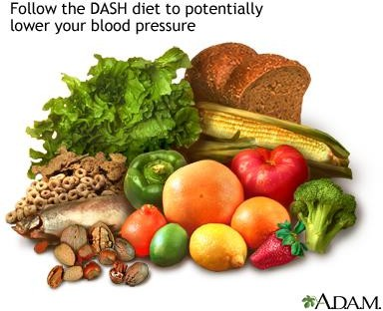
The goals of the DASH diet are:
- Limit sodium to no more than 2,300 mg a day (eating only 1,500 mg a day is an even more effective goal).

- Reduce saturated fat to no more than 6% of daily calories and total fat to 27% of daily calories. Low-fat dairy products appear to be especially beneficial for lowering systolic blood pressure.
- When choosing fats, select monounsaturated oils, such as olive or canola oil.
- Choose whole grains over white flour or pasta products.
- Choose fresh fruits and vegetables every day. Many of these foods are rich in potassium, fiber, or both.
- Eat nuts, seeds, or legumes (dried beans or peas) daily.
- Choose modest amounts of protein (no more than 18% of total daily calories). Fish, skinless poultry, and soy products are the best healthy protein sources.
Other daily nutrient goals in the DASH diet include limiting carbohydrates to 55% of daily calories and dietary cholesterol to 150 mg. Try to get at least 30 grams (g) of daily fiber.
Check with your provider before you increase the potassium in your diet or use salt substitutes (which often contain potassium). People who have kidney problems or who take certain medicines must be careful about how much potassium they consume.
HEART HEALTHY DIET
Eat foods that are naturally low in fat. These include whole grains, fruits, and vegetables.
- Look at food labels. Pay special attention to the level of saturated fat.
- Avoid or limit foods that are high in saturated fat (more than 20% of the total fat). Eating too much saturated fat is one of the major risk factors for heart disease. Food high in this type of fat include: egg yolks, hard cheeses, whole milk, cream, ice cream, butter, and fatty meats (and large portions of meats).
- Choose lean protein foods. These include soy, fish, skinless chicken, very lean meat, and fat-free or 1% fat dairy products.

- Look for the words "hydrogenated" or "partially hydrogenated" on food labels. Do not eat foods with these ingredients. They are very high in saturated fats and trans fats.
- Limit how much fried and processed foods you eat.
- Limit how many commercially prepared baked goods (such as donuts, cookies, and crackers) you eat. They may contain a lot of saturated fats or trans fats.
- Pay attention to how foods are prepared. Healthy ways to cook fish, chicken, and lean meats are broiling, grilling, poaching, and baking. Avoid adding high-fat dressings or sauces.
Other tips include:
- Eat foods that are high in soluble fiber. These include oats, bran, split peas and lentils, beans (such as kidney, black, and navy beans), some cereals, and brown rice.
- Learn how to shop for and cook foods that are healthy for your heart. Learn how to read food labels to choose healthy foods. Stay away from fast food restaurants, where healthy choices can be hard to find.

Healthy Eating for Diabetes
What is diabetes?
Diabetes is when your blood sugar (glucose) levels are higher than normal. This is because your body isn‘t making enough insulin, or any insulin at all.
After you eat, insulin helps the sugar in your blood move into your cells. This gives you energy.
A healthy lifestyle, including healthy eating can reduce your risk of developing other health conditions such as eye, heart, and kidney diseases.

Healthy eating to manage diabetes
The ideas below can help you to manage your diabetes. If you‘re ready to make a change, you can choose what works best for you.
Eat 3 meals a day. Space meals 4 to 6 hours apart. Spreading your food over the day helps manage blood sugar.
Snacks may reduce hunger between meals. Include snacks if they help you eat smaller portions at your next meal.
Spread carbohydrates over the day. Your body uses carbohydrate foods for energy. Carbohydrate foods raise your blood sugar. Spreading them over the day helps manage blood sugar.
Carbohydrate foods:

  - grains (wheat, oats, rice, barley, rye)
  - foods made
from grains (bread, tortillas, bannock, naan, roti, pasta, cereal)
  - beans, lentils, split peas
  - fruits
  - starchy vegetables (potatoes, yams, corn, green peas, squash, parsnips)
  - milk
  - yogurt
  - sweet foods, desserts
  - sugar (table sugar, honey, and molasses)

Eating a variety of carbohydrate foods can help you get enough calories

(energy), fibre, vitamins, and minerals.

Fill your plate like the one below to spread carbohydrates over the day.
    - Cover ½ of your plate with non-starchy vegetables. Some non-starchy vegetables are broccoli, bell peppers, carrots, cucumbers, and dark leafy greens. A portion of fruit the size of a tennis ball, or ½ cup (125 mL) may also be included in this part of the plate.
    - Put whole grains and starchy vegetables on ¼ of your plate. Some starchy vegetables are potatoes, yams, corn, squash, and parsnips.
    - Put protein foods on ¼ of your plate. Some protein foods are meats, fish, eggs, Greek yogurt and tofu.

Portion sizes
Choosing healthy portions of food can help you manage your diabetes. Below is a handy guide to help you choose portion sizes.
    - Use your fist to guide your portions of grains, starchy vegetables, and fruit. A portion is often ½ cup (125 mL) to 1 cup (250 mL).
    - A portion of non-starchy vegetables can be as much as you could hold in

both hands. 
    - Use the palm of your hand to guide your portions of meat, fish, or poultry. 
    - A portion of milk is 1 cup (250 mL). A portion of plain or no sugar- added yogurt is ¾ cup (175 mL). 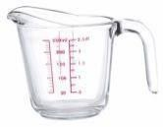

Eat more fiber
Eating fibre helps you manage your blood sugar levels. Fibre at each meal slows the movement of sugar into your blood. This helps to keep blood sugar from rising too high after eating.
Eating more fibre may also help lower your risk of heart disease. Aim to eat 30 grams (g) of fibre or more each day.
Read the Nutrition Facts table on food packages to find foods higher in fibre. The higher the % Daily Value the more fibre is in one serving.

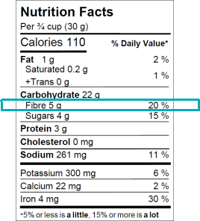

Use the tips below to eat more fiber:
    - Choose whole grain breads, cereals, crackers, whole wheat pasta, whole wheat couscous, quinoa, barley, oats, and brown rice.
    - Sprinkle 1-2 tbsp (15-30 mL) high fiber cereal (4 g of fiber or more per serving) on yogurt, applesauce, salads, casseroles.
    - Eat legumes such as split peas, beans, and lentils often. Add them to soups, casseroles, salads, and spaghetti sauce.
    - Choose vegetables or fruit at every meal and snack.
    - Eat these fruits more often: apples, oranges, berries, pears, cherries, plums.
Drink more fluid when you increase the amount of fibre you eat. Drink at least 9–12 cups (2.25–3 L) of fluid each day. Choose water, unsweetened
coffee or tea, and other sugar–free beverages.

Limit sweet foods and foods with added sugar
Sweet foods and foods and beverages with added sugar quickly raise blood sugar. Use the tips below to reduce the amount of added sugar you eat or drink:

    - Drink water most often.
    - Choose water or sugar-free drinks instead of juice or drinks with added sugar like regular pop, iced tea, and sugar-sweetened coffee and tea drinks.
    - Choose whole fruit instead of juice.
    - Limit sugar, jam, honey, desserts, candy, syrups, and sweet sauces.
    - To sweeten foods like coffee, tea, baking, jams, jellies, and syrups, you can use low-calorie or no- calorie sugar substitutes. Ask your dietitian about using sugar substitutes.

Limit salt intake
    - Eat less processed and packaged foods.
    - Read the Nutrition Facts tables on food labels to find foods lower in sodium. Choose foods with a lower % Daily Value. 5% is a little, 15% is a lot.
    - Add little or no salt when cooking or to food at the table.
    - Choose no salt added or salt–free canned goods.
    - Use herbs and spices for flavouring instead of salt.

Limit alcohol intake
Drinking less alcohol is better for your health.
Alcohol is high in calories. If you choose to drink alcohol, limit higher sugar drinks like coolers, liqueurs, dessert wines, and mixed drinks.

Choose unsaturated fats
People with diabetes are more likely to get heart disease. Eating more unsaturated fat and less saturated fat can decrease your risk.
Replace saturated fats with unsaturated fats like the ones listed below:
    - oils: olive, canola, peanut, sunflower
    - soft margarine
    - avocado, nuts and seeds, and nut butters
    - ground flax seeds, chia seeds, or hemp seeds
    - fish instead of other animal proteins

Use the tip of your thumb to guide your portions of oils and fats at

meals.

Choose less saturated fat
Saturated fat may increase your risk of heart disease. Choose these less often:
    - cream and ice cream
    - coconut oil, lard, butter, and hard margarine
    - processed meat like bacon, wieners, deli meat, and sausage
    - deep fried foods
    - snack food like chips, salty snacks, baked goods, cookies, donuts, chocolate bars
    - processed cheese and cheese spreads

Be active
Activity helps to lower blood sugar by helping the body use sugar for energy.
    - Be active for at least 30 minutes each day, 5 to 7 days a week.
    - Start with a few minutes a day and build up to 30 minutes.
    - Aim for at least 150 minutes (2½ hours) a week of activities that make your heart beat faster, like brisk walking, swimming, bike riding, sports, or running. You should breathe faster but still be able to talk.
      - On at least 2 days of the week do muscles strengthening activities using major muscle groups such as lifting weights, using resistance bands, or sit ups, squats, and wall push-ups.
If you haven‘t been active for a long time, talk to your doctor about your activity plans before you start.

As well as being active 150 minutes a week, it’s important to break up sitting time.
Sitting time is time watching TV, playing video games, using the computer at home or work, reading, and doing homework.
Plan to get up and move if you are sitting for more than 30 minutes at a time without moving.

Weight and diabetes

Carrying extra weight can make it harder to manage your diabetes. This handout contains many lifestyle choices for your weight and health. For support with weight and health talk, to your dietitian or doctor.

Next steps
This handout includes lifestyle choices that can help you manage your diabetes. Change can be hard, especially if you try to make too many changes at once. Ask your healthcare provider if you would like support with goal setting.

Sample meal ideas
The meal ideas on this page and the next page show how you can eat to manage your diabetes. These are samples only; they don‘t replace the advice of your healthcare team. Choose the small or large meal plan based on your appetite. Drink water throughout the day.

Smaller Meal Plan | My Meal Plan
Breakfast
1 whole grain English muffin 1 cup (250 mL) milk
1 egg scrambled with:
½ ounce (15 g) cheddar cheese
½ cup (125 mL) onions, tomato, mushrooms
Lunch
1 cup (250 mL) lentil soup
3-4 whole grain crackers (30 g)
¾ cup (175 g) plain or no sugar added yogurt
½ cup (125 mL) carrots
Supper
2½ ounces (75 g) baked salmon
⅔ cup (150 mL) brown rice, cooked
1 cup (250 mL) steamed green beans 1 tsp (5 mL) soft margarine
½ cup (125 mL) sliced tomatoes 1 small pear

Snacks
If you need help to keep portions smaller at meals, you may need a small snack between meals.

Snacks for a smaller meal plan (each bullet is one snack)
- 1 apple, sliced, with cinnamon • ¾ cup (175 mL) yogurt, plain or
- 3 cups (750 mL) plain popcorn with dill or no sugar added
Italian herbs • 1 cup (250 mL) milk or fortified
- 1 cup (250 mL) carrots, celery, cucumbers unsweetened soy beverage
with 2 Tbsp (30 mL) ranch dressing or ¼ • ¼ cup (60 mL) low sodium cup (60 mL) hummus cottage cheese with
- 3-6 (30 g) whole grain or rye crackers ½ cup (125 mL) pineapple
chunks, drained
Larger Meal Plan | My Meal Plan
Breakfast
1½ cups (375 mL) cooked oatmeal 2 Tbsp (30 mL) ground chia seeds Pinch of cinnamon
½ cup (125 mL) berries 1 cup (250 mL) milk
Lunch
Chicken sandwich with:
2 slices of whole grain bread
2½ ounces (75 g) chicken breast, sliced 1 ounce (30 g) mozzarella cheese
¹¤6 avocado, sliced
½ cup (125 mL) lettuce 1 Tbsp (15 mL) mustard
½ cup (125 mL) cucumber, sliced 1 cup (250 mL) milk
1 medium apple
Supper

2½ ounces (75 g) lean steak
1 cup (250 mL) baked yams or sweet potato
½ cup (125 mL) roasted cauliflower
1 cup (250 mL) mixed greens
2 Tbsp (30 mL) sunflower seeds
1 Tbsp (15 mL) dressing
1 cup (250 mL) milk
15 grapes or 1 cup (250 mL)

Snacks
If you need help to keep portions smaller at meals, you may need a small snack between meals.

Snacks for a larger meal plan (each bullet is one snack)
- 1 cup (250 mL) carrots, celery, cucumbers | - ¾ cup (175 mL) plain Greek
with | yogurt with ½ cup (125 mL)
¼ cup (60 mL) hummus | sliced strawberries, and ⅓ cup
- 2-3 rye crackers and 1 ounce (30 g) cheese | (75 mL) high fibre cereal
- 1 slice of whole grain toast with 1 Tbsp | - 1 (30 g) high fibre granola bar (4
(15 mL) nut butter, and ½ banana sliced | g of fibre or higher)
on top | - ½ tuna sandwich
- ¼ cup (
- 60 mL) unsalted nuts

Adverse reactions to food Food intolerance and Food Allergy Definition:
An adverse food reaction is defined as any abnormal clinical response that occurs following ingestion of a food or food component. It may be the result of food poisoning, food allergy or intolerances.

Adverse food reaction
1-nontoxic 2- toxic
immune mediated Food poisoning

Food Allergy
- non immune mediated

Food intolerance
Natural substances in foods that can cause adverse reaction:
Food additives: and colorings may cause an acute flare up of allergic reactions.
Additives include Monosodium glutamate (MSG), benzoates, salicylates, sulphites, and tartrazine and other coloring:

Monosodium glutamate (MSG)
  - May be responsible for Chinese restaurant syndrome
- Vasoactive amines such as tyramine, serotonin and histamine
  - Present naturally in: pineapples, bananas, baked meat, vegetables, red wine, avocados, chocolate, citrus fruits and mature cheese.
  - -Salicylates are natural aspirin like compounds
  - Present in a wide variety of herbs, spices as well as fruit and vegetables.

Sulfites
  - Sulfite sensitivity occurs most often in asthmatic adults & may be

life threatening.

Strict avoidance is advised in asthmatic people with sulfite allergy.
  - Greater than 10 ppm of sulfites present in:
  - dried fruits
  - bottled lemon juice
  - molasses
  - grape juices

Food intolerance
Definition:

Food intolerance is difficulty in digesting certain foods.
Usually result from deficiency of enzyme needed for metabolism of certain food this can lead to gastrointestinal symptoms such as gases, abdominal pain or diarrhea.
Food intolerance is sometimes confused with a serious condition; Food Allergy.

Lactose intolerance
Lactose is a sugar found in milk and dairy products. It needs lactase enzymes for its digestion. Lactose intolerance is caused by a lack of lactase enzymes.
Symptoms: include
- Gases &Bloating
- Diarrhea
- Abdominal pain

Management:
People with lactose intolerance should avoid dairy products like milk and ice cream.
Fermented products such as yogurt& kefir may be easier to tolerate, as they contain less lactose than other dairy products

There is a very serious difference between being intolerant to a food and having a food allergy.

Food Allergy (FA) Definition:
Food Allergy is an abnormal immune response to a dietary protein (or polysaccharide)
A food allergic reaction involves the immune system. The immune system overreacts by producing specific Immunoglobulin E (IgE) antibodies.
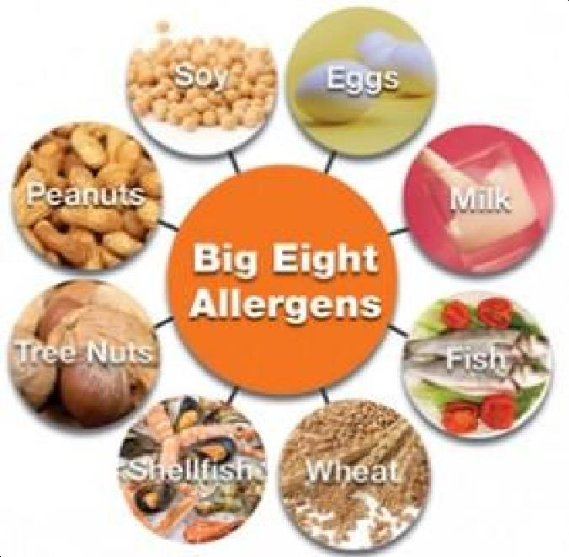
These antibodies travel to cells that release chemicals, causing an allergic reaction. Food allergy can cause a serious or even life-threatening anaphylactic reaction by eating a very small amount, touching or inhaling the food.

Food allergens
  - Any food can provoke allergic reactions.
  - The most common food allergy sources, responsible for up to 90% of IgE- mediated food allergic reactions, are the proteins in cows‗ milk, eggs, peanuts, wheat, soy, fish, shellfish, and tree nuts

(The Big Eight) figure 4-1.
  - Other food allergens include mustard, celery, sesame seeds and sulphur dioxide.

Children often outgrow allergies to milk, eggs, soybean products and wheat, typically between 3 and 8 years of age.

  - Children rarely grow out of allergies to peanuts, tree nuts, fish or shellfish.
  - Peanut was the allergen most frequently associated with anaphylactic food reactions, followed by tree nuts/seeds (including sesame).

The most common food allergens in children are:
- Milk
- Eggs
- Peanuts
Children may outgrow their allergic reactions to milk and to eggs. Peanut and tree nut allergies are likely to persist.

The most common food allergens in adults are:
- Fruit and vegetable pollen (oral allergy syndrome)
- Peanuts and tree nuts
- Fish and shellfish
Peanuts, tree nuts, fish and shellfish usually persist

Symptoms of food allergy:

Anaphylaxis
◻ Anaphylaxis is a severe systemic reaction to allergen ( such as nuts, bee stings or drugs), body-wide degranulation of mast cells leads to release of histamine and other mediators that cause vasodilatation and, if severe, symptoms of life Threatening shock .

 | Food intolerance | Food allergy
Cause | Deficiency of certain enzyme
Age of onset | Starts at any age | Usually in infants Could start at any  age
Amount of  food that cause symptoms | Dose related | Small amount may cause severe reaction

Onset of symptoms | Typically occurs several  hours after ingesting the causative food | Usually within few minutes to 2 hours
Symptoms | Usually gastrointestinal symptoms such as: intestinal gas, abdominal pain or diarrhea. | Skin Gastrointestinal Respiratory
Life threatening | NO | May cause  anaphylaxis
Prevention& Treatment | Diminish the amount of causative food | Elimination of causative food
Examples of Most common causative foods | Lactose, fructose, wheat | The big eight ( Milk, Egg, wheat, Soy, tree nuts,  peanut, fish & shellfish)

Table (1) Food intolerance versus food allergy

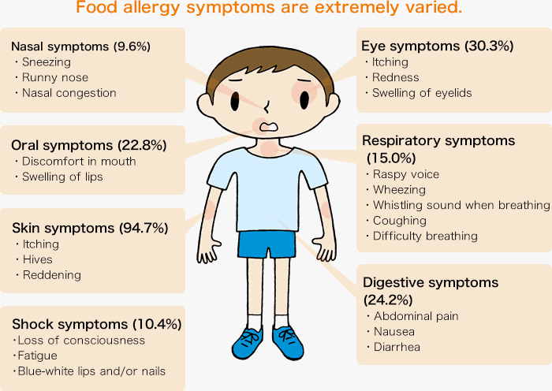
Foods that cause the majority of severe or anaphylactic reactions include: Peanuts, Tree Nuts, Fish& Shellfish

- Severe allergic reaction to a food usually develop within one hour from food ingestion
- Severe and fatal reactions can occur at any age and even upon first known exposure to a food, but those at greatest risk for fatal food- induced anaphylaxis appear to be adolescents and young adults with asthma and a known food allergy to peanut, tree nut or sea food
Management: Any person experienced severe food allergies, should have an epinephrine (adrenaline) injection at all times. In case of having a severe reaction, an immediate intramuscular injection of epinephrine and send out to emergency ward

Exercise-induced food allergy
- As the body is stimulated by exercise, a person with an exercise- induced food allergy may feel itchy and lightheaded.
- In severe cases, it can cause reactions such as hives or anaphylaxis.
- Food Triggers: wheat, shellfish, and nuts are noted as the most common food triggers. Less commonly reported food triggers include meat, vegetables, fruit, seeds, and cereals.
- The time between food ingestion and exercise about 30 to 120 minutes
- Drinking alcohol or taking a non-steroidal anti-inflammatory drug (NSAID) such as aspirin or ibuprofen may also trigger an allergy in people with this syndrome.
- Prophylaxis is by avoidance of taking foods, alcohol, aspirin or other NSAID for 2 hours before exercise.
Asthma & Food Allergy

Food-induced asthma symptoms should be suspected in patients with refractory asthma and history of:
atopic dermatitis
gastro esophageal reflux GERD
food allergy or feeding problems in infant,

history of positive skin tests or reactions to food

Individuals with food allergies who also have asthma may be at increased risk for severe or fatal food allergy reactions.
Management of food allergy:
AVOIDANCE is the only way to prevent an allergic reaction.

In food Allergy,avoid:
The offending allergen
- Foods containing additives
- Foods containing artificial colors
- Canned foods
- Hidden food allergens
- Hidden food allergens: Some food allergens are masked and may be taken un-noticed, they include:
- Spices: Mustard, pepper, sesame.
- Legumes and tree nuts, Peanut& soy.
- Milk protein (protein supplements): Casein, caseinates.
- Vaccines
- Kitchen tools.
- Volatile allergens.
- Parasitized food such as:
- Mites in flour ( pasta, pizzas)
- Anisakis simplex in fish.

Recommendation
- Food allergies at any age require:
1. Increase the awareness of food allergies
2. Strict attention to food eaten,
3. Careful reading of food labels,
4. Knowing food allergen derivatives, e.g.: butter is a milk product& mayonnaise is derived from egg.
5. Learning how to be extremely specific when eating out.
6. How to expect and manage allergic reactions.

- Even healthy natural foods can have adverse effect if a person is allergic to them.
- We can develop allergy even for foods we used to consume.
- The following foods are highly allergenic, to be careful with: dairy products, eggs, nuts, peanut, wheat, Soy, Fish &shellfish. Bananas, beef products, chocolate, citrus fruits, corn, oats, processed and refined foods, strawberries & tomatoes.

Children can outgrow many food allergies by the age of 10.
- Allergy to peanut, tree nut, or seafood usually outstand for life and may cause severe reactions.
- Egg white is more allergenic than egg yolk.
- Oils made from ingredients that cause allergy to some persons, should be avoided by them.
- Avoid any food products that contain artificial color or any other food additives.
- Cooking can destroy a number of the allergens in fruits and vegetables. However, the allergens in some vegetables, such as celery, aren't affected by cooking.
- Cooked meat is less likely to cause a problem with those with cow‗s milk allergy.
- Many people with milk and egg allergies can tolerate extensively heated milk and egg in baked foods.
- Newer processing techniques, such as high-pressure treatment of foods, fermentation and enzyme treatment, can help to reduce the allergen city of some food proteins.
- A food allergy management plan is needed for all persons with food allergy, and should include the need for an Epinephrine vials.

In milk allergy:
Avoid foods that contain milk or any of these ingredients:

- Milk (in all forms including condensed, derivative, dry, evaporated, goat‗s milk and milk from other animals, low-fat, malted, milk fat, non-fat, powder, protein, skimmed, solids, whole)
- Butter, butter fat, butter oil, butter acid, butter ester(s)
- Casein(in all forms)
- Cheese
- Cream
- Custard
- Ghee
  - Lactalbumin, lactalbumin phosphate Avoid other Possible Sources of Milk:
- Artificial butter flavor
- Baked goods
- Caramel candies
- Chocolate
- Lactic acid starter culture and other bacterial cultures
- Luncheon meat, hot dogs and sausages, which may use the milk protein casein as a binder.
- Margarine
- Non-dairy products, as many contain casein
- Some products made with milk substitutes (soy-, nut- or rice-based dairy products) are manufactured on equipment shared with milk.
- Many restaurants put butter on grilled steaks to add extra flavor.
- Some medications contain milk protein.

Exercise
- Plan diet menu for a one year old child with cow's milk allergy.
- Plan diet menu for a 3 years old child with multiple allergy for milk, egg, chicken and peanut.

Gluten disorders What is gluten?
Gluten is a protein found in grains, such as wheat, barley and rye. Several conditions relate to gluten, including:

  - Gluten intolerance
  - Wheat allergy.
  - Celiac disease

Gluten intolerance
Gluten intolerance is the body‗s inability to digest the gluten protein found in wheat and certain other grains such as barley and rye.

Wheat allergy
Wheat allergy is an allergic reaction to foods containing wheat. Allergic reactions can be caused by eating wheat, but in some cases, by inhaling wheat flour.Avoiding wheat and its products is the primary treatment for wheat allergy

Celiac disease
Celiac disease is an immune reaction triggered by eating gluten, a protein found in wheat, barley and rye, causing inflammation and damage to the small intestine. Celiac disease tends to run in families.

Enteral Nutrition (EN)
Definition: EN is a nutrition provided through the gastrointestinal tract via a tube, catheter, or stoma that delivers nutrients distal to the oral cavity"feeding tube with the tip in the stomach or small bowel".

Indications for Enteral Nutrition Patient Selection
Individuals with a functional GI tract, along with clinical situations in which oral intake are deemed unsafe, insufficient, or impossible, are candidates for EN support.

Benefits
Utilizing the normal route of digestion and absorption of the GI tract supports maintenance of the functional integrity of the gut.

EN is the preferred route of feeding due to the benefits of supporting the components of the gut barrier functions.

Nutrients provided via the enteral route undergo first-pass metabolism, promoting efficient utilization of the nutrients.

The presence of nutrients in the small intestine maintains normal gallbladder function by stimulating the release of cholecystokinin, reducing the risk of cholecystitis that may occur with parenteral nutrition.
Luminal nutrients provide structural support and also aid to maintain the gut-associated and mucosa-associated lymphoid tissues vital to gut-associated immune function. IgA, secreted within the GI tract, can prevent bacterial adherence and translocation. IgA production is reduced when intraluminal nutrients are not present.

EN has been shown to reduce infectious complications associated with pneumonia, sepsis, intravenous line sepsis.

From a cost standpoint, the overall provision of EN is less expensive than parenteral nutrition

Contraindications forEN
Although EN is the preferred route of nutrition support, it may be contraindicated in certain circumstances

Non-operative mechanical GI obstruction
Intractable vomiting/diarrhea refractory to medical managed
Severe short-bowel syndrome ( 100 cm small bowel remaining)

Paralytic ileus
Distal high-output fistulas (too distal to bypass with feeding tube) Severe GI bleed
Severe GI malabsorption Inability to gain access to GI tract

Need is expected for 5–7 days for malnourished adult patients or 7–9 days if adequately nourished

Aggressive intervention not warranted or not desired

Timing of Enteral Nutrition
Specialized nutrition support ―should be initiated in patients with inadequate oral intake for 7 to 14 days, or in those patients in whom inadequate oral intake is expected over a 7- to 14-day period.‖

For critically ill patients, EN should be initiated early within 24 to 48 hours of admission to the ICU.

Dosing of Enteral Nutrition
Achievement of greater than 50% to 65% of goal calories during the first week of hospitalization is desired.
EN delivery must reach as consistent infusion of 90% of a calculated caloric goal.

Enteral access selection depends on the:
Anticipated length of time enteral feeding will be required Degree of risk for aspiration or tube displacement Patient‗s clinical status
Adequacy of digestion and absorption
Patient‗s anatomy (e.g., after previous surgical resection or in extreme obesity)

Whether future surgical intervention is planned.

Enteral Nutrition Access
A)Short-Term Enteral Nutrition Support (no more than 3 to 4 week)

Naso-gastric Access

Naso-duodenal or Naso-jejunal Access

Potential Complications of Naso-enteric Tubes
Esophageal strictures
Gastroesophageal reflux resulting in aspiration pneumonia Tracheoesophageal fistula
Incorrect position of the tube leading to pulmonary injury Mucosal damage at the insertion site
Nasal irritation and erosion Pharyngeal or vocal cord paralysis Rhinorrhea, sinusitis, otitis media
Ruptured gastroesophageal varices in hepatic disease
Ulcerations or perforations of the upper gastrointestinal tract and
airway

Long-Term Enteral Access (EN is required for more than 3 to 4 weeks) Gastrostomy
Jejunostomy Formula Content and Selection Enteral formulas are classified as: Standard

Chemically defined (elemental)

Specialized (marketed for specific clinical conditions or diseases).

Selection of an enteral formula for a specific patient should involve consideration of the patient’s:
Nutrient needs GIT function Clinical status
In the past, osmolality was considered key to EN tolerance, and belief was widespread that EN formulas should be the same osmolality as body fluid Factors to Consider when Choosing an Enteral Formula
Ability of the formula to meet the patient‗s nutrient requirements
Caloric and protein density of the formula (i.e., kcal/ml, g protein/ml, ml fluid/L)) Gastrointestinal function

Sodium, potassium, magnesium, and phosphorus content of the formula, especially for patients with cardiopulmonary, renal, or hepatic failure
Form and amount of protein, fat, carbohydrate, and fiber in the formula relative to the patient‗s digestive and absorptive capacity

Cost effectiveness of formula Patient compliance
Cost-to-benefit ratio

Formula content

A) Protein

The amount of protein in available commercial enteral formulas varies from 6% to 25% of total kilocalories

Carbohydrate
Carbohydrate content in enteral formulas varies from 30% to 85% of kilocalories.
Corn syrup solids typically are used in standard formulas.
Sucrose is added to flavored formulas that are meant for oral consumption

Lipid
Lipid content of enteral formulas varies from 1.5% to 55% of the total kilocalories.

In standard formulas, lipid as corn, sunflower, safflower, or canola oil provides between 15% and 30% of the total kilocalories.
Elemental formulas contain minimal amounts of fat, typically in the form of medium chain triglycerides (MCTs) rather than long-chain (LCTs) triglycerides

Fluid
Adult fluid needs often are estimated at 1 ml of water per kilo-calorie consumed, or 30 to 35 ml/kg of usual body weight.

Administration EN
EN may be administered as a:
Bolus (optimal for patients with adequate gastric emptying who are clinically stable)
Intermittent (allow mobile patients to enjoy an improved quality of life by offering time ―off the pump‖)

Continuous feeding (It requires a pump. This method is appropriate for patients who do not tolerate the volume of infusion used with the bolus, cyclical or intermittent methods)

Selection of the optimal method should be based on: Patient‗s clinical status
Living situation

Quality-of-life considerations

One method may serve as a transition to another method as the patient’s status changes.
Complications of EN Nutrition
- Access
Leakage from ostomy/stoma site Pressure necrosis/ulceration/stenosis Tissue erosion
Tube displacement/migration Tube obstruction/occlusion
- Administration
Microbial contamination
Enteral misconnections or misplacement of tube (causing infection, aspiration pneumonia, peritonitis, pulmonary or venous infusion)

Regurgitation
Inadequate delivery for one or more reasons

- Gastrointestinal
Constipation
Delayed gastric emptying/elevated gastric residual volume Diarrhea
Osmotic diarrhea, especially if sorbitol is present in liquid drug preparations Secretory Distention/bloating/cramping
Formula choice/rate of administration Intolerance of nutrient components Maldigestion/malabsorption Nausea/vomiting
- Metabolic
Drug-nutrient interactions

Glucose intolerance/hyperglycemia/hypoglycemia Dehydration/overhydration Hypernatremia/hyponatremia
Hyperkalemia/hypokalemia Hyperphosphatemia / hypophosphatemia Micro nutrient deficiencies (notably thiamin) Re-feeding syndrome

Monitoring the Patient Receiving Enteral Nutrition
Ask about abdominal distention and discomfort
Confirm proper tube placement and maintain head of bed 30 degrees(daily)

Change feeding delivery container and tubing (daily) Fluid intake and output (daily)
Gastric residual volume if appropriate
Signs and symptoms of edema or dehydration (daily) Stool frequency, volume, and consistency (daily) Weight (at least 3/week)
Nutritional intake adequacy (daily) Clinical status/physical examination (daily)
Serum electrolytes, blood urea nitrogen, creatinine, (daily till stable, then 2 to 3 times/week)
Serum glucose, calcium, magnesium, phosphorus (daily till stable, then weekly)

PARENTERAL NUTRITION (PN)

Definition

PN provides nutrients directly into the bloodstream intravenously.

Indications
PN is indicated when the patient or individual is unable or unwilling to take adequate nutrients orally or enterally.

PN may be used as an adjunct to oral or EN to meet nutrient needs. Alternatively, PN may be the sole source of nutrition during recovery from illness or injury or may be a life-sustaining therapy for patients who have lost the function of their intestine for nutrient absorption.

PN Access Figure 6-2 Peripheral Access
Short-Term Central Access Long-Term Central Access Parenteral Solutions

Protein

Commercially available standard PN solutions contain all essential amino acids and only some of the nonessential amino acids.

The concentration of amino acids in PN solutions ranges from 3% to 20% by volume. Thus a 10% solution of amino acids supplies 100 g of protein per liter (1000 ml).

The use of carbohydrates (100 g daily for a 70-kg person) ensures that protein is not catabolized for energy during conditions of normal metabolism

Lipids
Administration should not exceed 2 g of lipid emulsion per kilogram of body weight per day, although recommendations of
to 1.5 g/kg are more common.

Triglyceride levels should be monitored. When they exceed 400, the lipid infusion should be discontinued.

A 10% lipid emulsion contains 1.1kcal/ml, whereas a 20% emulsion contains 2kcal/ml.

Providing 20% to 30% of total calories as lipid emulsion should result in a daily dosage of approximately 1 g of fat per kilogram of body weight

Carbohydrates
It is supplied as dextrose monohydrate in concentrations ranging from 5% to 70% by volume.

Maximum rates of carbohydrate administration should not exceed 5 to 6 mg/kg/min in critically ill patients

Electrolytes, Vitamins, Trace Elements
Daily Electrolyte Requirements during Total Parenteral Nutrition in
Adults:
Calcium 10-15 mEq

Magnesium 8-20 mEq
Phosphate 20-40 mmol
Sodium 1-2 mEq/kg + replacement Potassium 1-2 mEq/kg
Acetate As needed to maintain acid-base balance Chloride As needed to maintain acid-base balance

Fluid

Fluid needs for PN or EN are calculated similarly.
Maximum volumes of CPN rarely exceed 3 L, with typical prescriptions of
1.5 to 3 L daily.

Nutrient Osmolarity (mOsm/ml) Sample Calculations
Dextrose 5% "0.25/ 500 ml"

Dextrose 10% "0.505/ 500 ml" Dextrose 50% "2.52/500 ml" Dextrose 70% "3.53/500 ml" Amino acids 10% "0.998/1000 ml" Lipids 10% "0.6/500 ml"
Lipids 20% "0.7 500 ml"
Electrolytes Varies by additive Multitrace elements "0.36/5 ml" 5 , Multivitamin concentrate 4.11/10 ml
Administration Continuous Infusion Cyclic Infusion

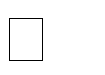
Parenteral Nutrition Complications Mechanical Complications
Air embolism Arteriovenous fistula Brachial plexus injury

Catheter fragment embolism Catheter misplacement Cardiac perforation
Central vein thrombophlebitis Endocarditis
Hemothorax Hydromediastinum Hydrothorax
Pneumothorax or tension pneumothorax Subcutaneous emphysema
Subclavian artery injury Subclavian hematoma Thoracic duct injury
Infection and Sepsis
Catheter entrance site

Catheter seeding from bloodborne or distant infection Contamination during insertion
long-term catheter placement Solution contamination
Metabolic Complications

Dehydration from osmotic diuresis Electrolyte imbalance
Essential fatty acid deficiency
Hyperosmolar, nonketotic, hyperglycemic coma Hyperammonemia
Hypercalcemia
Hyperchloremic metabolic acidosis Hyperlipidemia Hyperphosphatemia
Hypocalcemia Hypomagnesemia Hypophosphatemia
Rebound hypoglycemia on sudden cessation of PN in patient with unstable glucose levels

Uremia
Trace mineral deficiencies

Gastrointestinal Complications
Cholestasis

Gastrointestinal villous atrophy

Hepatic abnormalities

The principles of a healthy diet
Eat a variety of foods to ensure adequate intake of nutrients. Eat plenty of fruits and vegetables. ...
Consume whole grains, nuts and healthy fats rich in unsaturated fatty acids. Reduce the intake of saturated fats. ...
Limit sugar intake. ... Cut back on salt. ...
Drink water regularly

Dietary Plan
A set of scheduled meals in order to achieve different metabolic and health goals, such as weight loss, sugar control, muscle gain
The term Dietary Reference Intakes (DRIs) refers to a set of nutrient-based reference values, each of which has special uses. The development of DRIs expands on the periodic reports called Recommended Dietary Allowances (RDAs), which have been published since 1941 by the U.S. National Academies, and the Canadian Dietary Standards, called Recommended Nutrient Intakes (RNIs) published since 1938 by the Canadian government. This comprehensive effort has been undertaken by the Standing Committee on the Scientific Evaluation of Dietary Reference Intakes of the Food and Nutrition Board, Institute of Medicine, National Academies, at the request of the U.S. government and Health Canada.
Dietary planning involves using the DRIs to set goals for what intakes should be.
Dietary planning may be done at several different levels. It may refer to an individual planning a meal and making relevant food purchases, a food service manager in an institution planning daily menus, or a government agency planning large nutrition or food assistance programs. For the purposes of this report, dietary planning applies to planning intake, rather than the amount of food purchased or served.
Nutritional considerations are only one component of dietary planning. Other considerations include incorporating food preferences of the individual or group being planned for, and the cost and availability of

foods. However, using estimates of nutrient requirements to set intake goals should be part of the planning activity.

The principles of a healthy diet
- Eat a variety of foods to ensure adequate intake of nutrients.
- Eat plenty of fruits and vegetables. ...
- Consume whole grains, nuts and healthy fats rich in unsaturated fatty acids.
- Reduce the intake of saturated fats. ...
- Limit sugar intake. ...
- Cut back on salt. ...
- Drink water regularly

PRINCIPLES OF DIET PLANNING
Here are six principles we believe are important to incorporate into a diet plan
Maintaining adequate levels of energy, nutrients, movement and rest for optimal health
Balancing different food groups, and consuming foods in the right proportion
Consuming the appropriate number of calories to maintain a healthy weight depending on your metabolism and exercise levels
Focusing on creating a diet that is nutrient dense without being high in calories
Learning how to be moderate with foods that are higher in fat or sugar
Exploring a varied diet that provides all the nutrients necessary for good health

Poor Nutrition
Good nutrition is essential to keeping current and future generations healthy across the lifespan. A healthy diet helps children grow and develop

properly and reduces their risk of chronic diseases. Adults who eat a healthy diet live longer and have a lower risk of obesity, heart disease, type 2 diabetes, and certain cancers. Healthy eating can help people with chronic diseases manage these conditions and avoid complications.
However, when healthy options are not available, people may settle for foods that are higher in calories and lower in nutritional value. People in low-income communities and some racial and ethnic groups often lack access to convenient places that offer affordable, healthier foods.
Most people in the United States don‘t eat a healthy diet and consume too much sodium, saturated fat, and sugar, increasing their risk of chronic diseases. For example, fewer than 1 in 10 adolescents and adults eat enough fruits or vegetables. In addition, 6 in 10 young people aged 2 to 19 years and 5 in 10 adults consume at least one sugary drink on any given day.
CDC supports breastfeeding and works to improve access to healthier food and drink choices in settings such as early care and education facilities, schools, worksites, and communities.

Overweight and Obesity
Eating a healthy diet, along with getting enough physical activity and sleep, can help children grow up healthy and prevent overweight and obesity. In the United States, 20% of young people aged 2 to 19 years and 42% of adults have obesity, which can put them at risk of heart disease, type 2 diabetes, and some cancers.

Heart Disease and Stroke
Nutritional food arranged into a heart
Two of the leading causes of heart disease and stroke are high blood pressure and high blood cholesterol. Consuming too much sodium can increase blood pressure and the risk for heart disease and stroke. Current guidelines recommend getting less than 2,300 mg a day, but Americans consume more than 3,400 mg a day on average.
Over 70% of the sodium that Americans eat comes from packaged, processed, store-bought, and restaurant foods. Eating foods low in saturated fats and high in fiber and increasing access to low-sodium foods, along

with regular physical activity, can help prevent high blood cholesterol and high blood pressure.

Type 2 Diabetes
People who are overweight or have obesity are at increased risk of type 2 diabetes compared to those at a healthy because, over time, their bodies become less able to use the insulin they make. Of US adults, 96 million— more than 1 in 3—have prediabetes, and more than 8 in 10 of them don‘t know they have it. Although the rate of new cases has decreased in recent years, the number of adults with diagnosed diabetes has nearly doubled in the last 2 decades as the US population has increased, aged, and become more overweight.

Cancer
An unhealthy diet can increase the risk of some cancers. Consuming unhealthy food and beverages, such as sugar-sweetened beverages and highly processed food, can lead to weight gain, obesity and other chronic conditions that put people at higher risk of at least 13 types of cancer, including
endometrial (uterine) cancer, breast cancer in postmenopausal women, and colorectal cancer. The risk of colorectal cancer is also associated with eating red and processed meat.

Negative effects of unbalanced eating
What does a balanced diet contain?
When we think of a healthy lifestyle, our goal must be the balance, not perfection. A balanced diet contains:
- vegetables and fruits,
- nuts and raw seeds,
- green leaves,
- whole grains,
- fish fishing,
- meat from animals without hormones and antibiotics,

- eggs,
- whole dairy.
Diets based either on a small amount of fat, either on a small amount of carbohydrates, either on clear vegetable soup or on the consumption of fruit juices days and weeks in a row, are unbalanced and have unwanted effects on health status.
Where there are no medical conditions that require special diets without fats or with a small amount of carbohydrates, things can seriously degenerate.
Even short periods of unbalanced eating can have negative consequences in the long run.

The most common effects of unbalanced eating are:
- Lack of energy, concentration, irritability
Moods that arise when eating simple carbohydrates (white flour bread, white pasta and rice, sweets, and pastry). In the first 10 minutes after consuming these products, the blood glucose rises sharply, and the well- associated state appears.
But after 30-40 minutes, the blood glucose decreases as suddenly, and the lack of energy arises, the state of constant hunger, somnolence.
Consume often, and in the long term, simple carbohydrates make us always feel tired and lacking in energy, no matter how much we sleep.
- Water Retention
Either because we don‘t drink enough water and the body reserves it, either because of the surplus of sodium in the diet. In this situation, water is retained in the body until the urinary system eliminates excess sodium from the body.
Also, a surplus of sodium leads discreetly, but directly to arterial hypertension. When the kidneys are overworked to eliminate excess sodium, the heart pumps more blood to sustain their activity, and arterial hypertension occurs.
Instead of excess salt, to give flavor to your favorite dishes, we can add dried herbs or fresh greens.

Constipation
It is one of the effects of unbalanced eating and occurs when there is not enough fiber (fruits, vegetables, salads, whole grains) in daily nutrition, especially in protein diets, but also when we drink too little water.

Insufficient or unrestful sleep
During the night, during sleep, the body recovers. For a restful sleep, it is advisable to eat 3 hours before bedtime. This way, digestion is efficient, and the stomach is empty when we go to bed.
Vegetable soups, salads, or ripe vegetables should be devoided from dinner. They digest quickly and easily and are the allies of a good night‘s sleep.
- Other unbalanced eating effects
When we have too many products with sugar and sweeteners in our daily diet, but also white flour, there is often the lack of vitamins and minerals. Because sugar and white flour are empty calories, the body will use its reserves to metabolize them.
It is the reason why anemia that does not respond to iron or calcium deficiency occurs. Even if we care to have in the diet foods that contain these minerals, the consumption of empty calories prevents their absorption in the body.

Nutrition and Vulnerable Groups
Influence of Feeding Practices on Malnutrition in Haitian Infants and Young Children infant malnutrition remains an important cause of death and disability, and Haiti has the highest prevalence in the Americas. Therefore, preventive strategies are needed
Malnutrition is a frequent cause of consults and treatment
program referrals at this center, but the magnitude of the issue is unknown.
Low-cost evaluation methods using local staff and resources are needed to gather relevant data at the community level.
This information could enhance planning, resource utilization, and intervention strategies. Studying and improving feeding
practices is one important strategy [8].

The objectives of the present study were to assess the prevalence of malnutrition among
Ensuring Good Nutrition for Vulnerable Population Groups such as Elderly and Hospitalized Individuals in Affluent Societies The return of vitamin D deficiency diseases according to the International Osteoporosis Foundation‘s
(IOF) latest figures, approximately 88% of the world‘s population does not have an optimal vitamin D status.
4. This lack is leading to the return of a number of diseases that characterized the Victorian era, such as tuberculosis, scarlet fever and rickets. The lame and sickly child Tiny Tim, for instance, from Charles Dickens‘s 1843 novella A
Christmas Carol, has recently been diagnosed as suffering from both TB and rickets.
As cholecalciferol (vitamin D3), vitamin D is synthesized in the skin by the action of ultraviolet light on 7-dehydrocholesterol; it is also present in a small number of foods, most notably fatty cold saltwater fish such as sardines and mackerel. The return of the bone deficiency disease rickets among young people has been associated with lack of exposure to sunlight – a trend attributable partly to an excess of sedentary indoor activities among this
age group and partly to the extensive use of UV sun screens to protect against sunburn

Malnutrition in hospitalized patients
Clinical surveys in hospitalized patients continue to show an unacceptable high frequency of under nutrition from all over Europe. In the words of the Committee of Experts on Nutrition, Food Safety and Consumer Protection, Council of Europe: ―There are many adverse consequences of disease- related undernutrition. The patient becomes apathetic and depressed, and this may lead to loss of morale and loss of will to recover. Inability to concentrate means that the patient cannot benefit from instructions about techniques needed for self-care. A general sense of weakness impairs appetite and ability to eat. The respiratory muscles are weakened, making it difficult to cough and expectorate effectively, with increased risk of lung infection. Impaired ventilatory drive may also make it difficult to wean a

critically ill patient from a ventilator. Cardiac function is impaired, with reduced cardiac output and risk of heart failure. Gastrointestinal function and structure is injured.
Mobility is reduced, delaying recovery and predisposing to thromboembolism and bedsores. The undernourished patient develops impaired resistance to infection, which in turn can worsen nutritional status. Undernutrition, in combination with disease, is thus an insidious factor which prolongs recovery, increases the need for high-dependency nursing care and sometimes intensive care, increases the risk of serious complications of illness and, at its worst, leads to heath either from a preventable complication or from inanition. To all this is added the reduced quality of life of the patients.‖
The consequences of malnutrition in hospital patients are therefore highly ramified, although not always immediately evident. An inadequate diet in patients whose health may already be compromised by a variety of factors not only increases individual suffering but also greatly increases the costs of attempting to return that individual to a state of relative health and wellbeing. Longer stays in hospital, higher prescription rates and increased demands on medical and nursing staff are just some of the more obvious consequences of inadequate nutrition.

Malnutrition in elderly patients
The elderly are at increased risk of developing both protein-calorie malnutrition and vitamin and mineral deficiencies.
The frequency of undernutrition increases with advancing age due to problems such as poor dentition, loss of taste, difficulty swallowing and malabsorption. Drug-nutrient interaction is also a major factor, as many elderly people are on medication, and the actions of numerous active pharmaceutical ingredients can interfere with the body‘s ability to digest and utilize such nutrients as are ingested.

The anorexia of ageing
Ageing is associated with a wide range of physical changes, including reduction in bone mass, lean mass, and water content, accompanied by an increase in body fat. This may be accompanied by a decline in the function of one or more organs. This loss of physical robustness may lead to aphenomenon known as the ―anorexia of ageing,‖ whereby the feedback

loops in the elderly person‘s brain may falsely signal satiety or turn off the stimulation for hunger. The anorexic signals come to predominate over the central feeding drive
Example of a nutritional support strategy:
The different methods of nutritional support are:
- Oral nutritional support: this comprises nutritional guidance, assistance during eating, provision of fortified food, and oral nutritional supplements some of which are reimbursed
- Enteral nutritional support
- Parenteral nutritional support, only when the gastrointestinal tract is not functional or the patient is not capable of ingesting food.
The nutritional assessment should include a simple dietary interview of the elderly person or of his/her relatives, to establish whether the person has a varied diet, rich in fruit and vegetables, and if he/she eats protein- containing foods (meats, fish, eggs) regularly. It is also recommended to evaluate the daily fluid intake. malnourished elderly subjects or when there is a risk of malnutrition, not only should nutritional management be provided, but identified risk factors should be corrected, by proposing for example:
- Technical or human assistance during meals
- Oral and dental care
- A reassessment of the appropriateness of medication and diets
- Management of any underlying diseases.
Nutritional support is all the more effective when it is implemented early.

